American National Standard
Methods of Measurement of Compatibility between Wireless Communications Devices and Hearing Aids

Accredited Standards Committee on Electromagnetic Compatibility, C63®
accredited by the
American National Standards Institute

Secretariat
Institute of Electrical and Electronics Engineers, Inc.

Approved XX YYY 200Z
American National Standards Institute

© 1995 IEEE. Reprinted, with permission from the IEEE and Edwin L. Bronaugh (author), from his paper presented at the 1995 IEEE Symposium on EMC in Atlanta, GA.

Figure I.2 reprinted with permission from The Telecommunications Industry Association, TIA/EIA/IS-95-A, pp. 5–21, © 1995.
Acknowledgments
The Accredited Standards Committee on Electromagnetic Compatibility, C63®, thanks the IEEE and
Edwin L. Bronaugh (author) for granting permission to use Helmholtz Coils for Calibration of Probes and Sensors: Limits of Magnetic Field Accuracy and Uniformity, from the 1995 IEEE Symposium on EMC, Atlanta, GA, in Annex F of this standard.

Abstract: Uniform methods of measurement for compatibility between hearing aids and wireless communications devices are set forth.
Keywords: American National Standard, electromagnetic compatibility, hearing aid, hearing aid compatibility (HAC), measurement methods, operational compatibility, wireless communications device

________________________

The Institute of Electrical and Electronics Engineers, Inc.
3 Park Avenue, New York, NY 10016-5997, USA

Copyright © 2009 by the Institute of Electrical and Electronics Engineers, Inc.
All rights reserved. Published 8 June 2007. Printed in the United States of America.

C63® is a trademark of the Accredited Standards Committee on Electromagnetic Compatibility.

iDEN is a registered trademark in the U.S. Patent & Trademark Office, owned by Motorola, Incorporated.

PDF: ISBN xxxyyyzzz SS95692

No part of this publication may be reproduced in any form, in an electronic retrieval system or otherwise, without the prior written permission of the publisher.

American National Standard
An American National Standard implies a consensus of those substantially concerned with its scope and provisions. An American National Standard is intended as a guide to aid the manufacturer, the consumer, and the general public. The existence of an American National Standard does not in any respect preclude anyone, whether he has approved the standard or not, from manufacturing, marketing, purchasing, or using products, processes, or procedures not conforming to the standard. American National Standards are subject to periodic review and users are cautioned to obtain the latest editions.
CAUTION NOTICE: This American National Standard may be revised or withdrawn at any time. The procedures of the American National Standards Institute require that action be taken to reaffirm, revise, or withdraw this standard no later than five years from the date of publication. Purchasers of American National Standards may receive current information on all standards by calling or writing the American National Standards Institute.
Authorization to photocopy portions of any individual standard for internal or personal use is granted by the Institute of Electrical and Electronics Engineers, Inc., provided that the appropriate fee is paid to Copyright Clearance Center. To arrange for payment of licensing fee, please contact Copyright Clearance Center, Customer Service, 222 Rosewood Drive, Danvers, MA 01923 USA; (978) 750-8400. Permission to photocopy portions of any individual standard for educational classroom use can also be obtained through the Copyright Clearance Center.
ANSI C63.19-2007 requires the use of a color monitor (and color printer)
to view many of the graphics contained in this standard.
Color is essential to the understanding of the graphics.
ANSI C63.19-2007 requires the use of a color monitor (and color printer)
to view many of the graphics contained in this standard.
Color is essential to the understanding of the graphics.

Introduction
ANSI C63.19-2007 requires the use of a color monitor (and color printer)
to view many of the graphics contained in this standard.
Color is essential to the understanding of the graphics.
This introduction is not a part of ANSI C63.19-2007, American National Standard for Methods of Measurement of Compatibility between Wireless Communications Devices and Hearing Aids.
In the fall of 1995 the Federal Communications Commission (FCC) initiated a Steering Committee to initiate a summit on Hearing Aid Compatibility with Digital Wireless Telecommunications. The goal of the summit was to formalize and continue discussions among the three key affected interests in this issue: organizations representing people with hearing loss, hearing aid manufacturers, and the digital wireless telephone industry. The ultimate purpose of the summit was to find a resolution of the interference problem that was acceptable to the industries involved.

A summit meeting was held on January 3–4, 1996, in Washington, DC. At this summit meeting three working groups were formed to pursue issue resolution. Subsequently, the Long-Term Solutions User and Bystander Interference Group reached a consensus that a standards project was needed to document the consensus definition of and method of measurement for hearing aid compatibility with wireless telecommunications. Subsequently ANSI C63® was petitioned to undertake the joint standards projects documenting the methods of measurement and defining the limits for hearing aid compatibility with wireless telecommunications.

At its April 1996 meeting, ANSI C63® established a task group under its subcommittee on medical devices (SC 8). The charge to this task group (TG C63.19) was to develop such standards in cooperation with representatives of organizations representing people with hearing loss, hearing aid manufacturers, the digital wireless telephone industry, and other interested parties. ANSI C63.19-2001 was the result of that committee’s efforts.

The FCC adopted this standard to provide the technical requirements for its Report and Order establishing mandatory requirements for wireless hearing aid compatibility on July 10, 2003.ª Following the adoption by the FCC and for several reasons, including technical changes in wireless communications devices and hearing aids and new understanding coming from experience gained in working with the 2001 version of this standard, a new revision effort was started. The result of this revision effort culminated in the production of ANSI C63.19-2006.

During the final approval process for the ANSI C63.19-2006 version, several issues were raised. The working group and ANSI ASC C63® decided to open an amendment project to deal with these issues. The successful completion of that effort resulted in the publication of this version of the standard, ANSI C63.19-2007.
After the publication of C63.19-2007 the FCC issued Report and Order 06-107, allocating new wireless services to a frequency band in the 700 MHz range. As part of that rulemaking, the Commission requested that the C63® committee addressing the HAC requirements for the 700 MHz band, The committee agreed to address this 700 MHz band and also decided to extend the upper frequency range to 6 GHz, taking into account newer technologies that are also covered by similar regulations..

The working group and ANSI ASC C63® decided to open an amendment project to deal with these issues. The successful completion of that effort resulted in the publication of this version of the standard, ANSI C63.19-201x.

Notice to Users
Errata
Errata, if any, for this and all other standards can be accessed at the following URL: http:// standards.ieee.org/reading/ieee/updates/errata/index.html. Users are encouraged to check this URL for errata periodically.

ª FCC Docket 03-168
Interpretations
Current interpretations can be accessed at the following URL: http://standards.ieee.org/reading/ieee/interp/ index.html.
Patents
Attention is called to the possibility that implementation of this standard may require use of subject matter covered by patent rights. By publication of this standard, no position is taken with respect to the existence or validity of any patent rights in connection therewith. The IEEE shall not be responsible for identifying patents or patent applications for which a license may be required to implement an IEEE standard or for conducting inquiries into the legal validity or scope of those patents that are brought to its attention.
Participants
At the time this standard was published, the Accredited Standards Committee on Electromagnetic Compatibility, C63®, had the following membership:

Donald N. Heirman, Chair
Daniel Hoolihan, Vice Chair
Mike Kipness, Secretary

Organization Represented Name of Representative
Alcatel-Lucent Dheena Moongilan
Alliance for Telecommunications Industry Solutions (ATIS) James Turner
American Council of Independent Laboratories (ACIL) William Stumpf
Harry Hodes (Alt.)
American Radio Relay League (ARRL) Edward F. Hare
Kermit Carlson (Alt.)
AT&T Dave Chapman
Don Bowen (Alt.)
Bureau Veritas Jonathan Stewart
Mairaj Hussain (Alt.)
Cisco Systems Werner Schaefer
Dave Case (Alt)

Dell Inc. Richard Worley
ETS-Lindgren Michael Foegelle
Zhong Chen (Alt.)
Federal Communications Commission (FCC) William Hurst
Food and Drug Administration (FDA) Jeffrey L. Silberberg
Don Witters (Alt.)

Information Technology Industry Council (ITIC) John Hirvela
Joshua Rosenberg (Alt.)
Institute of Electrical and Electronics Engineers, Inc. (IEEE) Donald N. Heirman
IEEE-EMCS H. Stephen Berger
Donald Sweeney (Alt.)

Motorola Tom Knipple
National Institute of Standards and Technology (NIST) Dennis Camell
PCTest Greg Snyder
Steve Coston (Alt)
Polycom Jeff Rodman
Tony Griffiths (Alt.)
Research in Motion (RIM) Masud Attayi
Daoud Attayi (Alt.)
Samsung Telecommunications Tony Riveria
Kendra Green (Alt.)
Society of Automotive Engineers (SAE) Poul Andersen
Gary Fenical (Alt.)
Sony Ericsson Mobile Communications Mats Hansson
Gary Fenical (Alt.)
Telecommuication Certification Body (TCB) Council Arthur Wall
Bill Stumpf (Alt.)
Telecommunications Industry Association (TIA) Stephen Whitesell
TUV-America, Inc. David Zimmerman
David Schaefer (Alt)
Underwriters Laboratories Michael Windler
Robert Delisi (Alt.)
U.S. Department of Defense—Joint Spectrum Center Marcus Shellman
Joseph Snyder (Alt.)
U.S. Department of the Navy—SPAWAR David Southworth
Individual Members
Daniel Hoolihan
John Lichtig
Ralph M. Showers
Members Emeritus Warren Kesselman
Herbert Mertel
Robert Hofmann

At the time this standard was completed, C63® Subcommittee 8 had the following membership:

Bob DeLisi, Chair

Poul Andersen
Daoud Attayi

H. Stephen Berger
Donald Bowen

Dave Case

Dave Chapman
Steve Coston

David Dzumba
Kendra Green
Ed Hare
Donald N. Heirman

Robert Hofmann
Dan Hoolihan
William Hurst
Stephen Julstrom
Tom Knipple
Linda Kozma-Spytek
Victor Kuczynski
Stephen Liu

Dheena Moongilan

Ralph M. Showers
Jeffrey L. Silberberg
William Stumpf
James Turner
Tom Victorian
Michael F. Violette

Steve Whitesell

Michael Windler
Don Witters
David Zimmerman

At the time this standard was completed, the C63® Working Group had the following voting members:

H. Stephen Berger, Chair

Daoud Attayi
Donald Bowen
Dave Case
Dave Chapman
Steve Coston
Dave Dzumba
Kendra Green
Robert Hofmann
William Hurst
Stephen Julstrom
Tom Knipple
Linda Kozma-Spytek
Dave Preves
Jim Turner
Tom Victorian

Contents
1. Overview 1
1.1 Scope 1
1.2 Purpose 2
1.3 Organization and use of the standard 3
2. Normative references 6
3. Definitions, acronyms, and abbreviations 7
3.1 Definitions 8
3.2 Acronyms and abbreviations 10
4. Evaluation for low-power exemption 13
4.1 Analysis of RF protocol 13
4.2 Evaluation of interference potential 13
4.3 Product testing threshold 13
5. Wireless device, RF emissions test 14
5.1 Measured RF audio interference level 15
5.2 Test equipment and facilities 16
5.3 Test setup and validation 17
5.4 Near-field test procedure 22
6. Hearing aid RF near-field immunity test 29
6.1 Test facilities and equipment 29
6.2 Test setup and validation 31
6.3 RF immunity test procedure—primary 33
6.4 RF immunity test procedure—alternate 39
7. Wireless device T-Coil signal test 43
7.1 Test facilities and equipment 43
7.2 Test configurations and setup 44
7.3 Test procedure for T-Coil signal 47
7.4 Broadband test procedure—alternate 55
8. Performance 57
8.1 Audio coupling mode 57
8.2 T-Coil coupling mode 59
8.3 Accessories and options 63
8.4 Product line compliance 63
9. Calibration and measurement uncertainty 63
9.1 General 63
9.2 Ambient conditions 64
9.3 Specific calibration requirements 64
9.4 Measurement uncertainty 64
10. Test report 64
10.1 Test plan 64
10.2 Applicable standards 65
10.3 Equipment unit tested 65
10.4 Test configuration 65
10.5 List of test equipment 65
10.6 Units of measurement 65
10.7 Location of test site 66
10.8 Measurement procedures 66
10.9 Reporting measurement data 66
10.10 General and special conditions 66
10.11 Summary of results 66
10.12 Required signatures 67
10.13 Test report annexes 67
10.14 Test report disposition 67
Annex A (normative) Definition of reference axes 68
A.1 Axes definition for hearing aid RF immunity tests 68
A.2 WD RF emission measurements reference and plane 69
A.3 T-Coil measurement points and reference plane 71
Annex B (normative) Test frequencies 73
B.1 Acoustic test frequencies 73
B.2 Test channels and frequencies 73
Annex C (normative) Equipment and setup calibration 75
C.1 Test enclosures 75
C.2 Audio input source 75
C.3 Calibration of RF E-field probes 75
C.4 Modulation Interference Factor (MIF) 76
C.5 Calibration of dipoles 77
C.6 Weighting accuracy validation 80
C.7 Calibration of hearing aid probe coil 81
C.8 Selection and calibration of acoustic transmission line (Informative) 84
C.9 Microphone subsystem requirements 84
Annex D (normative) Test equipment specifications 86
D.1 Acoustic damper 86
D.2 Audio frequency analyzer or wave analyzer 86
D.3 Detector, Square Law 86
D.4 Dipole, resonant 88
D.5 Directional coupler 100
D.6 Filter, spectral weighting 100
D.7 Filter, temporal weighting 101
D.8 Hearing aid probe coil 101
D.9 Helmholtz calibration coils 102
D.10 Probe, near-field, E-field 104
D.11 RF cables 104
D.12 RF communications test set 104
D.13 RF power amplifier 104
D.14 RF signal generator 105
D.15 RF wattmeter 105
D.16 T-Coil integrator 105
D.17 TEM cell 108
D.18 Voltmeter, DC 108
D.19 Voltmeter, true rms 108
Annex E (informative) Sample measurement uncertainty estimates 109
E.1 WD near-field emissions measurement uncertainty 109
E.2 Hearing aid near-field immunity measurement uncertainty 110
E.3 WD audio band measurement uncertainty 113
E.4 Sample estimation 114
Annex F (informative) Use of Helmholtz coils for calibration 115
F.1 Introduction 115
F.2 Axial field-strength accuracy 116
F.3 Radial field-strength 119
F.4 Summary 122
F.5 References 123
Annex G (informative) Limits in linear units 124
G.1 Hearing aid immunity limits 124
G.2 WD emission limits 124
Annex H (informative) U.S. Frequency bands 127
H.1 CMRS Bands in the US 127
H.2 New and emerging services 128
Annex I (informative) RF envelope comparison for U.S. WD systems 131
I.1 Introduction 131
I.2 AMPS 131
I.3 NADC 132
I.4 GSM and PCS 132
I.5 CDMA 132
I.6 iDEN 133
I.7 OFDM 135
Annex J (informative) Explanation of rationale used in this standard 137
Annex K (informative) Bibliography 138

American National Standard
Methods of Measurement of Compatibility between Wireless Communications Devices and Hearing Aids
- Overview
  - Scope
This standard applies to both wireless communications devices (WDs) and hearing aids. It sets forth uniform methods of measurement and parametric requirements for the electromagnetic and operational compatibility of hearing aids used with WDs, including cellular, personal communications service (PCS) phones, and voice-over-Internet-protocol (VoIP) devices, operating in the range of 698 MHz to 6 GHz. TIA-1083, Telecommunications - Telephone Terminal Equipment - Handset Magnetic Measurement Procedures and Performance Requirements, has become the recognized standard for wireline communications devices, including cordless telephones (cordless handsets with wireline-connected base units). Ongoing communications between the TIA-1083 and ANSI C63.19 working groups have been maintained with the objective of harmonizing the two standards to the maximum extent possible.
This standard is intended to apply to all types of hearing aids with acoustic output, including, as examples, behind-the-ear (BTE), in-the-ear (ITE), in-the-canal (ITC), and completely-in-the-canal (CIC) types. Test methods are provided for acoustic (microphone input) mode or in tele-coil
(T-Coil) input mode of the hearing aid operator.
Users of this standard are cautioned to maintain the field strength called for in various places in the document within the limits for the radio-frequency (RF) safety set forth in Std IEEE C95.1..
  - Purpose
The purpose of this standard is to establish categories for hearing aids and for WDs that can indicate to healthcare practitioners and hearing aid users which hearing aids are compatible with which WDs and to provide tests that can be used to assess the electromagnetic characteristics of hearing aids and WDs and assign them to these categories. The various parameters required, in order to demonstrate compatibility are measured. The design of the standard is such that when a hearing aid and a WD achieve one of the categories specified, as measured by the methodology of this standard, the indicated performance is realized.
In order to provide for the usability of a hearing aid with a WD, several factors must be coordinated as follows:
- The field strength emitted by a WD must not exceed the RF immunity of the hearing aid
- The T-Coil, baseband H-field transmission of the WD must be compatible with the T-Coil mode of the hearing aid
- The electronic noise from the WD in the T-Coil band must not degrade the reception quality to unacceptable levels

Both the WD’s RF and audio-band emissions are measured. Hence, the following measurements are made for the WDs:
- RF near-field, E-field emissions
- T-Coil mode, magnetic signal strength in the audio band
- T-Coil mode, magnetic noise in the audio band
- T-Coil mode, magnetic signal frequency response through the audio band

Corresponding to these quantities, the hearing aid is measured for the following:
- RF immunity in microphone mode
- RF immunity in T-Coil mode

The hearing aid T-Coil reception characteristics are also important when assuring the usability of the
T-Coil mode. When these characteristics are coordinated, the goals of this standard are accomplished.
Two principal conditions expose hearing-aid-equipped users to undesired RF electromagnetic disturbances. The far-field condition corresponds to the type of field a hearing-aid-equipped bystander would experience when adjacent to a WD user. The near-field condition corresponds to the more intense fields that a hearing-aid-equipped user of a WD would experience. This standard assesses the near-field or user condition.
This standard describes preferred test methods and test facilities and, in some cases, alternative test methods and facilities. If alternative test methods or facilities are employed, every effort shall be made to establish correlation with the preferred ones. Any deviation from the preferred test methods, as set forth in this standard, shall be fully described in the test report.
Wherever the word shall is used in this standard, it indicates something mandatory. The word should indicates something that is advisory. The word may indicates an option, which is at the discretion of the test engineer.
  - Organization and use of the standard
These technical requirements define the measurement methods and categorical levels to ensure hearing aid operational compatibility with WDs.
To ensure hearing aid and WD compatibility, it is essential that uniform measurement methods be defined for hearing aid RF immunity and WD RF emissions. In addition, in order to provide for T-Coil mode, the WD T-Coil signal must be evaluated for signal strength, intended/unintended signal ratio and the frequency response of the signal in the audio band.
There are several factors impacting hearing aid performance when used in the presence of a WD. The hearing aid can be exposed to near-field illumination (when the hearing aid user uses a WD) or to far-field illumination (when the radiating element is at a distance from the hearing aid user). Different styles of hearing aids (for example BTE, ITE, ITC, and CIC) are positioned differently with respect to the WD. WDs can operate at different frequencies and utilize different transmission schemes.
Hearing aids can operate in an acoustic coupling mode or a T-Coil coupling mode. In acoustic mode, hearing aids use a microphone to pick up acoustic sound waves generated by the WD. In T-Coil mode, the microphone output is disabled (or attenuated) and a baseband H-field signal, generated by the WD becomes the signal source. During T-Coil operation the baseband H-field generated by the WD is intended to be the primary coupling mechanism to the hearing aid. The WD also can produce unintended H-fields (the result of circulating currents). Such H-fields produce noise, if detected during T-Coil operation, or may introduce interference in hearing aid circuits, even in the acoustic mode.
The WD generates an electromagnetic field as the main communication means with the public telephone network. However, it is possible for this field to interfere with the hearing aid’s proper operation. Interference is produced as a result of pickup and demodulation within the hearing aid circuitry. The goals are to control the E-field distribution and to provide hearing aids with a minimum amount of electromagnetic immunity such that levels in direct proximity to the hearing aid (with WD in normal position) are manageable and do not interfere with basic hearing aid functionality.
The technical requirements have been organized into ten general clauses. The following is a summary of each clause:
1 Overview: Describes the scope and purpose of the standard.
2 Normative references: References used in this standard.
3 Definitions, acronyms, and abbreviations: Definitions, acronyms, and abbreviations used in this standard.
4 Low-power exemption: Evaluates the need for RF testing under Clause 5. Some low-power RF modes can be exempted from mandatory testing.
5 Wireless device RF emissions test: Prescribes the measurements of the near-field RF generated by pulsed RF WD in the region controlled for use by a hearing aid.
6 Hearing aid RF near-field immunity test: Prescribes the measurement method to be used in determining the immunity level of a hearing aid to radiated electromagnetic fields originating from a WD.
7 Wireless device T-Coil signal test: Specifies the WD T-Coil signal measurement. Two quantities are measured: the desired and undesired H-field levels.
8 Performance criterion: Provides the criterion required for acceptable interoperability of a hearing aid with a WD. When these criteria are met, as defined by the tests described in this standard, a hearing aid will operate acceptably with a WD. The performance criteria for the T-Coil mode are specified in 9.2.1 and 9.2.2. This standard specified the set of parameters for the microphone and T-Coil modes of operation.
9 Calibration and measurement uncertainty: Provides guidance for estimating the uncertainty and reproducibility of measurements made in accordance with this standard.
10 Test report: Specifies the minimum content of the test report and is similar to the specifications of ANSI C63.4-2003 Clause 10.

Figure 1.1 depicts the organization and use of this standard. Both the WD and hearing aid have mandatory tests, in Clause 4 through Clause 8. These provide for both microphone and T-Coil modes of operation. The appropriate test is performed for each device and a category is determined, using the parameters found in Clause 9. The category information is then made available to the end user. Using the category information from both a WD and hearing aid, the end user is able to determine the performance to be expected from any particular WD and hearing aid combination. Clause 10 and Clause 11 provide guidance on calculating the measurement uncertainty and on preparation of the test report. The test report shall be delivered to the relevant authority requiring the testing.

EMBED Visio.Drawing.11 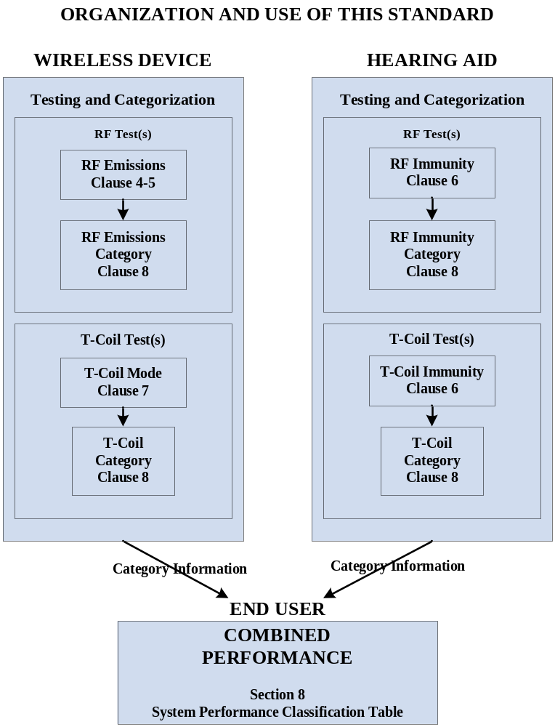

Figure 1.1—Organization of this standard

Using the category system, a user may determine whether a particular WD will be compatible and generally usable with a particular hearing aid. To do this, the immunity rating of the hearing aid is added to the emissions rating of the WD. A sum of 4 would indicate that the combination of WD and hearing aid is usable. A sum of 5 would indicate that the WD and hearing aid would provide normal use, and a sum of 6 or greater would indicate that the WD and hearing aid would provide excellent performance.
The measurements of WD emissions and hearing aid electromagnetic immunity (EMI) are performed fairly close to the devices, where small errors in instrumentation, electromagnetic field measurements, and hearing aid position can manifest in large uncertainties in measurement results.
Clause 10 describes the uncertainties involved in these measurements and instrument calibration procedures to control these.
This standard also contains several annexes with additional information about the measurements, instrumentation, calibration of instruments, and uncertainty of the measurements.
This standard is intended to provide a measure of the compatibility between hearing aid devices and WD products. The device categories are based on testing with hearing aid devices in the laboratory and in actual use. However, there is a wide range of human perceptions of normal communications with WD or even wired communications. Thus, even when compatibility between a particular hearing aid and WD is indicated by these tests, it cannot be guaranteed that the vocal output of the WD will be intelligible to all users of the two devices.
- Normative references
The following referenced documents are indispensable for the application of this standard. For dated references, only the edition cited applies. For undated references, the latest edition of the referenced document (including any amendments or corrigenda) applies.

ANSI C63.4, American National Standard for Methods of Measurement of Radio-Noise Emissions from Low-Voltage Electrical and Electronic Equipment in the Range of 9 kHz to 40 GHz.
ANSI C63.14, American National Standard Dictionary for Technologies of Electromagnetic Compatibility (EMC), Electromagnetic Pulse (EMP), and Electrostatic Discharge (ESD).
ANSI S1.4-1983 (Reaff 2005), American National Standard Specification for Sound Level Meters.
ANSI S3.22, American National Standard for Specification of Hearing Aid Characteristics.

CISPR/TR 16-4-3, Specification for Radio Disturbance and Immunity Measuring Apparatus and Methods—Part 4-3: Uncertainties, Statistics and Limit Modelling—Statistical Considerations in the Determination of EMC Compliance of Mass-Produced Products.

Code of Federal Regulations Title 47 Part 22 (47CFR22), Public Mobile Services.
Code of Federal Regulations Title 47 Part 24 (47CFR24), Personal Communications Services.
Code of Federal Regulations Title 47 Part 68 (47CFR68), Connection of Terminal Equipment to the Telephone Network.

Code of Federal Regulations Title 47 Part 90 (47CFR90), Private Land Mobile Radio Services.

IEC 60118-0, Hearing Aids—Part 0: Measurement of Electroacoustical Characteristics.

IEC 60118-7, Hearing Aids—Part 7: Measurement of the Performance Characteristics of Hearing Aids for Production, Supply and Delivery Quality Assurance.

IEC 61000-4-3, Electromagnetic Compatibility (EMC)—Part 4: Testing and Measurement Techniques—Radiated, Radio Frequency, Electromagnetic Field Immunity Test.

IEEE Std 269™, IEEE Standard Methods for Measuring Transmission Performance of Analog and Digital Telephone Sets, Handsets, and Headsets.,
IEEE Std 1027™, IEEE Standard Method for Measurement of the Magnetic Field in the Vicinity of a Telephone Receiver.
IEEE Std 1309™-2005, IEEE Standard for Calibration of Electromagnetic Field Sensors and Probes, Excluding Antennas, from 9 kHz to 40 GHz.
IEEE Std C95.1™, IEEE Standard for Safety Levels with Respect to Human Exposure to Radio Frequency Electromagnetic Fields, 3 kHz to 300 GHz.
IEEE Std C95.3™, IEEE Recommended Practice for the Measurements and Computations of Radio Frequency Electromagnetic Fields With Respect to Human Exposure to Such Fields, 100 kHz–300 GHz.
ISO 3-1973, Preferred Numbers—Series of Preferred Numbers.
ISO 266-1975, Acoustics—Preferred Frequencies.

NIS 81: Edition 1, May 1994, The Treatment of Uncertainty in EMC Measurements.
NIS 3003: Edition 8, May 1995, The Expression of Uncertainty and Confidence in Measurement for Calibrations.
NIST Technical Note 1297, Sept. 1994, Guidelines for Evaluating and Expressing the Uncertainty of NIST Measurement Results.
SAE J551/1, Performance Levels and Methods of Measurements of Electromagnetic Compatibility of Vehicles, Boats (up to 15 m), and Machines (50 Hz to 18 GHz).

TIA/EIA-136 Series, 800 MHz TDMA Cellular Standards.
TIA -2000 Series, CDMA 2000 Series.

- Definitions, acronyms, and abbreviations
The definitions given in ANSI C63.14-1998 and IEEE 100 [B48] apply throughout this standard, unless otherwise noted in 3.1. Particular product standards or applicable regulation definition take precedence. Definition sources (if applicable) are enclosed in brackets or parentheses following the definition.
  - Definitions

3.1.anechoic enclosure: An enclosure whose internal walls have low reflection characteristics. [ANSI C63.14-1998]
NOTE—Note that this implies that all six surfaces of the enclosure have low reflection characteristics for incident waves. For audio use, the anechoic enclosure may not necessarily be a metallic enclosure; for RF applications, the anechoic enclosure is a shielded (against RF ingress or egress) metallic enclosure. Both types of enclosures use absorbing material (suited to the frequency range of use) to implement the low reflection characteristics desired.
3.1.audio band: The audio frequency range. See: audio frequency.
3.1.audio band magnetic signal—desired (ABM1): Measured quantity of the desired magnetic signal.
3.1.audio band magnetic signal—undesired (ABM2): Measured quantity of the undesired magnetic signal, such as interference from battery current and similar non-signal elements.
3.1.audio coupling mode: Transmission of a signal between two pieces of equipment using sound.
3.1.audio frequency: Any frequency corresponding to a normally audible sound wave. (IEEE 100 [B48])
- Audio frequencies range roughly from 15 Hz to 20 000 Hz. This standard generally addresses audio frequencies from 50 Hz to 10 kHz.
- This term is frequently shortened to audio and used as a modifier to indicate a device or system intended to operate at audio frequencies, for example, audio amplifier.
3.1.band: Frequency range between two defined limits. (IEEE 100 [B48])
3.1.bandwidth: The range of frequencies within which performance, with respect to some characteristic, falls within specific limits. (IEEE 100 [B48])
3.1.compatibility: The ability of a WD and a hearing aid to work together; specifically with regards to radio-frequency interference and magnetic signal levels, frequency response and signal-to-noise levels.
3.1.dBm0: Power level in dBm, relative to a reference point called the zero transmission level point, or 0 TLP. A signal level of X dBm at the 0 TLP is designated X dBm0. In a codec, the 0 TLP is specified in relationship to the full-scale digital level or saturation. However, digital saturation is generally not 0 dBm0. For m-law codecs 0 dBm0 is 3.17 dB below digital full scale. For A-law codecs 0 dBm0 is 3.14 dB below digital full scale.
3.1.digital wireless telephone: RF-based, wireless telephones utilizing digital transmission formats over an air interface.
NOTE—Generally these are devices regulated under Parts 15, 22, and 24 of the Rules of the Federal Communications Commission. Annex I contains a more detailed discussion of these devices.
3.1.directional coupler: A transmission coupling device for separately (ideally) sampling (through a known coupling loss for measuring purposes) either the forward (incident) or the backward (reflected) wave in a transmission line. (IEEE 100 [B48])
3.1.far-field region: That region of the field of an antenna where the angular field distribution is essentially independent of the distance from a specified point in the antenna region.
- For a half-wavelength dipole, the reference point is usually taken as the center of the antenna, but may be anywhere on the surface of the antenna.
- For a half-wavelength dipole, the far-field region is considered to exist at distances much greater than λ/2π, where λ is the wavelength. For a half-wavelength dipole, this distance is at the geometric center of the transition region between the near-field and far-field regions.
- The distance 3λ is considered to lie in the far-field region. (IEEE 100 [B48]: (EMC) 377-1980r)
3.1.forward power: That power supplied by the output of an amplifier (or generator) traveling towards a load. [SAE J551/1]
3.1.gigahertz transverse electromagnetic chamber (GTEM): See: wideband TEM (WB TEM) cell.
3.1.hearing aid: A professionally dispensed, wearable, air-conduction, sound amplifying device that is intended to compensate impaired hearing.
3.1.input referenced ambient noise (IRAN): The equivalent acoustic input sound pressure level that would produce the acoustic noise output observed from a hearing aid. IRAN may be obtained by subtracting the acoustic gain in decibels from the acoustic noise output.
3.1.input referenced interference level (IRIL): The equivalent acoustic input sound pressure level (typically at 1 kHz) that would produce the same acoustic output in a hearing aid as that produced by an RF interference source. IRIL may be obtained by subtracting the acoustic gain in decibels from the acoustic interference output.
3.1.intentional radiator: A device that intentionally generates and emits RF energy by radiation or induction. [FCC 15.3(o)]
3.1.measurement reference point: Generally, the center of the earpiece receiver speaker openings. Physical location may be offset from earpiece center, if a secondary induction source is used.
NOTE—Wireline phones referenced this as ear reference point, this conflicts with the use of ear reference point as effective radiated power.
3.1.modulation interference factor (MIF): For a modulated signal, the difference, in dB, found by subtracting the signal’s steady state level, in dB, from its RF audio interference level, in dB.
3.1.near-field region: That part of space between the antenna and the far-field region. (IEEE 100 [B48]: (AP) 145-1993)
- The near field includes the quasi-static and induction fields varying as r⁻³ and r⁻², respectively, but does not include the radiation field varying as r⁻¹ (IEEE 100 [B48]: (PE/T&D) 1260-1996).
- For a half-wavelength dipole, the near-field region is considered to exist at distances much less than λ/2π, where λ is the wavelength.
- For a very short dipole, or equivalent radiator, the outer boundary is commonly taken to exist at a distance of λ/2π from the antenna surface. (IEEE 100 [B48]: (AP) 145-1993)
3.1.net power: Forward power minus reflected power at the same location on a transmission line.
[SAE J551/1]
3.1.personal communications service device: Intentional radiators operating in the frequency band specified by the applicable regulating agency that provide a wide array of mobile and ancillary fixed communication services to individuals and businesses. [Modification of FCC 15.303(g)]

3.1.reflected power: That power traveling towards the amplifier (or generator) reflected by a load caused by impedance mismatch between the transmission line and load. [SAE J551/1]
3.1. RF Audio Interference Level: The level of an unmodulated RF carrier that, when modulated by 80% 1 kHz sine wave AM, produces the same output from a weighted square-law detector as does the modulated RF signal under test when measured with the same weighted square-law detector.
3.1. shielded enclosure: A mesh or sheet metallic housing designed expressly for the purpose of separating electromagnetically the internal and the external environment. [ANSI C63.14-1998]
3.1.sound pressure level (SPL): The sound pressure level, in decibels, of a sound is 20 times
the logarithm to the base 10 of the ratio of the pressure of this sound to the reference pressure.
(IEEE 100 [B48])
NOTE—For this standard, the reference level shall be 20 μPa.
3.1.tele-coil (T-Coil): An inductive coil used in some hearing aids to allow reception of an audio band magnetic field signal, instead of an acoustic signal. The magnetic or inductive mode of reception is commonly used in conjunction with telephones, auditorium loop systems, and other systems that provide the required magnetic field output.
3.1.transverse electromagnetic (TEM) cell: A measuring device that is designed to utilize the TEM mode over the frequency range of interest. Common examples are the two port TEM cell (also known as the Crawford Cell) and the wideband TEM cell. [ANSI C63.4-2003]
3.1.wavelength (λ): Of a monochromatic wave, the distance between two points of corresponding phase of two consecutive cycles in the direction of the wave normal. (IEEE 100 [B48])
3.1.wideband TEM (WB TEM) cell: A TEM cell that has been altered to extend the usable frequency range. Often this is achieved by replacing one port of a two port TEM cell with a wideband load. One example is commonly called a GTEM (gigahertz transverse electromagnetic). [ANSI C63.4-2003]
3.1.wireless communications device (WD): A communications device using RF energy. These devices are used in a wireless communications networks such as cellular or personal communication service.
  - Acronyms and abbreviations
ABM audio band magnetic
ABM1 audio band magnetic signal—desired
ABM2 audio band magnetic signal—undesired

AM amplitude modulation
AMPS advanced mobile phone system
ANSI American National Standards Institute
BTE behind the ear (hearing aid)

CDMA code division multiple access
CFR Code of Federal Regulations
CIC completely in the canal (hearing aid)
CW carrier wave
DAI digital audio interface
dB decibel
dBc decibels below carrier
dB SPL decibels referenced to a sound pressure level of 20 μPa
dBm0 power level in dBm relative to zero transmission level point

EHIMA European Hearing Instrument Manufacturers Association
EMC electromagnetic compatibility
EMI electromagnetic interference
EUT equipment under test

f frequency
FDTD finite difference time domain
FFT fast Fourier transform
GSM Global System for Mobile communication
GTEM gigahertz transverse electromagnetic
HFA high frequency average

iDEN®, integrated digital enhanced network
IEC International Electrotechnical Commission
IEEE Institute of Electrical and Electronics Engineers
IRAN input referenced ambient noise
IRIL input referenced interference level
ISO International Organization for Standardization
ITC in the canal (hearing aid)
ITE in the ear (hearing aid)
ITU International Telecommunications Union
kHz kilohertz
MHz megahertz
MIF modulation interference factor
NADC North American Digital Cellular
o.d. outside diameter
OSPL output sound pressure level
P transmit power or forward power (watts)
PAR peak to average power ratio
PC personal computer
PCM pulse code modulation
PCS personal communications services

RL return loss

QAM quadrature amplitude modulation
RBW resolution bandwidth
RF radio frequency
RLR receive loudness rating
RTP reference test position
rms root mean square

SPL sound pressure level
T-Coil tele-coil
TDMA time division multiple access
TEM transverse electromagnetic
TMFS telephone magnetic field simulator

UARFCN UTRA absolute radio frequency channel
UKAS United Kingdom Accreditation Service
UMTS Universal Mobile Telecommunications System
UTRA universal terrestrial radio access
VoIP voice-over-Internet-protocol
VSWR voltage standing wave ratio
WB TEM wideband transverse electromagnetic
WCDMA wideband code division multiple access
WD wireless communications device
- Evaluation for low-power exemption
  - Introduction
This clause provides guidance on evaluating the RF interference potential of an Air Interference Technology. This evaluation analyzes the potential of an Air Interference Technology, which includes its modulated waveform and operating characteristics, to produce hearing aid interference.

  - Analysis of RF Air Interface Technology
An analysis shall be performed, following the guidance of sub-clauses 5.2 and 5.3, of the RF air interface technology being evaluated. Factors that will affect the RF interference potential shall be evaluated and the worst case operating mode shall be identified and used in the evaluation. Any factor that can affect the RF interference potential shall be evaluated. Examples of such factors are those that will change the RF envelope, such as discontinuous transmission due to data load, power management or configuration options of the RF air interface technology.
  - Evaluation of interference potential
A WD’s interference potential is a function both of the WD’s average near-field field strength and of the signal’s audio frequency amplitude modulation characteristics. The portion of the interference potential attributable to the modulation characteristic can be evaluated independently of any particular WD. This evaluation of this interference potential relative to a signal’s average field strength is described in Annex C.4, and is called its Modulation Interference Factor (MIF). The MIF may be determined through analysis and simulation, allowing evaluation of an RF technology’s RF interference potential in advance of actual product development.
  - Product testing threshold
RF air interface technologies that have low power have been found to produce sufficiently low RF interference potential, so that clause 6 product testing is not required. There are two methods for exempting an RF air interface technology from testing. The first method requires evaluation of the MIF for the worst-case operating mode, as described in sub-clause 6.3.4. An RF air interface technology of a device is exempt from testing when its average antenna input power plus its MIF is +17 dBm for any of its operating modes. If a device supports multiple RF air interfaces, each RF air interface shall be evaluated individually. The second method does not require determination of the MIF. The RF emissions testing exemption shall be applied to an RF air interface technology in a device whose peak antenna input power, averaged over intervals ≤50 μsec, does not exceed +23 dBm. An RF air interface technology that is exempt from testing by either method shall be rated as M4, per sub-clause 9.1. However, assignment of a T-rating category still requires individual product testing of the T-Coil signal.

- Wireless device, RF emissions test
This clause provides guidance on the measurements of the near E -fields generated by WDs in the region controlled for use by a hearing aid. Clause 66.4.1.3 sets forth the companion measurement, the immunity of the hearing aid. For the purposes of this standard, the term pulsed refers to the use of a noncontinuous RF envelope or carrier. Examples of wireless telephone systems of this type are described in Annex I. These systems may be deployed at a variety of RF frequency ranges, but this standard is restricted to the range of 698 MHz to 6 GHz. Additionally, it is generally considered sufficient to measure a particular pulsed RF WD at the frequencies at which the WD is capable of transmission as part of its normal operation, as specified by the manufacturer. However, the evaluation need not be limited to those frequencies.
As is stated in the scope (see 1.1) and organization and use (see 1.3) sub-clauses of this standard, the issue of interest is “interference to hearing aids.” To that end, the purpose of the measurements in this clause is to measure the quantity of the RF signal most closely correlated with the intensity of interference to hearing aids, termed the RF audio interference level.
The following discussion is given to clearly and succinctly describe the physical quantity to be measured. This quantity, the RF audio interference level, is defined by the following characteristics. Conceptually, this definition is intended to correlate to the user perception of interference received through an idealized hearing aid and is characterized by the following attributes (depicted in Figure 5.1):
The full signal bandwidth shall be presented to a wideband, square law detector, meaning that the sensing elements and the detector shall have a bandwidth greater than or equal to the emission bandwidth.
The RF signal shall be detected by a square law detector.
The post-detection, recovered audio signal shall be filtered by the spectral and temporal filters specified in Annexes D.6 and D.7.
The output from the spectral and temporal filters has been designed to be proportional to the interference as heard by hearing aid users. The level of an unmodulated RF carrier that, when modulated by 80% 1 kHz sine wave AM, produces that same output from the spectral and temporal filters is termed the RF audio interference level. The RF audio interference level is used in determining the final category.

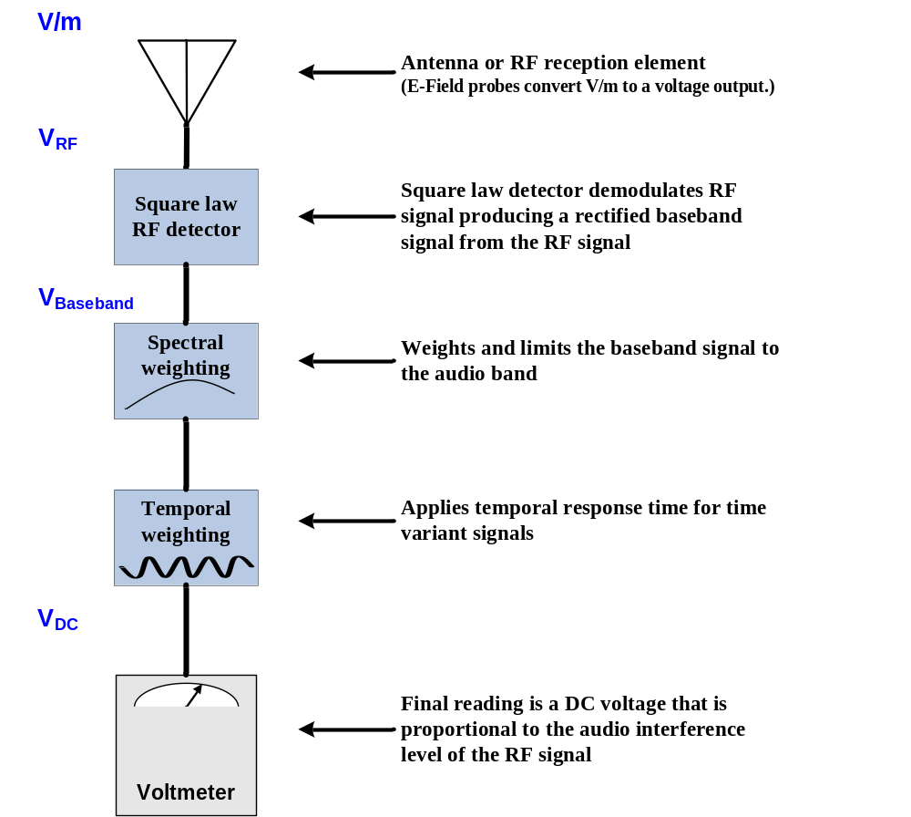

Figure 5.1—RF interference level measurement

  - Measured RF audio interference level
The RF audio interference level measurement is used to predict, in combination with the hearing aid RF immunity the worst-case RF interference experienced by a user with a given combination of hearing aid and WD. The WD emissions category, measured per clause 5, is added to the hearing aid RF immunity category, measured according to the method of clause 6. The summation of these two categories provides their predicted usability indicated in sub-clause 8.2.

A measured RF audio interference level will not generally be directly proportional to any of the conventional measurements of RF field strength for that signal such as average power, burst average power, or peak envelope power. These quantities have not been shown to be consistently predictive of the subjective interference capability of a modulated signal.

Two methods of measuring RF audio interference level are presented:

  - Direct measurement using a probe and detector meeting the frequency response requirements of Annexes C.3 and D.3, and
  - Indirect measurement using a calibrated probe and detector that does not meet the 10 kHz frequency response requirements of Annexes C.3 and D.3, in combination with a waveform-specific modulation interference factor (MIF), defined in Annex C.4.
Both of these methods can be shown mathematically to yield the exact same value. However, the variability between test instrumentation and test setups may result in differences between readings. The indirect method shall be the preferred method and the direct measurement shall be the alternate method for testing, due to the long standing history of data available and widespread use of the indirect method at the time this standard was written.
  - Test equipment and facilities
Portions of this standard place requirements on the test facilities, in addition to the general requirements of ANSI C63.4, and are discussed in this clause, as well as in C.1. Unless stated otherwise, the requirements of ANSI C63.4 apply to the test facilities, including the site design, dimensions, and validation. Additional site validation requirements above 1 GHz are currently under development.
A careful review shall be made of the factors affecting measurement uncertainty, as described in Clause 10 and Annex E. Efforts made to reduce the measurement uncertainty improve the stability and reproducibility of the measurement.
    - Test equipment
This sub-clause provides a list of the test equipment required to perform this test. The test equipment used shall meet the applicable specifications of Annex D.
- E-field, near-field probe
- Probe positioning system
- Square-law detector
- Spectral weighting filter
- Temporal weighting filter
- DC Voltmeter
- WD support
- Reference dipole antenna as described in 6.3.2 and D.4
- RF enclosure, if applicable
    - Near-field measurement system
The near-field measurement system shall include a small, with respect to a wavelength, E-field probe suitable for measuring the field strength of the RF field. For the direct measurement method, the RF signal from a probe is delivered to a square law detector which delivers the recovered audio. The post detection signal from the probe and detector shall have modulation frequency response of at least 50 Hz to 10 kHz, +/-1 dB. The output from the detector is passed through the spectral and temporal weighting filters. The final measurement is the average output voltage from the weighting filters.
IEEE Std C95.3 advises that to avoid certain measurement errors, a probe should not be used closer than a distance equal to three times the length of the active elements of the probe. The probes shall meet the requirements given in D.10 for the E-field.
The use of an automated movement system, such as robotic arms or three-axis positioners, is preferred, as it can provide superior probe placement accuracy and placement repeatability. The placement accuracy and repeatability of the system used shall be determined and included in the measurement uncertainty calculation. Alternatively, manual placement systems may be used. It is recommended that a placement fixture be used with manual systems to assist in accurate probe placement. Such a fixture should be constructed of expanded foam or other RF-transparent materials.
The probe shall be held in such a way as to not significantly influence the readings. For manual measurements, the use of an extension handle, made of low dielectric material, allows the body of the operator to remain sufficiently distant from the test area. In addition, such a probe handle can also serve to assist in maintaining the required 15 mm separation distance from the center point of the probe element(s) to the reference plane for the WD under test.
  - Test setup and validation
This sub-clause provides procedures to prepare for testing, including: supporting the device, reducing reflections, validating the measurement system, and configuring the WD.
    - Device support and check for reflections
The WD shall be supported in such a way that there are no significant RF reflecting objects within a distance of at least two wavelengths at the frequency of measurement, or at a distance such that the total reflections from these objects is kept at least 20 dB below the desired direct signal. The purpose of a
two-wavelength distance to the nearest significant RF reflective object is to maintain at least a 20 dB reflection loss due to these objects. If it is not practical to measure the reflection loss, then the
two-wavelength spacing rule may be used. Support structures such as expanded foam and very low dielectric constant plastics may be used for supporting the WD. The region of the WD that is to be in close proximity to a hearing aid during normal operating conditions shall be available for access by the measurement system.
To check for reflections or other influence from nearby objects move the WD ¼ wavelength relative to the structure, repositioning the measurement probe, so as to keep the same relative spacing between the WD and measurement probe. Rescan the WD and compare the results. The WD may also be reoriented by 45° or 90° and rescanned.
The RF ambient and noise floor shall be > 20 dB below the intended measurement limit. If the RF ambient is within 20 dB of the intended measurement limit, the WD and measurement probe shall be contained within an RF test enclosure conforming to C.1.1.
    - Routing of probe cables
Cable to probes can perturb the field being measured and influence the measurement. While high resistance cables are less prone to influencing the field, they are not entirely invisible and should follow the guidance of this sub-clause. Metallic cables, such as coaxial cables, have greater potential for influencing the field.
To minimize the influence of probe cables, the cables shall be routed to the probe in the least perturbing fashion. Typically this requires that the cable be routed so as to be parallel with the body of the probe and perpendicular to the face of the WD being measured. The cable should exit the field as directly as possible. If cable influence is observed to be a factor, additional dampening may be required, such as through the application of ferrite beads or materials to damp currents on the cable.
    - Setup validation
The test setup should be validated when first configured and verified annually thereafter to ensure proper function. The procedure provided in this sub-clause is a validation procedure using dipole antennas for which the field levels were computed by numeric modeling. Alternate procedures may be used if fully justified.
      - Validation procedures using dipoles
This sub-clause provides guidance on a validation procedure using dipole antennas. Separate but equivalent procedures are provided for both regular dipoles and planar dipoles.
A simulation of dipole free-space E-fields should be made, if possible, to obtain theoretical calculated values for the validation measurements. Compare the measured readings to the simulated values for the reference dipole. Target values derived from numeric modeling for dipoles constructed to the specifications in D.4.1 and following are provided in Table 5.2. Note that these dipoles have different specifications from those used in Clause 6.3.
Probe measurements are generally recorded as rms V/m.
The validation described in subsequent clauses should be performed according to the following:
Average input power P = 100 mW (20 dBm) after adjustment for return loss. An input power which generates field levels similar to those from the WD or other suitable level may also be used.
A dipole as described in D.4 should be used.
The test fixture should meet the two-wavelength separation criterion, per 6.3.1.
The probe-to-dipole separation, which is measured from closest surface of the dipole to the center point of the probe sensor element, should be 15 mm, as shown in Figure A-3and 1.

See E.1 for measurement uncertainty values for E-fields.
RF power shall be recorded using both an average reading meter and a peak reading meter per the setup illustrated in Figure C.1. Readings of the probe shall be provided by the calibrated
near-field probe measurement system.
Table 5.2—Illustrative dipole calculated and measured values at 15 mm
Dipole  (see Annex D) | Frequency range  (MHz) | Center frequency  (MHz) | E-field  calculated  values (V/m) | E-field  measured  values (V/m) | E-field delta  (calculated to  measured)  (V/m) & %
thick | 698-806 | 750 | 101.0
thick | 790–850 | 835 | 116.6
thick | 896–901 | 898.5 | 185
thick | 1880–2000 | 1880 | 96.1
planar | 698-829 | 813.5 | 131.1
planar | 790–850 | 835 | 131.5
planar | 896–901 | 898.5 | 126.4
planar | 1880–2000 | 1880 | 93.1
- Numeric modeling results will vary based on several factors, including the size of the computational area, boundary conditions selected, grid resolution, accuracy of models for material properties, and other factors. Further, the results obtained by numeric modeling will vary from measured results based on many additional factors, including the degree to while the probe perturbs the field, the degree to which the probe averages the field strength over its dimensions, the linearity of the probe, the differences between the physical dipole and its modeled representation, and many other factors. Numeric computations provided to the committee showed significant variability between different results. Accordingly the values provided should be used judiciously and not interpreted to be absolutely correct. The calculated values provided for dipoles were developed using theoretical numerical computation.
- Delta % = 100 × (measured peak minus calculated) divided by calculated. Values within ± 18% are acceptable, of which 12% is deviation and 13% is measurement uncertainty. Values independently validated for the dipole actually used in the measurements should be used, when available.

ª The peak field mentioned in this table is sinusoidal peak. The values cannot be directly compared to the “desired quantity.”

        - Validation procedure
Place a dipole antenna meeting the requirements given in D.4 in the position normally occupied by the WD. The dipole antenna serves as a known source for an electrical and magnetic output. Position the E-field probe so that:
The probe and its cable are parallel to the coaxial feed of the dipole antenna
The probe cable and the coaxial feed of the dipole antenna approach the measurement area from opposite directions; and
The center point of the probe element(s) is 15 mm from the closest surface of the dipole elements.

Scan the length of the dipole with the E -field probe and record the two maximum values found near the dipole ends. Average the two readings and compare the reading to expected value in the calibration certificate or expected value in this standard.
        - Test cases
Three test cases are recommended. The real or emulated WD transmission signal, an unmodulated (CW), and an 80% amplitude modulation (AM) RF signal shall be used for each relevant frequency band. Each of the cases below shall be measured with the E-field probe.
          - Measurement of real or emulated signal
Set a WD or emulated signal source to apply full rated power into the reference dipole. Set the probe measurement system averaging interval duration to be long enough so as to enable an accurate steady state reading.
Measure both the steady state average input power and the peak power within an averaging interval ≤50 µsec applied to the dipole and record these values.
Using the near-field measurement system, scan the dipole over the appropriately sized area and record both steady state rms field strength reading observed and, if using a detector meeting the requirements of D.3, the peak rms field strength observed within the same ≤50 µsec averaging interval as the previous step. Field strength measurements shall be made only when the probe is stationary.
NOTE—The uncertainty for the WD signal in step 6.3.3.1.2.1 is greater than when using AM or CW, as in 6.3.3.1.2.2.
          - Measurement of CW and AM modulated signals
Set the RF signal generator for either CW or 1 kHz 80% AM. Set its output power so the peak power applied to the antenna is equal to that recorded for the real or emulated signal using the WD modulation format.
Measure both the peak and average input power applied to the antenna, confirm that the ratio is 0 dB for the CW signal and 5.1 dB for the 1 kHz 80% AM signal and that the average power rises 1.2 dB when the modulation is applied, Record these values.

Using the near-field measurement system, scan the antenna over the appropriately sized area and record the greatest steady state rms field strength reading observed with and without the modulation applied, and, if using a detector meeting the requirements of D.3, the peak rms field strength. Field strength measurements shall be made only when the probe is stationary.
        - Procedure using regular dipoles
The probe is positioned over the illuminated dipole at 15 mm distance from the center point of the probe sensor element to the top surface (edge) of the dipole element as shown in C.5.3.
        - Procedure using planar dipoles
Position the reference dipole in a suitable holder that enables meeting the RF ambient conditions prescribed in sub-clause 6.3.1. The near field measurement probe is positioned and scanned over the illuminated dipole at a distance of 15 mm from the center point of the probe element(s) to the top surface (edge) of the etched dipole (not the edge of the PC board). A gauge block, as depicted in A.2.1, simplifies the alignment of the probe to the dipole. The scan area for 813 MHz to 899 MHz is 20 mm by 180 mm, and at 1880 MHz it is 20 mm by 90 mm. 3 illustrates the instrumentation setup.
    - WD setup and use
Search for the combination of power and modulation characteristic that is representative of the worst case (highest interference potential) likely to be encountered in normal voice mode operation. Standardize on this specific modulation characteristic for all WD-related measurements. Transmitting modes and conditions which are transient in nature, likely to occur less than 1% of the time, on average, in the network, may be excluded from consideration. Hence, unique transmit modes which occur only during call set-up or tear-down, or during hand-over between base stations, may be excluded. Only continuous (non-discontinuous) transmit modes that occur during conversational speech with the WD held in a talking position at the ear are to be considered. The transmit modes to be tested shall be clearly identified in the test report. The MIF value applied to indirect measurements shall also be established for the same specified transmit modes as those tested.
Since the presence of wires or conductors in the close vicinity of the WD will disturb the RF fields, the WD should also be operated solely under its own power source, with no external connections unless specifically required so by the manufacturer for normal operation. It is assumed that the user of a WD will operate the device in a manner that is consistent with the recommendations of the manufacturer with regards to maximum efficiency of the WD.
Some WDs have more than one antenna position, for example stowed and deployed. In such cases, it is only necessary to test the WD in the condition of maximum antenna efficiency, as defined by the manufacturer. This is considered to be the recommended or specified operation by the manufacturer for the WD. If the fields were found to be higher at another antenna position, the results would be of little concern as the user of the WD would simply have to move the antenna to the more efficient position to reduce the field strength at the hearing aid. However, in cases where the advertised category can only be achieved in certain user controllable configurations it is very important that the consumer be properly informed. Therefore, when the category reported can only be achieved in certain antenna position(s) or other user configuration instructions are required, these conditions shall be reported with the assigned category in the user documentation, label or other locations where the category information is communicated to the user.
      - Multiple, simultaneous transmitters
WD’s capable of operating multiple transmitters simultaneously shall be subject to emissions requirements for all such transmitters expected to be operated when the WD is in voice mode while positioned at a user’s ear. Emissions testing of such qualified transmitters may be accomplished using either of two methods:
- Direct method: Each qualified transmitter is set to the fixed and repeatable combination of power and modulation characteristic that is representative of the worst case (highest interference potential) likely to be encountered while the WD is experiencing normal voice mode operation. The WD is scanned as described in sub-clause 6.4.1.2 with all qualified transmitters operating simultaneously, if this represents an expected operating mode. If only subsets of the qualified transmitters are expected to be operated simultaneously, then operational modes with those subsets should be independently scanned. The limiting measurement for M-rating determination is the result obtained for the worst (highest emission) of these modes.
- Indirect method: Each qualified transmitter is tested individually with no other transmitters operating, using the method of 5.4.1.3. Each is set to the fixed and repeatable combination of power and modulation characteristic that is representative of the worst case (highest interference potential) likely to be encountered while the WD is experiencing normal voice mode operation. The limiting measurement for M-rating determination is the result for the worst (highest emission) of these independent transmitters.
With either method, the low power exemption of sub-clause 5.3 may be applied to an individual transmitter to potentially eliminate it from required further RF emissions testing.
  - Near-field test procedure
In actual use, the wearer of a hearing aid would place the WD in a position that gives the best acoustic coupling from the WD to the hearing aid. In other words, the WD would be located so that the user could hear the WD desired acoustic or T-Coil output the best. This would be with the output transducer (receiver or T-Coil signal source) of the WD in close proximity to the microphone or T-Coil receiver of the hearing aid. For the purposes of this standard the measurements are made in these areas of the WD. In order to best estimate this usage condition as well as provide a repeatable test procedure a measurement grid in the vicinity of the audio output (receiver or T-Coil signal source) has been defined.
A measurement grid is defined over which the RF field strength will be measured. The grid is a 50 mm by 50 mm area that is divided into nine evenly-sized blocks or sub-grids. The grid is centered on the audio frequency output transducer of the WD (speaker or T-Coil). The grid is located by reference to a reference plane, as defined in Annex A.2. A measurement plane is located parallel to the reference plane and 15 mm from it, out from the phone. The grid is located in the measurement plane.
The E-field probe, is to be used to measure the highest field strength in the 50 mm by 50 mm reference plane.
If the T-Coil perpendicular measurement location is in a different location from the acoustic output, ≥ 5.0 mm,, then two different 50 mm by 50 mm areas may need to be scanned, the first for the microphone mode assessment and the second for the T-Coil assessment. The location of the microphone mode 50 mm by 50 mm area is centered on the acoustic output of the WD and is defined in A.2 and depicted in Figure A.2. If needed, the location of the second grid for the T-Coil assessment is identical in shape, but is centered on the T-Coil perpendicular measurement location, as defined in A.3 and depicted in Figure A.3.
The 50 mm by 50 mm area is divided into nine sub-grids (see the diagram in Figure A.2). Three contiguous sub-grids may be excluded from the measurement. The reason for allowing three contiguous sub-grids to be excluded is that extreme “hot spots” are often encountered at the base of the antenna. These high field areas are very localized and easily avoided by the user. Therefore, an exclusion area is allowed so as to not make the requirements needlessly harsh. This allows for RF “hot spots” that can easily be avoided in actual use. The highest reading defined by the sub-grid in the center, containing the acoustic output, and the five remaining sub-grids determines the category rating. The field probe is carefully moved through the measurement area and the highest reading is located. In order to accurately scan the entire 50 mm by 50 mm area, the center of the probe shall be moved through this area. Accordingly the total area covered by the outside edge of the probe shall be the 50 mm by 50 mm area, increased by half (½) the probe diameter on all sides.
The distance from the WD reference plane to the center point of the probe element(s) shall be 15 mm. The WD reference plane is a plane parallel with the front “face” of the WD and containing the highest point on its contour in the area of the phone that normally rests against the user’s ear. The probe element is that portion of the probe that is designed to receive and sense the field being measured. The physical body of the probe housing shall not be used when setting this 15 mm distance as this would place the sensing elements at an indeterminate distance from the reference plane. See Figure A.2.
In the case of a field probe that may have less than three orthogonal elements, it is necessary to rotate the probe to obtain the measurement. Two methods may be used. In the preferred method, the probe shall be rotated in three dimensions for maximum alignment and the reading at maximum field alignment used. An alternative method is to rotate the probe about its geometric center so as to obtain measurements in all three mutually orthogonal orientations. The geometric center is the point that is physically located at the center of electromagnetic sensing element(s) of the probe. This may be determined from physical measurements or from field pattern measurements during calibration. The maximum field shall be the vector sum of all three individual mutually orthogonal measurements. Note that even when using three element probes the probe may be rotated so as to align one element for maximum field coupling. When this is done the reading of the single, maximally aligned element is used as the field reading at that location. Readings taken in this manner are preferred over those taken with the non-aligned method because of the greater accuracy. However, when the alignment method is used, the probe shall be realigned at every measurement point.
In summary, the scan shall adhere to the following requirements:
The center of the probe shall scan to the edges of the grid. Accordingly the total area covered by the outside edge of the probe shall be the 50 mm by 50 mm area, increased by half (½) the probe diameter on all sides.
The center point of the probe measurement element(s) shall be held 15 mm from the WD reference plane. The probe element is that portion of the probe that is designed to receive and sense the field being measured. The physical body of the probe housing shall not be used when setting this 15 mm distance as this would place the sensing element(s) at an indeterminate distance from the reference plane.
The step size of the scan shall be determined by the target measurement uncertainty. Scanning increments of 5 mm or less (see E.2.3) in most cases should meet the uncertainty recommendations. (See E.2.3 and Figure E.1 for specific guidance on step size selection.)
Three blocks can be excluded for each field measurement.
The center block containing the WD output may not be excluded.
    - Detailed near-field test procedure
      - Pre-test procedure
The following steps shall be performed before the WD near-field emissions test is performed (see
Figure 5.2). However, these steps need not be performed before every test. They shall be performed periodically, consistent with good laboratory practice and as required, for example, before testing types of WDs not assessed previously at a laboratory.
Steps 1) and 2) check the probe positioning system for repeatability, accuracy and to confirm that reflective objects are not influencing the measurement. The rest of the procedure characterizes the output of a probe and measurement system, compliant with the requirements of sub-clause 6.2.2, determining the transfer function of the probe from the RF field presented to it to the resulting weighted output level, over the range of expected frequencies and field strengths to be tested. This characterization is performed starting at step 3).
- Check for probe positioning system repeatability and accuracy.
- Confirm interference of reflective objects is less than –20 dB of the intended signal. This may be done by performing the same measurements on the same WD using multiple WD positions and orientations. The readings shall not differ, due to reflections, by more than ± 0.8 dB.

For the direct method perform the following steps:
- Apply a known field strength and frequency to the probe.
- Modulate the field with 1 kHz 80% AM and read the output of the measurement system, after the weighting filters.
- The transfer function,of the measurement system is the level of the square root of the output reading, R, divided by the level of the unmodulated carrier, in V/m. This takes into account the probe factor, which transfers V/m to V presented to the detector, the square law relationship created by the detector, and the effect of the weighting filters on the modulated carrier. Expressed as a formula, the transfer function is:
TF = R^{1/2} / FS
where:
TF – Transfer Function (dB)
FS – Field Strength of the unmodulated carrier (V/m)
R – Output reading

Sufficient measurements shall be performed so as to fully characterize the measurement system for the range of field strengths and frequencies to be measured.

For the indirect method perform the following step:

6) Determine the Modulation Interference Factor (in dB) for the specific modulation characteristic to be tested using the procedure of Annex C.4

EMBED Visio.Drawing.11 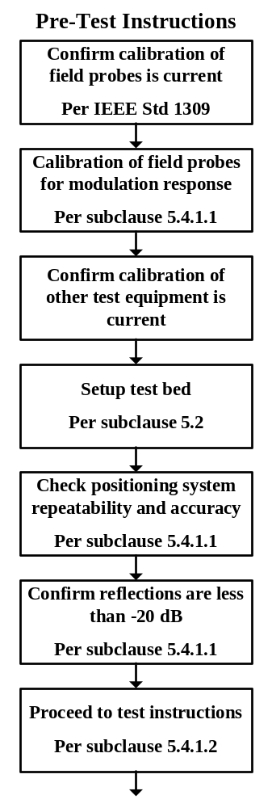
Figure 5.2—WD near-field emissions pre-test flowchart

      - Test procedure – direct measurement - alternate
The following methods are sample step-by-step test procedures. Other comparable procedures may be used. Either manual or automatic test procedures may be used. The automated test procedure is preferred.

The following steps, depicted in Figure 5.3, shall be followed when using this test procedure:

EMBED Visio.Drawing.11 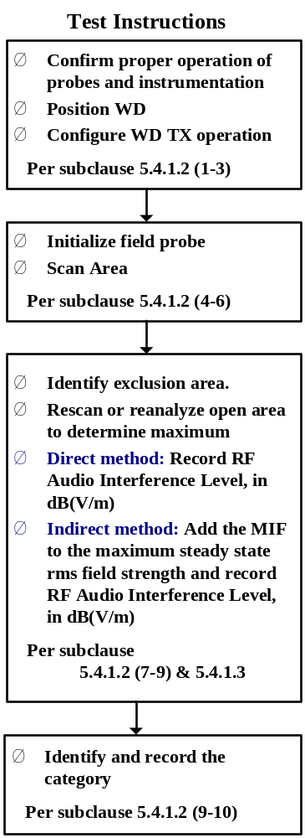

Figure 5.3—WD near-field emission scan flowchart

- Confirm proper operation of the field probe, probe measurement system and other instrumentation and the positioning system.
- Position the WD in its intended test position. The gauge block, depicted in A.2.1, can simplify this positioning.
- Set the WD to transmit a fixed and repeatable combination of signal power and modulation characteristic that is representative of the worst case (highest interference potential) encountered in normal use. Transiently occurring start-up, changeover, or termination conditions, or other operation likely to occur less than 1% of the time during normal operation may be excluded from consideration.
- The center sub-grid shall be centered on the T-Coil mode perpendicular measurement point or the acoustic output, as appropriate. Locate the field probe at the initial test position in the
50 mm by 50 mm grid, which is contained in the measurement plane, described in 6.3.4 and illustrated in Figure A.2. If the field alignment method is used, align the probe for maximum field reception.
- Record the reading at the output of the measurement system.
- Scan the entire 50 mm by 50 mm region in equally spaced increments and record the reading at each measurement point. The distance between measurement points shall be sufficient to assure the identification of the maximum reading. See E.2.3 for guidance in determining the distance between measurement points.
- Identify the five contiguous sub-grids around the center sub-grid whose maximum reading is the lowest of all available choices. This eliminates the three sub-grids with the maximum readings. Thus the six areas to be used to determine the WD’s highest emissions are identified.
- Identify the maximum reading within the non-excluded sub-grids identified in Step 7).
- Convert the maximum reading identified in Step 8) to RF audio interference level, in, V/m,, by taking the square root of the reading and then dividing it by the measurement system transfer function, established in sub-clause 6.4.1.1 Pre-test procedure. Convert the result to dB(V/m) by taking the base-10 logarithm and multiplying it by 20. Expressed as a formula:
RF audio interference level in dB(A/m) = 20*log(R_{max}^{1/2}/TF)
Where R_{max} is the maximum reading.
- Compare this RF audio interference level to the categories in Clause 9 and record the resulting WD category rating.
- For the T-Coil mode M-rating assessment, determine if the chosen perpendicular measurement point is contained in an included sub-grid of the first scan.. If so, then a second scan is not necessary. The first scan and resultant category rating may be used for the T-Coil mode M rating.

Otherwise, repeat Step 1) through Step 9), with the grid shifted so that it is centered on the perpendicular measurement point. Record the WD category rating.
      - Test procedure – indirect measurement - preferred
The measurement procedure using a probe and instrumentation chain with a response of < 10 kHz is identical to the direct measurement method, sub-clause 6.4.1.2, but, because of the bandwidth limitations, cannot involve the direct use of the spectral and temporal weighting functions. The output of such measurement systems must be readings of steady state rms field strength in dB(V/m).
Replacing step 9) of sub-clause 6.4.1.2, the RF audio interference level in dB(V/m) is obtained by adding the Modulation Interference Factor (in dB) to the maximum steady state rms field strength reading, in dB(V/m), from step 8). Use this result to determine the category rating per sub-clause 9.1.

- Hearing aid RF near-field immunity test
This clause prescribes the measurement method to be used in determining the immunity level of a hearing aid to radiated electromagnetic fields originating from a WD. The method is intended to simulate the RF fields experienced by a hearing aid equipped user of a WD and so evaluates the hearing aid’s immunity.
This test procedure uses near-field illumination in assessing the hearing aid immunity rather than far-field illumination. This is a more realistic simulation of the near-field condition experienced by the hearing aid; the intention is to achieve a better correlation between the measured immunity level and the immunity level experienced by an actual hearing aid equipped user of a WD.
Far-field illumination testing, such as in a WB TEM, offers advantages of being more repeatable and less sensitive to issues of placement and positioning. Also far-field illumination testing is commonly required in other standards. Some may prefer to test immunity using a WB TEM to avoid duplicative testing or for other reasons. Sub-clause 7.4 provides guidance on WB TEM testing as an alternate method. However, in case of dispute the results obtained with the near-field illumination test, as described in this clause shall take precedent.
All acoustic measurements are to be made unweighted (i.e., with the acoustic instrumentation set for “linear” or flat frequency response), unless otherwise noted.
The evaluation of the interference effect of the WD’s RF emissions on a hearing aid in acoustic coupling mode is procedurally very similar to that used for the T-Coil mode. For this reason the procedures for evaluating a hearing aid’s immunity to the RF emission, set forth in this clause, is called for in evaluating the T-Coil coupling mode. For simplicity, some helpful notes are contained within the procedures in this clause for evaluation of the T-Coil coupling mode. However, for the T-Coil mode an evaluation must be made of the effects of baseband interference sources to fully evaluate the signal quality that a user experiences.
  - Test facilities and equipment
This sub-clause describes the test facility and equipment to be used for these measurements.
    - General test conditions
This sub-clause lists the test equipment and provides the general test conditions that should be used when performing the test described in this clause. Any deviation from the recommendations contained in this clause shall be identified in the test report.
      - Ambient conditions
See 10.2 for ambient conditions.
      - Power supply voltage
A fresh battery of the type specified by the hearing aid manufacturer shall be mounted inside of the hearing aid during the immunity test. The battery should be within ± 5% of its rated voltage, under no-load conditions.
      - Test sites
Any indoor site meeting the conditions as specified in 10.2 and C.1.1 is acceptable, provided the equipment used for application of RF fields is electromagnetically shielded to the extent necessary to meet federal government electromagnetic emission regulations. A sound-proof booth is not a mandatory requirement. However, ambient noise levels in the test area should be as low as possible and constant for the duration of the test.
    - Test equipment
This sub-clause lists the test equipment needed to perform the near-field immunity tests, using the generic test equipment hookup diagram shown in Figure 6.1. The test equipment used shall meet the applicable specifications of Annex D.
- Two resonant dipoles designed to radiate between 800 MHz and 950 MHz and 1.6 GHz and
2.5 GHz
- RF signal generator
- RF power amplifier
- RF directional coupler
- RF power meters (2)
- Microphones
  - Pressure field microphone
  - Free field microphone
- Microphone pre-amplifier
- Frequency analyzer
- Ear coupler
- Microphone calibrator
- Audio signal generator
- Acoustic transmission line
- Hearing aid immunity test fixture
- RF cables

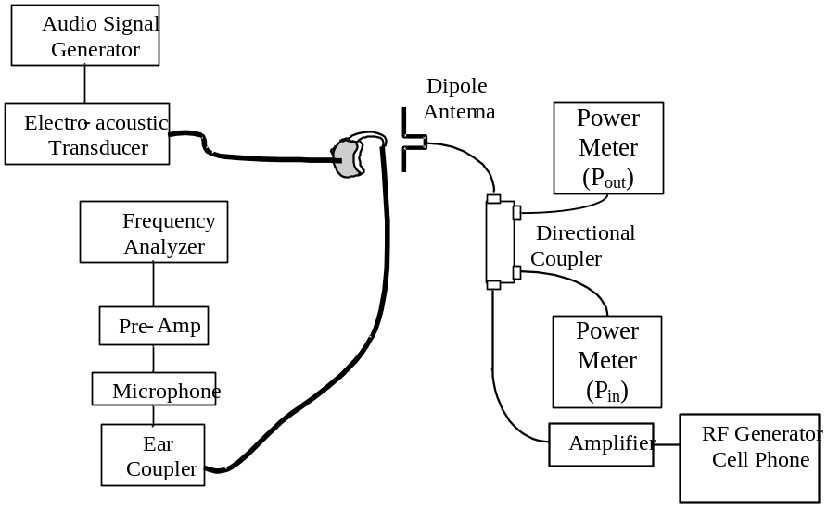
Figure 6.1—Near-field immunity test setup

  - Test setup and validation
Sub-clause 7.2.1 describes how to configure the experimental setup required for hearing aid RF immunity tests. Before hearing aid testing commences, the experimental setup shall be validated. Sub-clauses 7.2.1 through 7.2.5 include a set of pre-test procedures designed to validate the experimental setup in order to ensure the accuracy of the results. In order to verify that the hearing aid performs per the manufacturer’s specifications, 7.2.5 advises that the hearing aid be pre-tested per ANSI S3.22.
    - Hearing aid near-field immunity test setup
Figure 6.1 is a schematic of how the equipment listed in 7.1.2 is set up for RF immunity testing. As shown, the hearing aid acoustic output is connected to the microphone via an acoustic transmission line and ear coupler. The microphone is then coupled to the audio frequency analyzer via a pre-amplifier. This constitutes the audio frequency measurement system. From the RF source, an RF signal is fed to an RF power amplifier, to supply power to the dipole. A two-way directional coupler with RF power meter is placed in-line just before the dipole in order to monitor forward and reflected RF power into the dipole. The RF power level to the dipole is set using a CW RF signal. After the proper test level is established 1 kHz 80% AM is added for the actual test.
The relative spacing between the hearing aid under test and the dipole is critical to the accuracy and repeatability of the test. See E.2.3 for a more detailed discussion of the effect of variation in the relative spacing on the measurement uncertainty.
    - Check for RF interference to test equipment
Set up the equipment as illustrated and described in 7.2.1. With the hearing aid battery removed and RF off, record the ambient spectrum and sound pressure level (SPL) using the same instrumentation to be used for the measurements. Then energize the dipole with the maximum RF power that will be used in the test plus 3 dB, at 900 MHz. Apply 1 kHz 80% AM. Record the audio band spectrum and overall SPL from the frequency analyzer. Alternative measurements can be made at the 1/3 octave bands from 300 Hz to 3.4 kHz, to determine if any change in SPL, due to the RF from the dipole, has occurred.
Repeat the procedure with a 1 W, 1.8 GHz RF signal modulated with a 1 kHz 80% AM. Record the spectrum and overall SPL.
There should be no change in spectrum and overall SPL from ambient during this system check (with the hearing aid battery removed), indicating that the system is immune to interference. If there is an increase in recorded SPL or peaks in the spectrum that appear due to exposure to the energized dipole, it shall be necessary to provide a separation distance between the victim device (which shall be determined) and the radiating dipole. Repeat the above test with increasing separation distance between the victim device and dipole and record the distance at which the interference disappears. Configure the test setup described in 7.2.1 such that this minimum separation distance is achieved between the test equipment and the dipole. If the determined separation distance is impractical, shielding may be employed to eliminate the interference to the test equipment.
    - Characterization of tubing acoustic attenuation and resonances
The required level of interference is to be assessed at the output of the hearing aid. Therefore, it is important to characterize the tubing between the hearing aid under test and the microphone used to monitor it during the test.
    - Audio input source setup
The experimental setup for this sub-clause is illustrated in Figure 6.1. See C.2 for a description of the audio input source.
    - RF field strength validation
The RF field strength presented to the EUT shall be validated either by measuring the field strength using RF field probes or by having the dipoles calibrated per C.5.
    - Pre-tests required for the hearing aid under test
A hearing aid shall be verified to be operating properly and set at an appropriate gain for the test.
  - RF immunity test procedure—primary
This sub-clause describes the procedures, illustrated in Figure 6.2, for testing a hearing aid for immunity to near-field electromagnetic interference (EMI). The measurements are performed first using the dipole for the 800 MHz to 950 MHz band and then repeated with the dipole for the 1.6 GHz to 2.5 GHz band.
- Equipment setup
Configure the equipment as illustrated in Figure 6.1 and described in 7.2.
- Hearing aid setup
  - Set the hearing aid to acoustic mode.
  - Couple the hearing aid through an acoustic transmission line, as defined in 7.2.3. The acoustic transmission line, in turn is connected to an ear coupler in a hearing aid test box or other suitable test arrangement.
  - Adjust the hearing aid to the reference test gain with 60 dB SPL input using HFA (high frequency average) measurements as defined in ANSI S3.22.
  - Secure the volume control against movement with non-conductive tape, glue, or other means.
  - Connect the audio input source.
- Measure hearing aid input versus output gain curve at 1000 Hz and 1300 Hz
Perform an input/output measurement curve of the hearing aid with an acoustic input to the hearing aid covering the range of measurement noise floor to 90 dB SPL in 5 dB steps, at
1000 Hz and 1300 Hz.
- Measure the IRAN (input referred ambient noise) at 1000 Hz
  - Record the acoustic output SPL from the hearing aid, in the 1 kHz 1/3 octave filter band, with the RF source and acoustic source turned off.
  - Using the input/output characteristics at 1000 Hz, determine the gain for the measured acoustic output level.
  - Subtract the 1000 Hz gain from the acoustic output SPL. The result is the ambient acoustical noise referenced to the input, which shall be called the IRAN. The IRAN should be sufficiently below the target input referenced interference level (IRIL) to permit accurate measurement. (The IRAN should be at least 10 dB below the IRIL.)

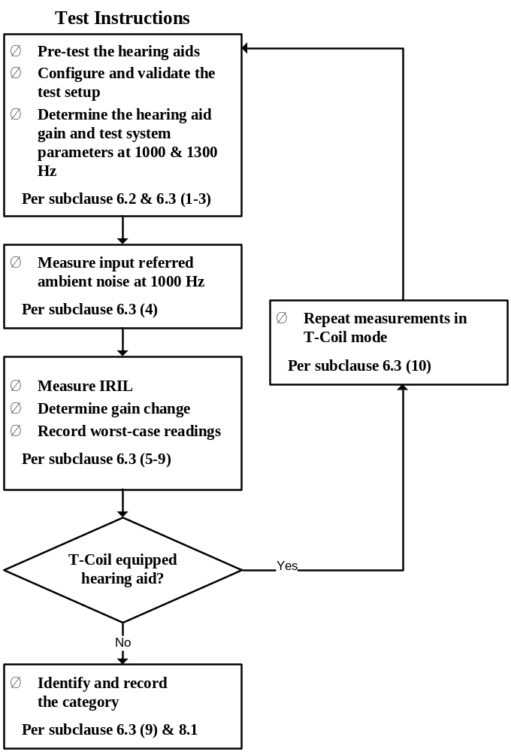
Figure 6.2—Hearing aid immunity test flowchart

- Hearing aid placement
  - To improve the repeatability of the test, the tester should perform prescans of the hearing aid to determine the regions on the hearing aid and dipole that appear most sensitive and to find the corresponding measurement plane and antenna polarization.
  - The hearing aid should then be placed initially in the configuration determined to be most sensitive.
  - The hearing aid shall be placed with the selected reference orientation facing the dipole. For E-field exposure the hearing aid shall be placed 15 mm from the dipole tip. For H-field exposure the hearing aid shall be placed 15 mm from the dipole center (see Figure 6.3).
  - Record the hearing aid orientation in the test report.

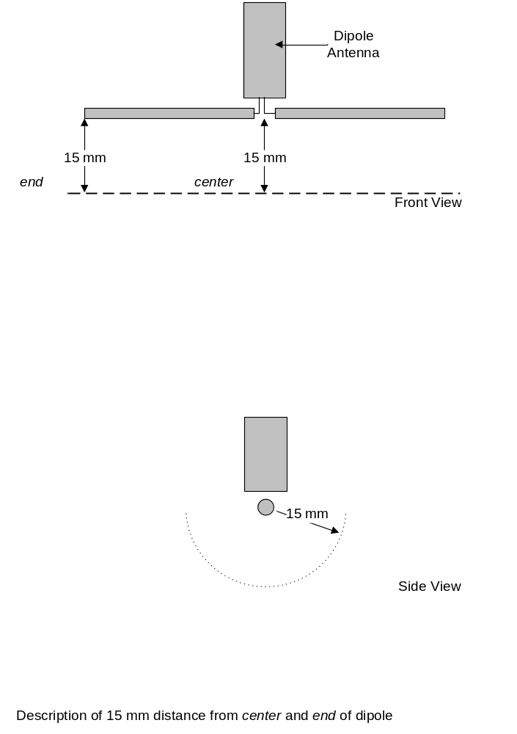
Figure 6.3—Illustration of test positions—15 mm distance from center and end of dipole

- IRIL measurement (E- and H-fields)
  - Energize the dipole at its middle frequency with an RF signal modulated with a 1 kHz AM signal. Tune the dipole or adjust the matching section, if necessary, to meet the voltage standing wave ratio (VSWR) requirement of D.4. Set the power to assure that the interference measured is not saturating the hearing aid.
  - The carrier frequency shall be stepped or swept as specified in IEC 61000-4-3, using a step size of 1% of the carrier frequency. Determine the frequency of maximum response.
Monitor the hearing aid response and adjust RF power so the hearing aid output does not exceed the target SPL.
NOTE—A constant RF drive level may be used to facilitate automation of the testing. However, changes in antenna response with frequency will result in some variation in the field strength presented to the EUT. Care shall be taken to assure that the true frequency of maximum response is identified.
  - Set the carrier frequency to the frequency of maximum response.
  - Drop the RF power by 5 dB and confirm that the hearing aid response is consistent with the input/output curve determined in Step 3). If the response is not consistent, continue to reduce the RF level until the hearing aid response is consistent with the input/output curve. If the hearing aid was in saturation, repeat Step c) at the reduced RF power.
  - While monitoring the hearing aid, rotate the hearing aid in the plane parallel with the dipole elements. Rotate the hearing aid 360° and determine the position of maximum response.
As illustrated in Figure 6.4 the red “X” is the point of maximum sensitivity. The hearing aid is rotated 360° in the Y-Z plane, alternately it can be said, around the X axis.

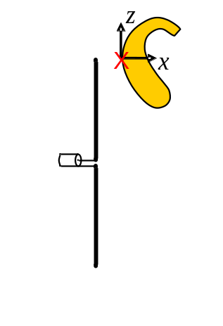
Figure 6.4—Illustration of initial test position and rotation for dipole illumination test

  - With the hearing aid at the position and frequency of maximum response, determine and record the net CW RF power level (forward power minus reflected power) that produces an IRIL level of 55 dB SPL. Once the required 55 dB SPL response is achieved, turn off the modulation and record the net CW RF power level.
  - In order to establish a scan of a second orientation, turn the hearing aid 90° in the plane perpendicular to the dipole elements, as illustrated in Figure 6.5.

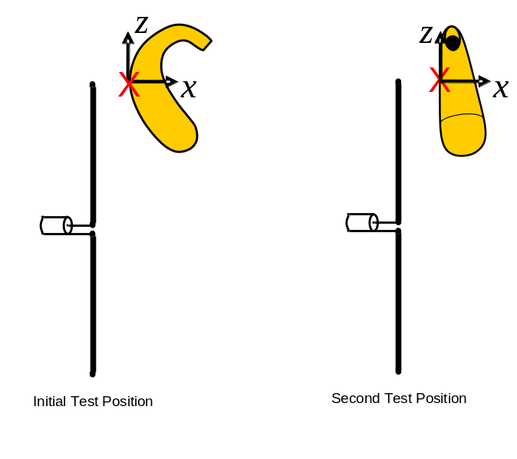
Figure 6.5—Illustration of 90° rotation to the second hearing aid test position

  - Repeat Step b) through Step f) for the new position.
The RF power recorded is the net RF power, as measured with a power meter and directional coupler. From the recorded RF power levels determine the resulting field strength produced by the dipole, derived from the antenna calibration procedure in C.5. The following steps are used to derive the field strength from the calibration chart derived in C.5:
      - At the frequency of interest, determine the net RF power into the dipole.
      - Locate this frequency in the calibration chart and subtract the chart power at this frequency from the measured net power level.
e.g., (P_{measured} – P_{chart}).
      - Add this value to the calibrated field strength value used to create the chart.
e.g., For E-field (P_{measured} – P_{chart}) + 49.54
=
      - The result is the E-field = at a 15 mm distance.

- Establish 1300 Hz hearing aid bias
  - Apply a 1300 Hz acoustic bias signal to the microphone input.
  - With the frequency analyzer resolution bandwidth (RBW) set to 30 Hz, measure the hearing aid acoustic output at 1300 Hz.
  - Adjust the amplitude of the 1300 Hz signal to produce 65 dB SPL at the hearing aid microphone input port, as determined from the measured hearing aid input/output characteristics from Step 3).
  - Document acoustic output level and the gain at 1300 Hz.
  - During T-Coil mode test, apply a 1300 Hz magnetic bias signal to the hearing aid T-Coil that gives the equivalent acoustic output at 1300 Hz, as determined in Step 3) to that delivered by an acoustic input of 65 dB SPL.
  - During the test, monitor the output for changes in gain.
NOTE—The purpose of this step is to measure any gain change and determine if the gain remains within 6 dB of its value before the application of the RF, as required by 9.1. It is desirable that 1300 Hz sine wave test signal be used to determine any gain changes that may occur due to RF carrier effects; however, accurate results may not be possible with some hearing aids by using simple sine wave signals. Such devices may require the use of voice-like signals, e.g., real voice, and artificial voice (see ITU recommendation P.50). Such signals may have frequency weighting and temporal characteristics that require additional processing to correlate with sine wave based test methods. It is up to the tester to ensure that non-sine test signals are properly implemented. A suggested method would be to include an artificial speech signal along with the 1300 Hz signal. The reference gain can then be determined by using just the
1300 Hz portion of the combined artificial voice/1300 Hz signal.
- Determination of gain change due to RF signal
  - Remove the RF signal, disable the modulation, and apply the 1300 Hz acoustic bias to the hearing aid.
  - Adjust the amplitude of the bias, as established in Step 7), so that an equivalent input level of 65 dB SPL is achieved.
  - Using the same worst-case frequency and orientation from the previous measurement, energize the dipole with a CW RF signal, using the same peak RF level used in Step 6).
  - Record any gain changes > 2 dB. Gain change is determined by comparing the audio level with the RF source both on and off.
  - If the gain change is greater than 2 dB, use the gain adjusted by the change measured in this step when calculating the IRIL. See the second note as follows for further details.
- The unmodulated RF level shall be increased by 5.1 dB to achieve the same peak RF power levels as those achieved by 1 kHz 80% AM.
- The purpose of this check for hearing aid gain change is to determine if the hearing aid gain is affected directly by the RF exposure of the test rather than by the demodulated audio signal. Gain measurements in Step 3) account for the audio effect on gain but not the RF effect. This step is used to determine if the gain measured in Step 3) represents gain during RF exposure. If the gain does change by more than 2 dB then the actual hearing aid gain under the RF exposure test condition shall be used in calculating the acoustic input referenced level rather than the hearing aid gain measured before the test. The following steps shall be taken to properly account for gain compression or expansion in the hearing aid:
    - Record the maximum gain deviation greater than 2 dB during RF exposure.
    - Add to the acoustic output level the amount by which the gain decreased from the acoustic output level measured in Step 7). If the gain increased, the amount of gain increase will instead be subtracted from the acoustic output level.
    - Use the new, adjusted acoustic output level in determining the IRIL value and related test results.,
- IRIL and gain change measurements (E-field)
Repeat Step 5) through Step 8) while exposing the hearing aid to within 15 mm of the tip of one radiating dipole element. This should expose the hearing aid under test to the maximum electric field from the dipole.
- Acoustic IRIL measurements (E- and H-fields) for 1.6 GHz to 2.5 GHz
Repeat Step 5) through Step 9) for the 1.6 GHz to 2.5 GHz band using the correct dipole for that frequency range.
- Record data
  - Record the minimum E-field and H-field levels for each of the frequency bands that produce an IRIL level of 55 dB SPL. This is the desired overall test result, which shall be compared against the limit threshold as outlined in 9.1 in Table 8.1.
  - Determine the category according to the immunity ranges given in Table 8.1 of sub-clause 9.1. When using dipole illumination, the worst of the E-field and H-field values is used to assign the immunity rating.
  - Record the category achieved by the hearing aid under test.
- Measurement of additional operating modes (E- and H-fields)
Repeat Step 1) through Step 11) of this sub-clause with the hearing aid in each operating mode provided, e.g., microphone, directional microphone (if provided), and T-Coil (if provided).

  - RF immunity test procedure—alternate
This sub-clause provides guidance on WB TEM testing as an alternate method.
In case of dispute, the results obtained with the near-field illumination test, as described in 7.3, shall take precedence.
Joint investigations between the IEC and ANSI committees were pursued in the interest of reaching consensus on a single test. The conclusion reached was that either the dipole test or the WB TEM test yields a satisfactory evaluation of the RF immunity of the hearing aid. However, the tests are not equivalent in that a fixed relationship in the test results could not be established.
    - WB TEM RF immunity test procedures
- The RF test equipment, test configuration, and test procedures as specified in IEC 61000-4-3 shall apply. This requires that a 1 kHz 80% sine AM of the carrier wave (CW) be used.
NOTE—For small systems (such as hearing aids) suitable WB TEM cells and striplines may be used as indicated in IEC 61000-4-20-2003 [B43].
- Other than the hearing aid, no objects that could distort the RF field shall be present in the test volume.
- In order to remove the metallic ear simulator or coupler as specified in IEC 60711 and
IEC 60126 from the test volume, the normal tubing between the hearing aid and the ear simulator or coupler shall be replaced by tubing of 2 mm bore and with a length typically between 50 mm and 500 mm. For ITE instruments, a suitable adapter shall couple the outlet from the receiver to the tubing. This adapter and the length of the tubing are not critical, as the hearing aid gain is determined in each individual test configuration. The complete acoustical coupling arrangement used shall be described when presenting the results. An example of a suitable test arrangement is given in Figure 6.6.
NOTE—Measurements should be made to ensure that the background noise level of the test configuration is at least
10 dB lower than the lowest interference level to be measured.

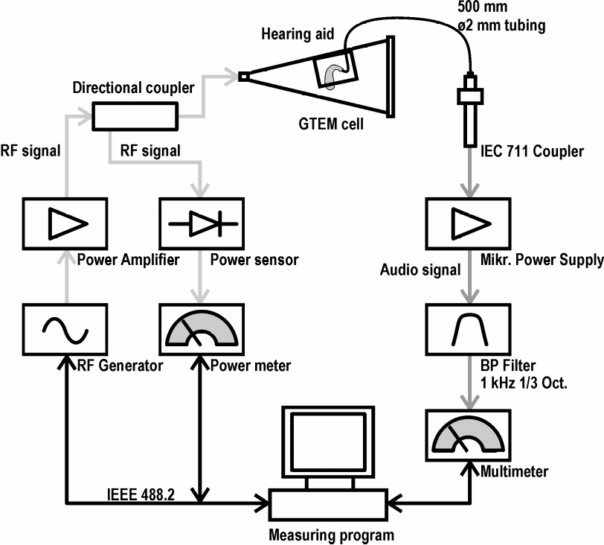
Figure 6.6—Example of test arrangement for hearing aid immunity measurements

- The hearing aid volume control shall be adjusted to the reference test gain control position as described in Amendment 1 of IEC 60118-0-1983 or Amendment 1 of IEC 60118-7-1983. Any other controls on the hearing aid shall be set to positions giving the widest frequency response and the maximum acoustic output.
- With the acoustical coupling described in Step 3) and the test conditions described in Step 4),
the input–output response of the hearing aid shall be measured at 1000 Hz as described in
IEC 60118-0 or IEC 60118-7. From the input–output response curve, determine the output obtained at 55 dB SPL input level. If the hearing aid provides a T-Coil, determine the output SPL (OSPL) for an input of 20 mA/m. Examples of input–output response curves are given in
Figure 6.5.
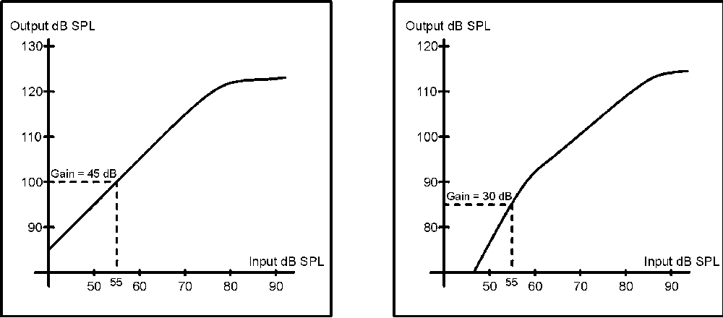
Figure 6.6—Examples of input–output response curves at 1000 Hz and the determination of output SPL at an input level of 55 dB SPL

- The hearing aid, with the controls set as in Step 5), shall be placed in the RF field, and the SPL of the interference signal at 1000 Hz shall be determined.
The hearing aid shall be placed in the initial or reference orientation, as described in 7.3. Figure 6.7 illustrates the initial test position. The rotation is in the X-Y plane.
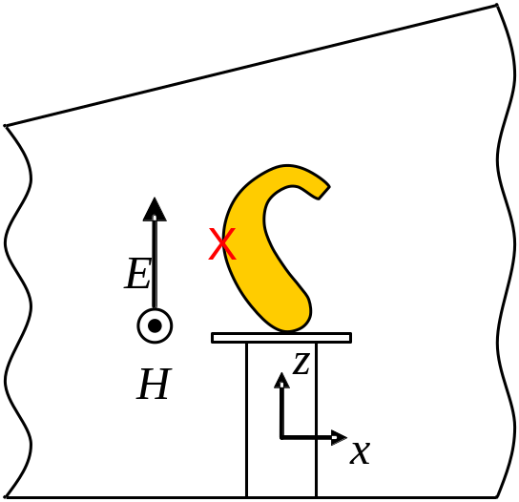
Figure 6.7—Illustration of initial test position and rotation for GTEM illumination test

Using a frequency near the center of each frequency band to be tested (800 MHz to 950 MHz and 1.6 GHz to 2.5 GHz), rotate the hearing aid in each of the two positions, as required in 7.3, and identify the position of maximum sensitivity. Figure 6.8 illustrates the second test position. The rotation is in the X-Y plane.
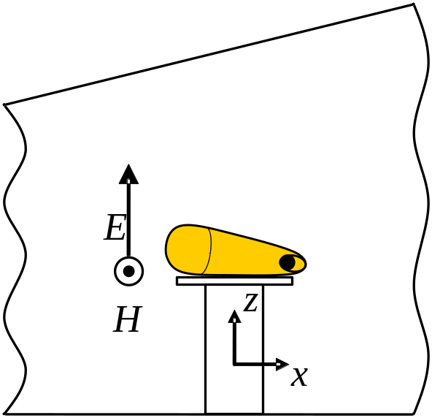
Figure 6.8—Illustration of the second test position and rotation for GTEM illumination test

The measurement of the interference SPL shall be carried out with the hearing aid in the orientation for which the interference signal reaches its maximum value. The maximum value within each frequency range is used to characterize the interference.

Sweep the frequency through the frequency band being tested and identify the frequency of maximum sensitivity.
NOTE—Measurement results from hearing aids with automatic signal processing (ASP) characteristics or other non-linear processing should be interpreted with care, as the interference signal may activate these systems in an unpredictable way. If a “test mode” is provided for a hearing aid, it should be used during the test to defeat such processing.

Follow the procedure described in Step 8) of 7.3. If gain change does occur it shall be accounted for in the final result, as described in Step 8) of 7.3.

- In the worst-case orientation and at the frequency at which the interference reaches its maximum value, increase the field strength until the hearing aid output level determined in Step 5) is reached. Then record the field strength required to produce an IRIL = 55 dB SPL in the hearing aid. This field strength that produces a hearing aid IRIL of 55 dB SPL is used to determine the hearing aid category using Table 8.2.
The measurement shall be carried out with the hearing aid in each operating mode provided, e.g., microphone, directional microphone (if provided), and T-Coil (if provided).

- Wireless device T-Coil signal test
This clause describes the measurement of the T-Coil signal from the WD. Three quantities are measured and evaluated. The first is the field intensity of the desired signal at the center of the audio band. The second is the frequency response of the desired signal measured across the audio band. The third is the signal quality, which is defined as the difference between the desired and undesired magnetic field levels. The measurement procedure is fully described in 8.3.1. Parameters for each of these quantities are found in Clause 9.

Measure both the desired and undesired magnetic signals with the WD in calling mode.

The measurement shall not include undesired properties from the WD’s RF field.

Sub-clause 7.1 describes recommended test facilities and equipment, including probe coils and test equipment. Sub-clause 7.2 describes test configuration and setup. Sub-clause 7.3 describes measurement procedure for T-Coil fields. Sub-clause 7.4 describes alternate measurement procedures using a broadband signal source.
  - Test facilities and equipment
See Annex C and Annex D for test facility requirements.
    - Test equipment
      - Foundational test equipment
The following test equipment, or equivalent instruments, is required to perform this test. Test equipment used shall meet the applicable specifications of Annex D.

- Audio signal generator
- 1/3 octave bandpass filter
- A-weighting filter (per ANSI S1.4)
- Probe coil assembly
- Helmholtz calibration coils
- True rms voltmeter
- Base station simulator/ communications test set with audio input–output or nonradiating load

      - Additional test equipment
The following equipment may be required:

- Anechoic or shielded chamber (magnetic)
- Graphics recorder
- Optional controller
- Power supply
- Test interface adapter (TIA)
- Telephone magnetic field simulator (TMFS)
  - Test configurations and setup
Figure 7.1 and Figure 7.2 illustrate the basic test configurations for magnetic field measurements.

Note that the setup assumes that the proper reference input level to the base station simulator or phone interface as defined in 8.3.2.1 has already been determined.

The receive audio signal for the WD may be injected into the base station simulator, which transmits it to the WD while the WD is on a call. An alternate method is to use the WD manufacturer’s test mode, if available. If a manufacturer’s test mode is used, it is up to the tester to show that the signal is equivalent to the reference input level into a base station simulator as defined in 8.3.2.1.
All battery types intended for use with the EUT shall be investigated. Dummy batteries that are not representative of the batteries used by the end-user shall not be used.
    - Ambient and test system noise
It is necessary that the magnetic and RF ambient levels be low enough as to not significantly affect the intended measurement. In order to achieve these levels, audio band magnetic and RF ambient shielding may be required. In some cases, a full RF shielded chamber may be required to accurately perform the intended measurements.

Care shall be taken to ensure that measured field strengths due to noise in the test system or from the environment should be at least 10 dB below the category limit being measured, which is specified in 9.2, or below the device ABM2 level of the device being measured. For the measurement of ABM1 (audio band magnetic signal—desired), this criterion applies in each 1/3 octave band over the specified voiceband. The noise ambient shall be measured and recorded in the test report to document its level relative to the ABM2 reading. Satisfaction of the criterion may be confirmed by placing the probe and receiver in the position to be used for WD field strength measurements. Remove the WD and measure the remaining noise field strength in the same way and over the same frequency range used for WD measurements.
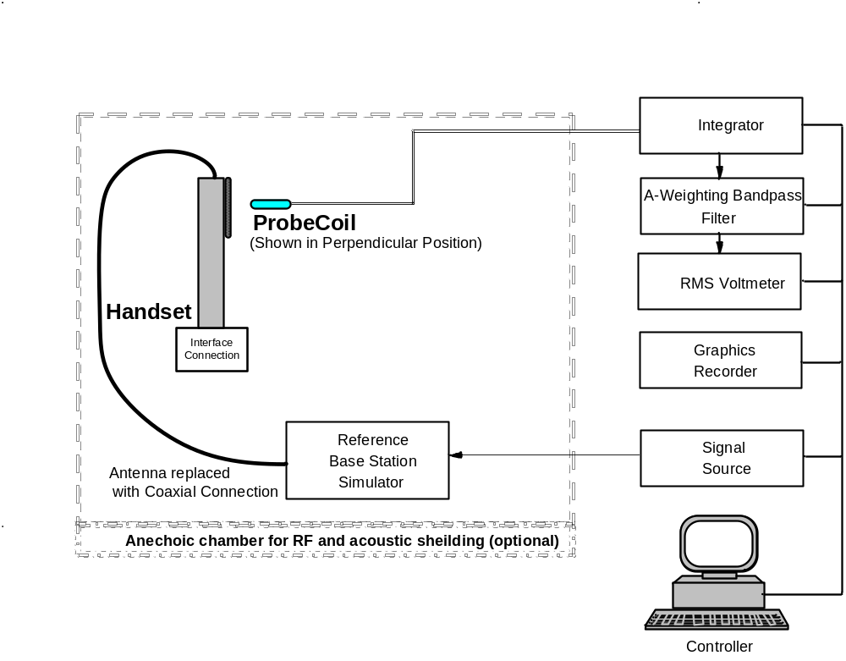
Figure 7.1—T-Coil signal measurement test setup—in call method
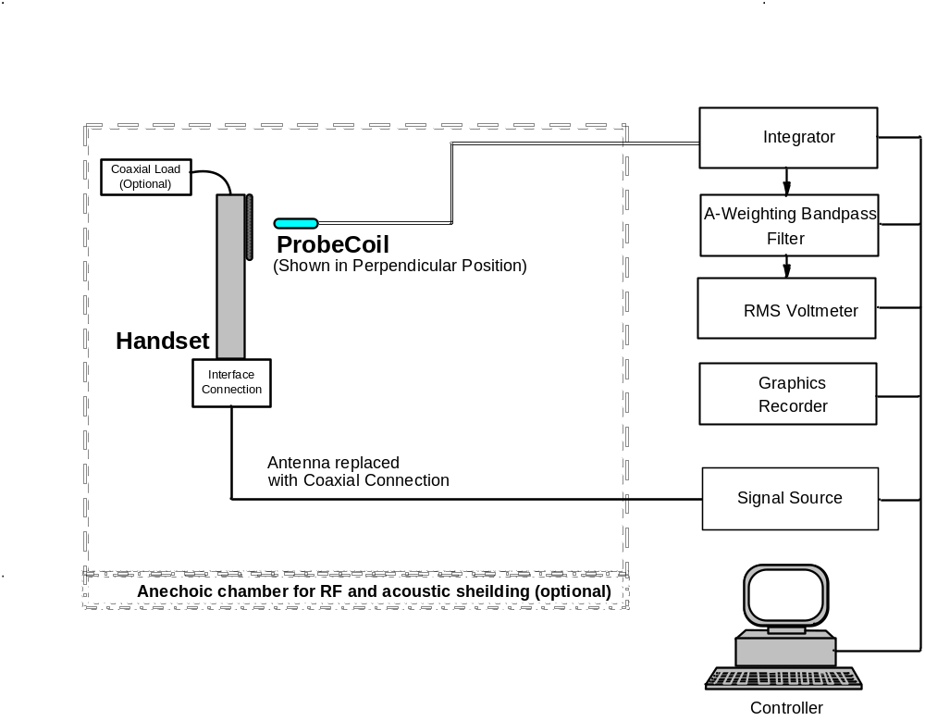
Figure 7.2—T-Coil signal measurement test setup—test mode method

    - Base station simulator method
A base station simulator, as shown in test setup Figure 7.1, allows the WD to be in its conversation mode. It is required that the base station simulator provide the complementary audio signal processing to the WD. Through the base station simulator, command the WD to transmit at maximum RF power.
NOTE—The WD is set to transmit at maximum RF power to ensure that associated baseband effects such as battery surge currents are accounted for. However, the WD antenna is replaced by a coax so as to mask the effects of the RF transmission signal from the measurement.

Set the base station simulator to provide a low-level RF signal, approximately –50 dBm, using a frequency near the center of the frequency band. Inject a P.50 artificial speech signal, or similar speech signal in accordance with sub-clause 8.3.2, for the digital mode.

CAUTION
The test operator is cautioned about using a sine wave for digital modes and is referred to
IEEE Std 269 for additional information.

    - Manufacturer’s test mode method
The WD can be placed in test mode. This is normally done through the interface connection shown with the line in the test setup (see Figure 7.2). The base station simulator may be replaced by an optional
non-radiating RF load to allow the WD to transmit at maximum RF power without interfering with the measurement instrumentation. In test mode, provide an audio input by injecting the signal into the system connector and redirecting it to the earphone through the electrical sidetone path or other electrical loopback path. An alternate method is to inject a PCM coded signal into the virtual digital interface also referred to as the digital audio interface (DAI).

It is considered the responsibility of each WD manufacturer to fulfill and verify the specification points. Some advantages to the test mode method are that the base station simulator is not needed and the digital voice coder might be bypassed so a sine wave signal can be used. The WD RF is set to a channel near the center of the frequency band and the RF power is set to its maximum.
    - Calibration of the probe coil
Specifications and the required response curves for the probe coil are contained in C.7. If the probe coil is not in compliance with C.7 and D.8, then information similar to that contained in the annexes should be provided to fully justify use of the probe and to explain the linearity compensation utilized and identify the probe model number.
  - Test procedure for T-Coil signal - preferred
This sub-clause describes the procedures used to measure the ABM (T-Coil) performance of the WD. In addition to measuring the absolute signal levels, the A-weighted magnitude of the unintended signal shall also be determined. In order to assure that the required signal quality is measured, the measurement of the intended signal and the measurement of the unintended signal must be made at the same location for each measurement positions. In addition, the RF field strength at each measurement location must be at or below that required for the assigned category.
Measurements shall not include undesired properties from the WD’s RF field; therefore, use of a coaxial connection to a base station simulator or non-radiating load may be necessary. However, even then with a coaxial connection to a base station simulator or non-radiating load there may still be RF leakage from the WD, which may interfere with the desired measurement. Pre-measurement checks should be made to avoid this possibility. All measurements shall be done with the WD operating on battery power with an appropriate normal speech audio signal input level given in Table 7.1. If the device display can be turned off during a phone call then that may be done during the measurement as well, but should be documented in the test report.

Measurements shall be performed at two locations specified in Annex A.3, with the correct probe orientation for a particular location, in a multi-stage sequence by first measuring the field intensity of the desired T-Coil signal (ABM1) that is useful to a hearing aid T-Coil. The undesired magnetic components (ABM2) shall be examined for each probe orientation to determine possible effects from the WD display and battery current paths that may disrupt the desired T-Coil signal. The undesired magnetic signal (ABM2) must be measured at the same location as the measurement of the desired ABM or T-Coil signal (ABM1) and the ratio of desired to undesired ABM signals calculated. For the perpendicular field location only the ABM1 frequency response shall be determined in a third measurement stage. The flowchart in Figure 7.3 illustrates this three-stage, two-orientation process.
When a WD is capable of operating multiple transmitters simultaneously, all such transmitters expected to be operated when the WD is in voice mode and positioned at a user’s ear shall be active during the measurement of ABM2. Each transmitter shall be set to the fixed and repeatable combination of power and modulation characteristic that is representative of the worst case (highest ABM2 interference potential) likely to be encountered while the WD is experiencing normal voice mode operation. If only subsets of the transmitters are expected to be operated simultaneously, then ABM2 should be measured separately for each of those subsets. The limiting measurement for T-rating determination is the result obtained for the worst (highest emission) of these modes.
    - Test flow for T-Coil signal test
The following steps summarize the basic test flow for determining ABM1 and ABM2. These steps assume that a sine wave or narrowband 1/3 octave signal can be used for the measurement of ABM1. An alternate procedure yielding equivalent results utilizing a broadband excitation is described in 8.4.

- A reference check of the test setup and instrumentation may be performed using a TMFS or Helmholtz Coil. Position the TMFS or Helmholtz Coil into the test setup at the position to be occupied by the WD. Measure the emissions and confirm that they are within tolerance of the expected values.
- Position the WD in the test setup and connect the WD RF connector to a base station simulator or a non-radiating load as shown in Figure 7.1 or Figure 7.2. Confirm that equipment that requires calibration has been calibrated, and that the noise level meets the requirements given in 8.2.1.
- The drive level to the WD is set such that the reference input level defined in 8.3.2.1, Table 7.1 is input to the base station simulator (or manufacturer’s test mode equivalent) in the 1 kHz,
1/3 octave band. This drive level shall be used for the T-Coil signal test (ABM1) at f = 1 kHz. Either a sine wave at 1025 Hz or a voice-like signal, band-limited to the 1 kHz 1/3 octave, as defined in sub-clause 8.3.2, shall be used for the reference audio signal. If interference is found at 1025 Hz an alternate nearby reference audio signal frequency may be used. The same drive level will be used for the ABM1 frequency response measurements at each 1/3 octave band center frequency. The WD volume control may be set at any level up to maximum, provided that a signal at any frequency at maximum modulation would not result in clipping or signal overload.

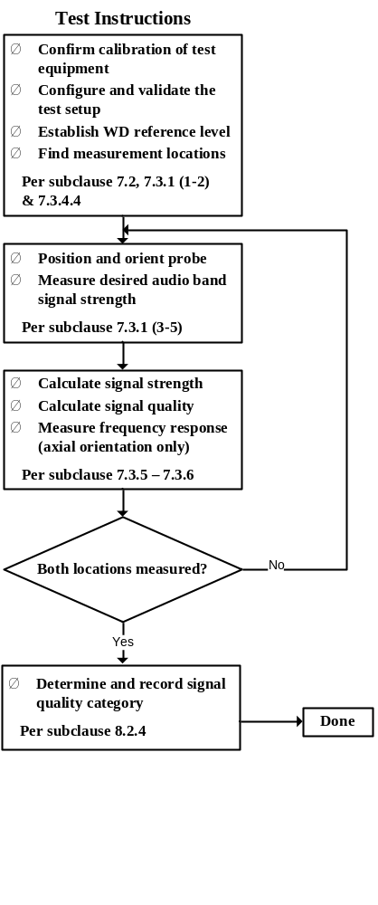
Figure 7.3—WD T-Coil signal test flowchart

- Determine the magnetic measurement locations for the WD device (see A.3), if not already specified by the manufacturer, as described in 8.3.4.1.1 and 8.3.4.2.
- At each measurement location, measure and record the desired T-Coil magnetic signals (ABM1 at f_{i}) as described in 8.3.4.2 in each individual ISO 266-1975 R10 standard 1/3 octave band. The desired audio band input frequency (f_{i}) shall be centered in each 1/3 octave band maintaining the same drive level as determined in Step 3) and the reading taken for that band.
Equivalent methods of determining the frequency response may also be employed, such as fast Fourier transform (FFT) analysis using noise excitation or input–output comparison using simulated speech. The full-band integrated or half-band integrated probe output, as described in D.17, may be used, as long as the appropriate calibration curve is applied to the measured result, so as to yield an accurate measurement of the field magnitude. (The resulting measurement shall be an accurate measurement in dB A/m.)
All measurements of the desired signal shall be shown to be of the desired signal and not of an undesired signal. This may be shown by turning the desired signal on and off with the probe measuring the same location. If the scanning method is used the scans shall show that all measurement points selected for the ABM1 measurement meet the ambient and test system noise criterion in 8.2.1.
- At the measurement location for each orientation measure and record the undesired broadband audio magnetic signal (ABM2) as described in 8.3.4.4 with no audio signal applied (or digital zero applied, if appropriate) using A-weighting, and the half-band integrator. Calculate the ratio of the desired to undesired signal strength (i.e., signal quality).

- Determine the category that properly classifies the signal quality based on Table 8.5.

    - Test signals
It is generally simpler and therefore preferred to use sine wave test signals for audio band tests. However, accurate results may not be possible with some voice coders using simple sine wave signals. Such devices may require the use of voice-like signals such as real voice or artificial voice, as described in IEEE Std 269-2010 or ITU recommendation P.50 (P.50 voice). Such signals may have frequency weighting and temporal characteristics that require additional processing to correlate with sine wave based test methods. It is up to the test operator to ensure that non-sinusoidal test signals are properly implemented.
      - Reference input level
The following reference input levels that correlate to a normal speech input level shall be used for the standard transmission protocols:

Table 7.1—Normal speech input levels
Standard | Technology | Input  (dBm0)
TIA/EIA/IS 2000 | CDMA | –18
TIA/EIA-136 | TDMA (50 Hz) | –18
J-STD-007 | GSM (217 Hz) | –16
T1/T1P1/3GPP ª | UMTS (WCDMA) | –16
iDEN | TDMA (22 Hz and 11 Hz) | –18
ª For UMTS refer to 3GPP TS26.131 and TS26.132 (http://www.3gpp.org).

For systems not listed in the previous table, use the normal speech input level as defined in the relevant specifications for that air interface.
    - Measurement of source magnitude
All measurements in this sub-clause shall use the probe-coil-voltage to ampere-per-meter conversion process outlined in IEEE Std 1027. Relevant portions are included in Annex C of this standard. For the measurement of ABM2 in 8.3.4.4, a T-Coil half-band integrated response spectral weighting (as also described in D.16.2) is employed with the probe-coil-voltage to ampere-per-meter conversion applied at 1 kHz.
    - Measurement of source magnitude and direction
      - Setup of receiver assembly

A 1025 Hz ± 10 Hz signal is recommended for sine test signals for the signal quality measurements. For voice-like test signals, such as ITU P-50 artificial speech, the speech should be band-limited to the
1/3 octave centered at 1 kHz and the level set to the reference input level defined in 8.3.2.1. (Note that this is not the same as setting the artificial speech level to the reference input level using the entire signal bandwidth.) The same reference input level should be maintained for T-Coil signal measurements at all the other frequency bands for the frequency response measurement.
        - Auxiliary induction sources
To increase durability and battery life and to decrease component weight; a WD manufacturer may elect to incorporate an induction coil in addition to a non-inductive speaker assembly (e.g., piezo-electric). The location of the induction source shall be consistent with providing the required T-Coil signal in typical use as held to the head. The probe coil, in the perpendicular orientation, shall be used to establish the reference axis for such assemblies.

Measurements of the T-Coil signal as described in 8.3.4.3 are performed using the auxiliary induction source reference axis. The location may be obtained from the WD manufacturer or found by scanning with the probe coil.
      - Probe coil position and orientation
Generally the probe orientation is either perpendicular (probe coil axis is parallel to the receiver earcap axis) or transverse (probe coil axis is perpendicular to the receiver earcap axis and transverse to the body of the WD). The position and orientation of the probe coil used should be stated for all measurements.

Figure A.4 illustrates the standard probe orientations. The center of the earpiece holes or slots marks the reference axis unless an auxiliary reference axis is used or the manufacturer specifies otherwise. These locations can also be found by scanning with a properly oriented probe coil. Scanning increments of 2.5 mm or less (see Figure E.1) is recommended to minimize measurement uncertainty.

Care shall be taken to ensure that the probe is not moved between the desired T-Coil signal measurement and the undesired T-Coil signal measurement steps for each test position of the probe. In other words, the desired signal measurement shall be followed by the undesired signal measurement in order to maintain identical probe position for both tests.
      - Desired plus undesired T-Coil signal measurement (ABM1)
Measure the T-Coil signal at both of the magnetic measurement positions as determined in 8.3.4.2. These measurements are made over the frequency range of 300 Hz to 3000 Hz either in 1/3 octave bands centered at the ISO 266-1975 R10 series of standard test frequencies (as described in 8.3) or using a broadband signal that is subsequently analyzed for frequency content (as described in 8.4). All results should be reported in dB(A/m). Output data shall be corrected if any frequency weighting of the input test signal is used.

      - Undesired ABM signal measurement (ABM2)
Turn off the audio test signal to the base station simulator (or send a digital zero code if possible) and set the WD to operate at its most interfering, typically highest power, operating mode compatible with voice operation.

Measure the broadband undesired T-Coil noise at both of the ABM1 measurement positions established in sub-clause 8.3.4.2. The measurement shall be made using an A-weighted filter, applied to the half-band integrated probe coil signal (T-Coil response), as described in D.16.2. Any additional bandwidth-limiting filtering that may be applied shall not affect frequencies within the range of at least 100 Hz to 10 KHz. Set the measurement system averaging interval duration to be long enough so as to enable an accurate steady state reading. The resulting reading represents the “1 kHz equivalent” value of the broadband A-weighted T-Coil response magnetic noise (ABM2) for each measurement position. All results should be reported in dB(A/m). Magnetic field intensity data shall be corrected if any frequency weighting of the input test signal is used.

As noted in 8.3.4.2, undesired signal measurements shall be made in exactly the same probe positions as the desired signal measurements. Most accurate results are obtained by use of a fixture, robotic movement or by measuring the noise immediately after the signal measurement for each of the probe positions.

Undesired signal measurements shall be made with the batteries in place and without any external shielding of the WD.

    - Calculation of signal quality
Upon completion of measuring the desired T-Coil signal (primary ABM1) and the undesired noise (secondary ABM2), the signal quality shall be calculated and used to determine the applicable category, per Clause 9. The signal quality shall be calculated for each measurement position. The signal quality for a given measurement position is the difference, in decibels, between the value of ABM1 in the 1 kHz
1/3 octave band and ABM2.
    - T-Coil frequency response measurement
The perpendicular magnetic field strength shall be measured over the audio frequency band and in particular recorded for the frequency range given in 9.2.2, at the frequencies listed in Annex B. The result is reported in decibels relative to one ampere per meter [dB (A/m)].
  - Broadband test procedure—alternate
This sub-clause describes an alternate test procedure that uses a broadband audio signal. This alternate procedure may be used to measure the ABM performance of the WD. In case of dispute the method of 8.3 shall take precedence.
    - Test procedure for broadband test
The following summarizes the basic test flow:

- Confirm that equipment that requires calibration has a current calibration.
- Set up the WD to output a broadband signal, such as in IEEE Std 269-2010 or the ITU recommendation P.50 artificial voice signal referenced in 8.3.2.
- Determine the acoustic reference point for the WD device. Set the drive level per sub-clause 8.3.2.1. Set the WD volume control so that the handset produces a broadband signal that is within the normal acoustic output range of the WD. The maximum setting that satisfies this criterion and avoids clipping may be used.
- Measure the audio power spectral density of the broadband signal input to the WD. Perform a frequency domain analysis, such as an FFT, of the broadband signal and record the level at each frequency in the corresponding 1/3 octave BW in the frequency range specified in 9.2.2. If the input signal cannot be measured directly, other means to determine the frequency response may be used such as calculation from a digital input or extrapolation from a measurement of the acoustic output. However, these steps must be fully justified.
- Orient the magnetic probe in the perpendicular orientation.
- Locate the desired perpendicular measurement position as shown in Figure A.4. It has proven helpful to perform a field map of the T-Coil signal not only to locate the best position for the measurement but also to provide insight into the size and shape of the T-Coil signal.
- Measure the broadband audio band magnetic signal, ABM1. Perform a frequency domain analysis, over the frequency range given in 9.2.2, such as a fast Fourier transform, of the broadband magnetic signal as represented by the integrated probe coil output and record the level in decibels (A/m) for each 1/3 octave frequency band.
- Turn off the audio reference input signal and measure the half-band integrated, per D.16.2, A-weighted undesired audio band magnetic signal, ABM2.
- Repeat Step 6) through Step 8) for the transverse position.
- Correct the reading for the spectrum of the broadband input by subtracting the input signal spectrum, found in Step 4), from the magnetic field spectrum, found in Step 7). (Delta T-Coil to input decibels = measured T-Coil signal – measured input signal.) Record results for use in the T-Coil assessment of the signal magnitude and signal quality at each probe orientation.

    - Calculation of signal magnitude
For each orientation, calculate the 1 kHz sensitivity for the input signal by adding the appropriate reference level from 8.3.2.1 in decibels to the 1 kHz band sensitivity found in Step 10) of 8.4.1. Compare the adjusted readings to the requirements of 9.2.1.
    - Calculation of frequency response
Normalize the frequency response to 0 dB at the 1 kHz band by subtracting the 1 kHz band sensitivity found in 8.4.1 step 10 from all the band sensitivities found in that step. Compare the results to the frequency response requirements of 9.2.2.
    - Calculation of signal quality
Calculate the difference between the1 kHz intended (sub-clause 8.4.2) and undesired (8.4.1 step 8) magnetic field for each measurement position. If the WD passes both the signal magnitude at each of the measurement positions and frequency response requirements, compare the results to the requirements of 9.2.4 and determine the category of the WD based upon the lowest of the (S+N)/N measurements. If the WD fails either the signal magnitude or frequency response, it fails the T-Coil signal requirements of this standard and cannot be categorized for
T-Coil use.
- Performance
This clause provides the requirements that allow classification of the combination of hearing aid and WD for acceptable performance under standardized conditions. When the tests described in this standard are performed and the results categorized according to Table 8.1 through Table 8.3, the hearing aid and WD combination should perform according to the system classification in Table 8.4.

Information from the system classification per Table 8.4 is the ultimate result of this standard and describes general compatibility and usability of the combination of a particular hearing aid and WD. Following the testing described in Clause 4 through Clause 8, the equipment performance is categorized. Category sums of less than 4 indicate an incompatible combination of hearing aid and WD that is likely not useable by most hearing aid wearers. A category sum of 4 or more is considered “useable.” A category sum of 5 is considered to result in “normal use” of the aid and WD, and a sum of 6 or more is considered to result in “excellent performance.”
  - Audio coupling mode
Research studies (Levitt et al and Julstrom et al) show that an audio signal-to-interference ratio of 20 dB provides a signal quality that is acceptable for normal operation. An improvement of the signal-to-interference ratio of 10 dB, to 30 dB, improves performance to the level where there is little perception of interference. Alternately, a reduction of the signal-to-interference ratio of 10 dB, to 10 dB, degrades the performance to that which would generally be judged to be useable but not acceptable for regular use.

In addition to immunity and emission requirements, hearing aid response performance, as measured by gain, can be adversely affected by WD RF interference. The criterion established in this sub-clause sets the requirement for achieving these levels and gain requirements.

Equipment that is categorized according to these requirements shall be coordinated according to Table 8.1 to Table 8.3.

Where a value is contained in two categories, the stricter limit applies.
NOTE—It should be noted that because the common interference response of hearing aid circuitry is proportional to the square of the RF field, a 5 dB change in the RF yields a 10 dB change in the interference level.

Table 8.1—Hearing aid immunity categories using dipole illumination, in logarithmic units
Category | Hearing aid RF parameters  (hearing aid must maintain < 55 dB IRIL interference level  and < 6 dB gain compression)
Near field | E-field immunity  (CW) |  | H-field immunity  (CW)
Category M1/T1 | 30.0 to 35.0 | dB (V/m) | –23.0 to –18.0 | dB (A/m)
Category M2/T2 | 35.0 to 40.0 | dB (V/m) | –18.0 to –13.0 | dB (A/m)
Category M3/T3 | 40.0 to 45.0 | dB (V/m) | –13.0 to –8.0 | dB (A/m)
Category M4/T4 | > 45.0 | dB (V/m) | > –8.0 | dB (A/m)

Table 8.2—Hearing aid immunity categories using GTEM illumination, in logarithmic units
Category | Hearing aid RF parameters  (hearing aid must maintain < 55 dB IRIL interference level  and < 6 dB gain compression)
Near field | E-field immunity  (CW)
Category M1/T1 | 23.0 to 28.0 | dB (V/m)
Category M2/T2 | 28.0 to 33.0 | dB (V/m)
Category M3/T3 | 33.0 to 38.0 | dB (V/m)
Category M4/T4 | > 38.0 | dB (V/m)

To determine the compatibility of a WD and a particular hearing aid simply add the numerical part of the hearing aid category (e.g., M2/T2 = 2) with the numerical part of the WD emission rating (e.g., M3 = 3) to arrive at the system classification for this particular combination of WD and hearing aid. A sum of 4 would indicate that the combination of WD and hearing aid is usable; a sum of 5 would indicate that the WD and hearing aid would provide normal use; and a sum of 6 or greater would indicate that the WD and hearing aid would provide excellent performance. A category sum of less than 4 would likely result in a performance that is judged unacceptable by the hearing aid user. The system classification for a combination of hearing aid and WD is based upon a study of hearing aid users and includes objective measures of speech intelligibility and subjective judgments of announce and other factors. The equipment performance measurements, categories, and system classifications are based upon the best information available but cannot guarantee that all users will be satisfied.

Table 8.3—WD RF audio interference level categories in logarithmic units

Emission Categories |  | < 960 MHz
 | E-field emissions
Category M1 | 50 to 55 |  | dB (V/m)
Category M2 | 45 to 50 |  | dB (V/m)
Category M3 | 40 to 45 |  | dB (V/m)
Category M4 | < 40 |  | dB (V/m)

Emission Categories | > 960 MHz
 |  | E-field emissions
Category M1 |  | 40 to 45 | dB (V/m)
Category M2 |  | 35 to 40 | dB (V/m)
Category M3 |  | 30 to 35 | dB (V/m)
Category M4 |  | < 30 | dB (V/m)

Table 8.4—System performance classification table
System classification | Category sum  sum of hearing aid category  + telephone category
Usable | Hearing aid category + telephone category = 4
Normal use | Hearing aid category + telephone category = 5
Excellent performance | Hearing aid category + telephone category = ≥ 6

  - T-Coil coupling mode
In order to be rated for T-Coil use a WD shall meet the requirements for signal level and signal quality contained in this sub-clause.
    - T-Coil coupling field intensity
When measured as specified in this standard, the T-Coil signal shall be ≥ –18 dB (A/m) at 1 kHz, in a
1/3 octave band filter for all orientations. These measurements shall be made with the WD operating at a reference input level as defined in 8.3.2.1.

These levels are designed to be compatible with hearing aids that produce the same acoustic output level for either an acoustic input level of 65 dB SPL or a magnetic input level of –25 dB (A/m) (56.2 mA/m) at either 1.0 kHz or 1.6 kHz. The hearing aid operational measurements are performed per ANSI S3.22.
    - Frequency response
The frequency response of the perpendicular component of the magnetic field, measured in 1/3 octave bands, shall follow the response curve specified in this sub-clause, over the frequency range 300 Hz to 3000 Hz.
Figure 8.1 and Figure 8.2 provide the boundaries for the specified frequency. These response curves are for true field strength measurements of the T-Coil signal. Thus the 6 dB/octave probe response has been corrected from the raw readings.
    - Relationship of M and T ratings
This sub-clause describes the relationship between the M rating, which is based on the RF emission tests performed in Clause 6, and the T rating, which is based on the T-Coil tests performed in Clause 8.

If the WD meets an acceptable category rating per 9.1, as determined by the appropriate regulating authority, it becomes a candidate for the T designation (see 9.2.4).

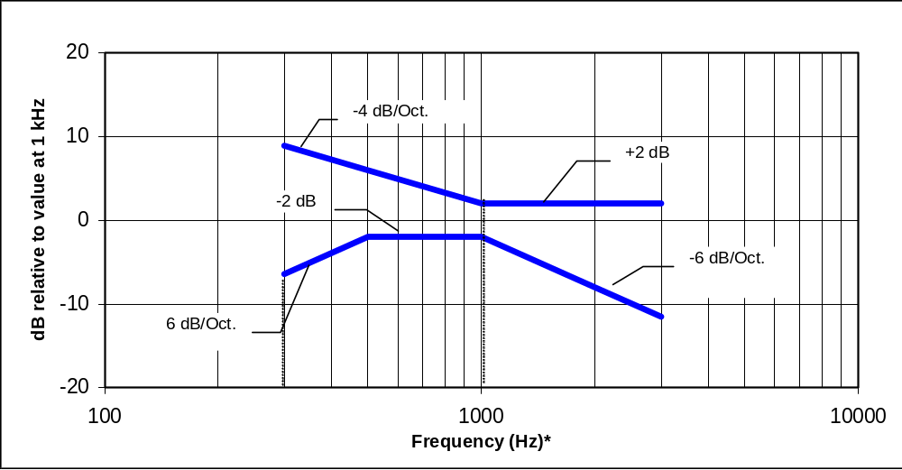
NOTE—Frequency response is between 300 Hz and 3000 Hz.

Figure 8.1—Magnetic field frequency response for WDs with a field ≤ –15 dB (A/m) at 1 kHz

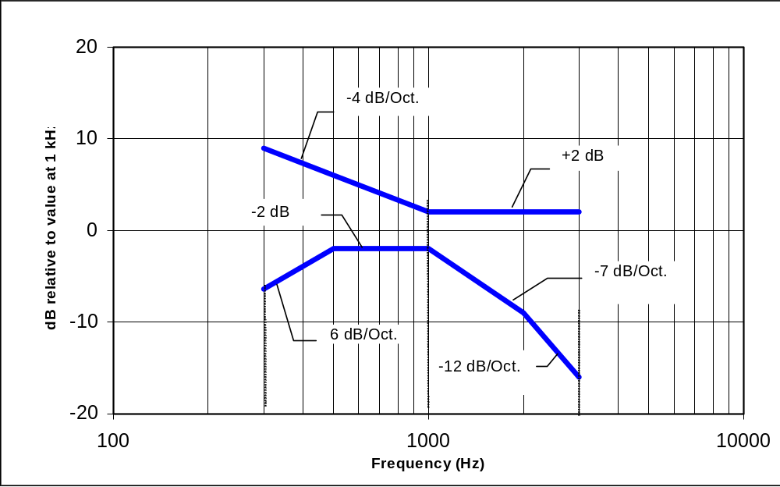
NOTE—Frequency response is between 300 Hz and 3000 Hz.

Figure 8.2—Magnetic field frequency response for WDs with a field
that exceeds –15 dB(A/m) at 1 kHz

    - Signal quality
This sub-clause provides the signal-to-noise quality requirement for the intended T-Coil signal from a WD. The worst signal-to-noise of the two T-Coil signal measurements, as determined in Clause 8, shall be used to determine the T-Coil mode category per Table 8.5.

Only the RF immunity of the hearing aid is measured in T-Coil mode. It is assumed that a hearing aid can have no immunity to an interference signal in the audio band, which is the intended reception band for this mode. So, the only criteria that can be measured is the RF immunity in T-Coil mode. This is measured using the same procedure as for the audio coupling mode and at the same levels as set forth in the procedure contained in sub-clause 7.3.

Table 8.5—T-Coil signal-to-noise categories
Category | Telephone parameters  WD signal quality  [(signal + noise)-to-noise ratio in decibels]
Category T1 | 0 dB to 10 dB
Category T2 | 10 dB to 20 dB
Category T3 | 20 dB to 30 dB
Category T4 | > 30 dB

  - Accessories and options
A product may be qualified with an accessory, option or in an alternative mode of operation. However, in these cases all claims of compliance shall clearly state all components or conditions necessary to realize the stated performance level. Examples may be as follows:

- Product WD model #abc when used with headset adapter model #def complies with category T4
- Product WD model #abc with optional firmware version #ghi complies with category M3
- Product WD model #abc with user-interface option setting #xyz selected complies with category T4

  - Product line compliance
A product line may be qualified as being compliant to this standard by using the sampling and statistical guidance of CISPR/TR 16-4-3 or equivalent.
- Calibration and measurement uncertainty
  - General
It is important that measurements made using the procedures contained herein follow acceptable practices sometimes called “good engineering practices” as it relates to the calibration of the instrumentation used. The basic accuracy and reproducibility of measurements made in accordance with this standard depend primarily upon the accuracy of the test equipment used, the care with which the calibration and the measurements are conducted, and the inherent stability of the WD under test. Where a given set of measurements is repeated in the same laboratory and by the same operator, a relatively high degree of reproducibility should normally be obtained. However, when comparing measurements made by different laboratories, allowances should be made for the influencing factors mentioned.

As a minimum the following guidance should be used. For each measurement instrument, the following shall be clearly marked on the instrument:

- Date of last calibration
- Date of next calibration
- Validation initials and/or source and location of calibration records

Such calibration records are also used as inputs into the calculation of overall measurement uncertainty, which is discussed in 10.4.
  - Ambient conditions
All tests in this standard shall be performed at the manufacturer’s recommended normal operating temperature and humidity and, if important, at a nominal barometric pressure. This includes both the hearing aid and the WD as well as the test instrumentation.

For reference the basic ambient conditions are as follows:

Ambient temperature: 23 °C ± 5 °C
Relative humidity (RH): 0% < RH < 80%
Atmospheric pressure: 101.3 kPa + 10 to –5 kPa (762 mm Hg + 75 to –38 mm Hg)
Baseband magnetic ambient noise: > 10 dB below the measurement level, where applicable

  - Specific calibration requirements
Specific calibration requirements for the equipment discussed are contained in Annex C. When any of the equipment listed is required for a test the calibration listed in that annex shall be conducted before the subject measurement is made.
  - Measurement uncertainty
Typically, the overall uncertainty is calculated in part by identifying uncertainties in the instrumentation chain used in performing each of the measurements in Clause 4 through Clause 9 of this standard. The figures associated with each technique show the basic components of the instrumentation chain and hence each component is evaluated as to its individual uncertainty (based on its calibration tolerances). The most common guidance documents for such evaluations are NIS 81, NIS 3003, and NIST Technical Note 1297. Sample measurement uncertainty calculations and typical uncertainty values are given in Annex E.

The overall uncertainty shall be reported along with the test results required in Clause 11.
- Test report
Test reports are the means of presenting the test results to the appropriate procuring or regulatory agency or for archiving the data in the permanent files of the testing organization. As such, test reports shall be clearly written, in unambiguous language. Unless otherwise specified, the general requirements of the test report shall follow the details contained in Clause 10 of ANSI C63.4-2003.

The test conditions listed in 11.1 through 11.14 shall be described in the test report in order for the test results to be properly documented.
  - Test plan
Using the guidance of this standard a specific test plan shall be prepared and included in the test report. The test plan shall detail how the more general guidance from this standard was specifically applied to the WD or hearing aid tested. Specifics of the WD’s or hearing aid’s operating state, test orientation, and other details shall be included. If any adjustments or modifications to the guidelines given in this standard are required these shall be recorded as well.
  - Applicable standards
In addition to this standard, any standards that were used in assessing the WD or hearing aid under shall be clearly described in the test report. Where referenced standards have more than one measurement procedure, or where the referenced measurement procedure has options, the test report shall state which procedures or options were used. The test report shall also state the issue or year of the referenced standard(s) used.
  - Equipment unit tested
The test report shall list all equipment tested, including product type, model number and any marketing designations. Serial numbers and any other distinguishing identification features shall also be included in the test report. A detailed description of any modifications made to the WD or hearing aid under test shall be recorded. When applicable, figures or photographs should be provided to document the physical implementation of modifications. Identification or detailed description shall also be made of any accessories or cables. The rationale for selecting the WD or hearing aid tested (including the equipment units needed to be functionally complete and the necessary cabling) shall be noted in the test report.
  - Test configuration
The setups of the equipment and cable or wire placement on the test site that produce the highest emissions shall be clearly shown and described. It is allowable to use drawings or photographs for this purpose.
A block diagram showing the interconnection of the major functional units is also useful.

The operating state of the WD or hearing aid under test shall be recorded, such as the means used to assure that the WD was operating in the desired mode, the transmission channel, RF power level, and loudness control. In addition, when applicable, the base station simulator used, the type of computer control, with software revision levels, a description of feeding circuits, and a description of other similar support equipment shall be recorded.
  - List of test equipment
A complete list of all test equipment used shall be included with the test report. Manufacturer’s model and serial numbers, and date of last calibration and calibration interval, shall be included. Measurement cable loss, measuring instrument bandwidth and detector function, video bandwidth, if appropriate, and antenna factors shall also be included, when applicable. When appropriate, site calibration data shall be included or summarized and the location of the complete calibration data referenced.
  - Units of measurement
Measurements of operating frequency, including variations of the operating frequency with ambient temperature and input voltage, and occupied bandwidth of intentional radiators shall be reported in units of hertz or multiples thereof [e.g., kilohertz (kHz), megahertz (MHz)]. Measurements of RF input power to intentional radiators shall be reported in units of watts.
All information necessary to reproduce a given measurement shall be recorded. If a reference voltage is used, the location of the reference voltage within the system and how it was measured, for example open or closed circuit, shall be recorded. For other types of measurements the locations of measurement reference point or plane, alignment and other relevant factors shall be recorded. All formulas of conversions and conversion factors, if used, shall be included in the measurement report.
  - Location of test site
The location of the test site shall be identified in the test report. Sites that have received recognition from various accreditation bodies shall use the same site address information as was included in their original application for recognition.
  - Measurement procedures
The sequence of testing followed to determine the data included in the test report should be documented.
  - Reporting measurement data
The measurement results along with the appropriate limits for comparison shall be presented in tabular or graphical form. Alternatively, recorded charts or photographs of a spectrum analyzer display or other
self-displaying instrumentation may be used if the information is clearly presented showing comparison to the limits, and all data conversions are explained. The method of comparing measured data output to the limits shall be included. The measurement uncertainty of the measurements shall also be recorded. The calculations leading to the overall measurement uncertainty shall also be included as an annex in the test report. See Annex E for guidance on preparing a measurement uncertainty analysis.
  - General and special conditions
If an alternate test method was used, the test report shall identify and describe the alternate method used, provide justification for its use, and describe how the results obtained were correlated with the methods specified by this standard. Instrumentation, instrument attenuator and bandwidth settings, detector function, WD or hearing aid arrangement, and all other pertinent details of the test shall be provided so that the alternate test method can be replicated. Where automatic scan techniques were used, the name of the program used with version number and an explanation of how the highest emission relative to the limit from the WD or hearing aid under test was determined and the scan rate used to obtain recorded emissions is to be included in the test report. The actual operating and environmental conditions (e.g., voltage, power line frequency, temperature, relative humidity, etc.) shall be listed in the report.
  - Summary of results
The test report summary sub-clause shall indicate the category of WD or hearing aid under test or if the device failed all the category requirements, and give margins (where applicable) with respect to the limits to which it was tested. Due consideration shall be made with respect to the measurement uncertainty in stating the passing or failing result. See 10.4 for a discussion on uncertainty. If the equipment only passes with specific modifications or special attributes, this information shall be included in the summary results.
  - Required signatures
The test report shall contain the signature of the representative of the organization performing the tests. In addition, the test report shall contain the identification of the personnel who were responsible for the proper execution of the test, and the name and address of the party requesting the tests. If changes are made during the period of test to bring the WD or hearing aid into compliance, the test report shall so indicate. In addition, the report submitted to the procuring organization or regulatory agency shall include a signed statement by the manufacturer or developer agreeing to the changes and their incorporation into production.
  - Test report annexes
The test report shall contain, if required, photographs or detailed sketches of the configuration of the WD or hearing aid under test. Sufficient information shall be recorded for the setup to be reconfigured with adequate detail so as to allow the original test to be replicated with a high likelihood that the test results would be in agreement with the results of the original test, within acceptable tolerances.
  - Test report disposition
The test report shall be maintained by the testing organization for a period of at least three years following the date of the test. The manufacturer may be required by a regulatory agency to maintain a copy of the report for a longer period of time.

(normative)
Definition of reference axes

Axes definition for hearing aid RF immunity tests
The Z axis is the vertical axis, the X axis is approximately parallel to the side surface of the user’s head and orthogonal to the Z axis, and the Y axis is orthogonal to both the Z and X axes. Alternately, the Y axis may be defined by a line through the center points of the ears on the head. The +Z direction is up, the
+Y direction is into the head, for a right-hand side hearing aid position, and the +X direction is from the back of the head to the front of the head.

The hearing aid reference orientation is defined by the manufacturer for each type of hearing aid with respect to this framework to represent the typical orientation on the user, similar to the example shown in Figure A.1 for the BTE hearing aid.

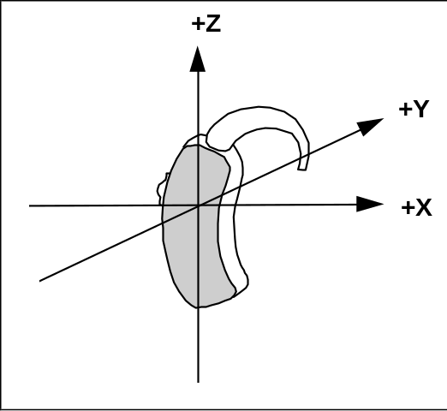
Figure A-1—BTE hearing aid

WD RF emission measurements reference and plane
Figure A.2 and Figure A.3 illustrate the references and reference plane that shall be used in the WD emissions measurement.

The grid is 50.0 mm by 50.0 mm area that is divided into nine evenly sized blocks or sub-grids.
The grid is centered on the audio frequency output transducer of the WD (speaker or T-Coil signal).
The grid is in a reference plane, which is defined as the planar area tangent to the highest point in the area of the phone that normally rests against the user’s ear. It is parallel to the centerline of the receiver area of the phone and is defined by the points of the receiver-end of the WD handset, which, in normal handset use, rest against the ear.
The measurement plane is parallel to, and 15.0 mm in front of, the reference plane.
The measurement points may be located where the perpendicular and transverse field intentisyt measurements are optimum with regard to the requirements and may be chosen independently of each other. However, the measurement points should be near the acoustic output of the WD and shall be located in the same half of the phone as the WD receiver
The location of each measurement point shall be noted in the test report.
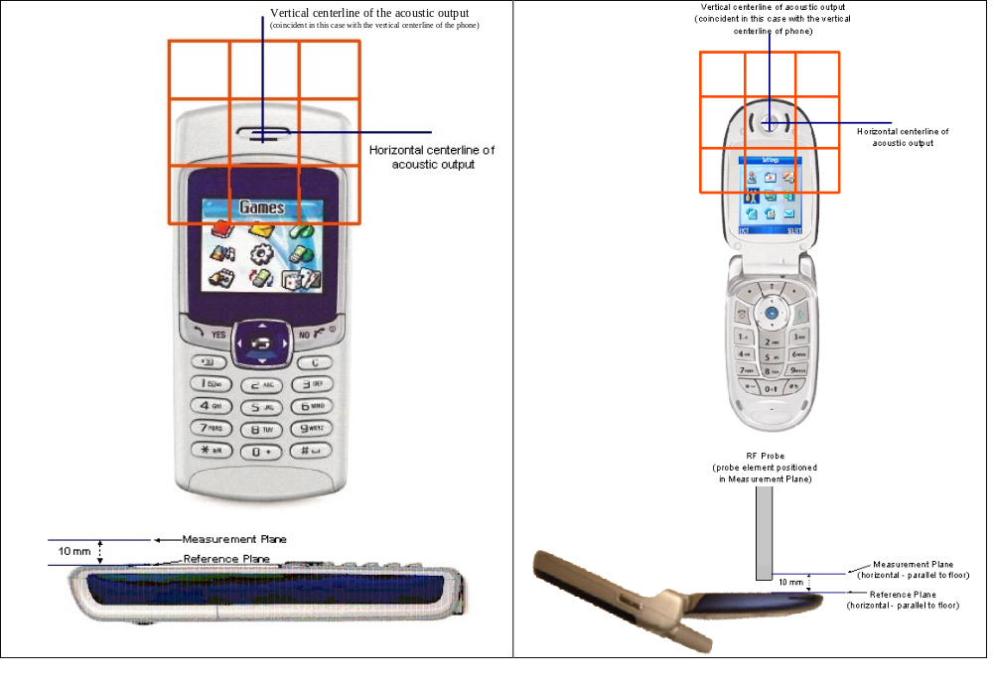

Figure A-3—WD reference and plane for RF emission measurements

Gauge blocks for setting measurement distance to probe

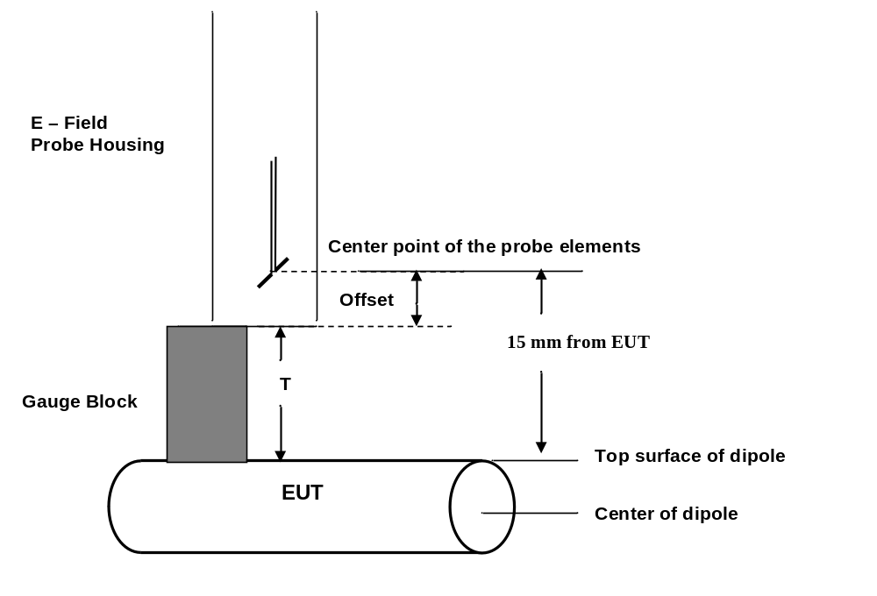
Figure A-5—Gauge block with E-field probe

T-Coil measurement points and reference plane
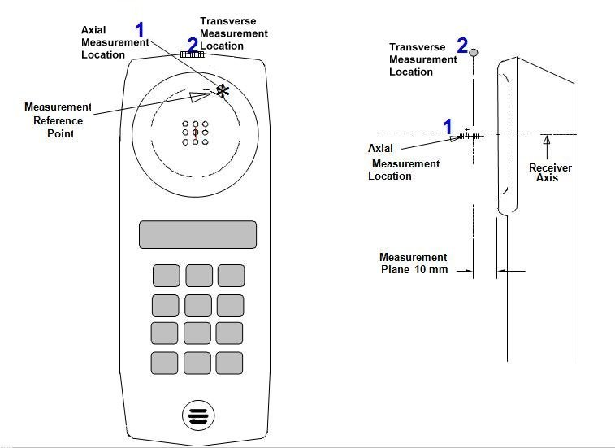
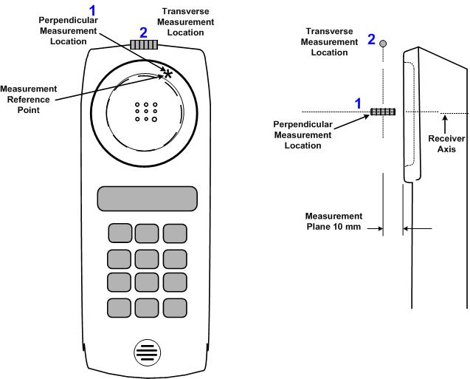
Perpendicular
Perpendicular

Figure A-7—Axis and planes for WD audio frequency magnetic field measurements
Perpendicular
Figure A.4 illustrates the standard probe orientations. Position 1 is the perpendicular orientation of the probe coil; orientation 2 is the transverse orientation. The space between the measurement positions is not fixed. It is recommended that a scan of the WD be done for each probe coil orientation and that the maximum level recorded be used as the reading for that orientation of the probe coil.

- The reference plane is the planar area that contains the highest point in the area of the phone that normally rests against the user’s ear. It is parallel to the centerline of the receiver area of the phone and is defined by the points of the receiver-end of the WD handset, which, in normal handset use, rest against the ear.
- The measurement plane is parallel to, and 10 mm in front of, the reference plane.
- The reference axis is normal to the reference plane and passes through the center of the receiver speaker section (or the center of the hole array); or may be centered on a secondary inductive source. The actual location of the measurement point shall be noted in the test report as the measurement reference point.
- The measurement points may be located where the perpendicular and transverse field intensity measurements are optimum with regard to the requirements. However, the measurement points should be near the acoustic output of the WD and shall be located in the same half of the phone as the WD receiver. In a WD handset with a centered receiver and a circularly symmetrical magnetic field, the measurement axis and the reference axis would coincide.
- The relative spacing of each measurement orientation is not fixed. The perpendicular and transverse orientations should be chosen to select the optimal position.
- The measurement point for the perpendicular position is located 10 mm from the reference plane on the measurement axis.
- The actual locations of the measurement points shall be noted in the test report.

(normative)
Test frequencies

Acoustic test frequencies
Table B-1 lists the test frequencies and 1/3 octave test bandwidths to be used for the test contained in this standard. These frequencies are from ISO 3-1973 and ISO 266-1975.

Table B-1—Acoustic test frequencies
1/3 octave band  (Hz) | Included frequencies  (Hz)
50 | 44.7 to 56.2
63 | 56.2 to 70.8
80 | 70.8 to 89.1
100 | 89.1 to 112.0
125 | 112 to 141
160 | 141 to 178
200 | 179 to 224
250 | 224 to 282
315 | 282 to 355
400 | 355 to 447
500 | 447 to 562
630 | 562 to 708
800 | 708 to 891
1000 | 891 to 1120
1250 | 1120 to 1410
1600 | 1410 to 1780
2000 | 1780 to 2240
2500 | 2240 to 2820
3150 | 2820 to 3550
4000 | 3550 to 4470
5000 | 4470 to 5620
6300 | 5620 to 7080
8000 | 7080 to 8910
10000 | 8910 to 11200
NOTE—The required measurement points for WD testing use frequencies from 300 Hz to 3000 Hz. See 9.2.

(normative)
Equipment and setup calibration

Test enclosures

RF test enclosures
When tests require semi-anechoic enclosures, the quality of the enclosures shall be measured. This can be done using at least two common ways as follows:

- Measuring and meeting the “volumetric” normalized site attenuation using the procedures described in ANSI C63.4
- Calibrating the radiated immunity field using the procedures in IEC 61000-4-3

The previously mentioned general requirements also satisfy the requirement that the undesired reflections from those enclosures, which are not perfectly anechoic, are suppressed by at least 20 dB. In addition, such anechoic enclosures shall be tested to ensure that any RF leakage from the RF ambient outside the enclosure is at least 10 dB down from the required measurement level.

The calibration requirements for wideband transverse electromagnetic (WB TEM) devices are based on the direct measurement of the field produced in the test zone. A secondary procedure is performed by calculation, using the power into the device and the physical dimensions of the center conductor (septum) separation from the referenced ground plane. See [B2], [B10], [B11], ANSI C63.4, and FCC 47 CFR 20.19.

Audio input source
An acoustic signal shall be supplied to the hearing aid under test during application of interfering RF test fields, so that hearing aid automatic gain control circuits are in a realistic state of operation, and so that interfering effects on the intended audio signal may be detected. This frequency shall have sufficient separation from 1000 Hz (the RF modulation frequency used in testing) so that as the intended signal it can be independently observed at the hearing aid output by means of tuned filters or an audio signal analyzer or wave analyzer. A frequency of 1300 Hz shall be used provided that the hearing aid frequency response between 1000 Hz and 1300 Hz is smooth (< 0.5 dB ripple) and changes less than a total of 2 dB over this range. The pre-test data shall be examined to verify this fact. If necessary one or both of the two frequencies involved may be shifted to a region where the response is smoother and the slope is less than
6 dB per octave in the frequency interval. The frequency interval should be at least 1/3 octave and should lie within the bounds of 600 Hz to 3000 Hz.

Calibration of RF E-field probes
The probe calibration shall assure that the probe gives an accurate rms field strength reading for the modulated field being measured. For direct measurement systems the modulation response must be ±1 dB for modulations from 50 Hz to 10 kHz. For indirect measurement systems, the probe must provide an accurate steady-state rms reading.
Probes used for measuring near-field emissions and calibrating immunity field levels shall be calibrated using the guidelines contained in IEEE Std 1309-2005. The field pattern shall be isotropic to a tolerance of
± 20%. If probes with coaxial cables are used, the influence of cables on the field shall be accounted for in the calibration. In the case where these probes have less than three mutually orthogonal elements, they shall be capable of rotation about their geometric centers to allow calibration and measurement in the three orthogonal axes.

IEEE Std 1309-2005 provides for three calibration methods and several grades of calibration. The two methods that are most appropriate for ANSI C63.19 probe calibrations are Method A, using a transfer standard probe, or Method B, using a standard gain horn antenna in an anechoic chamber. The most appropriate grade of calibration is: FD, F2 (f_{L}, f_{M}, f_{H}), A1, I0 for single-axis probes or I1 for “isotropic” probes, R0, T0, and M0. The grade designations are found in Annex A of IEEE Std 1309-2005.

The “maximum interception alignment” as defined and specified in 4.2.2.1 of IEEE Std 1309-2005 shall
be used for calibration. The calibration field generation shall be via a pyramidal horn antenna in an anechoic chamber, either as a standard gain antenna, Method B (Table 2 of IEEE Std 1309-2005), or
as a reference field generator using a similar probe as a transfer standard, Method A (Table 2 of
IEEE Std 1309-2005). Anisotropy of “isotropic” probes shall be measured in accordance with 7.1.3 and Equation (2) of IEEE Std 1309-2005.

The best-case expanded uncertainty, U, for probe calibration is U ≈ ± 1.1 dB for Method A and
U ≈ ± 1.0 dB for Method B. Out of the allowable expanded uncertainty of ± 2 dB (see 4.1.2), these calibration uncertainties leave approximately ± 0.84 dB to ± 0.86 dB in terms of combined standard uncertainty, u_{C}, for other contributors. That is: U = ± 2 dB, thus u_{C} = ± 2 ÷ 2 = ± 1 dB; u_{S}² = u_{C}² – u_{cal}²;
u_{cal} = U_{cal} ÷ 2 = ± 1.1 ÷ 2 = ± 0.55 dB (the value, U_{cal} = ± 1.1 dB, is from Method A); and,
u_{S} = √(1² – 0.55²) = ± 0.84 dB. (See Annex E for further information on estimation of uncertainty.)

Modulation Interference Factor (MIF)
For any specific fixed and repeatable modulated signal, a Modulation Interference Factor (MIF, expressed in dB) may be developed that relates its interference potential to its steady state rms signal level or average power level. This factor is a function only of the audio frequency amplitude modulation characteristics of the signal and is the same for field strength or conducted power measurements. It is important to emphasize that the MIF is valid only for a specific repeatable audio frequency amplitude modulation characteristic. Any change in modulation characteristic requires determination and application of a new MIF.

MIF may be determined using a radiated RF field, a conducted RF signal, or, in a preliminary stage, a mathematical analysis of a modeled RF signal.
- Verify the slope accuracy and dynamic range capability over the desired operating frequency band of a fast probe or sensor, square-law detector, as specified in sub-clause D.3, and weighting system as specified in sub-clause D.6 and D.7. For the probe and instrumentation included in the measurement of MIF, additional calibration and application of calibration factors are not required.
- Using RF illumination, or conducted coupling, apply the specific modulated signal in question to the measurement system at a level within its confirmed operating dynamic range.
- Measure the steady-state rms level at the output of the fast probe or sensor.
- Measure the steady-state average level at the weighting output.
- Without changing the square-law detector or weighting system, and using RF illumination, or conducted coupling, substitute for the specific modulated signal a 1 kHz, 80% amplitude-modulated carrier at the same frequency and adjust its strength until the level at the weighting output equals the step 4 measurement.
- Without changing the carrier level from step 5, remove the 1 kHz modulation and again measure the steady-state rms level indicated at the output of the fast probe or sensor.
- The MIF for the specific modulation characteristic is given by the ratio of the step 6 measurement to the step 3 measurement, expressed in dB (20*log(step6/step3).
In practice, steps 5 and 6 need not be repeated for each MIF determination if the relationship between the two measurements has been pre-established for the measurement system over the operating frequency and dynamic ranges. In such cases, only the modulation characteristic being tested needs to be available during WD testing.
As a check on the procedure, the MIF for the specific modulation consisting of a 1 kHz, 80% AM signal is -1.2 dB, which is the ratio in dB of the average power of the unmodulated carrier to the average power of the modulated carrier (10*log(P_{unmod}/P_{mod}), or equivalently the ratio in dB of the rms level of the unmodulated carrier to the rms level of the modulated carrier (20*log(L_{unmod}/L_{mod}). The MIF for a 1/8 duty cycle, 217 Hz pulse-modulated signal (similar to basic GSM) is +3.3 dB. (Actual GSM WD measurements could vary due to differences in implementation or network protocol.) Results for other arbitrary pulse modulation patterns and arbitrary sine wave amplitude modulations are as shown in the following tables:

Table C-3 – Sample MIF values for pulse modulations
PULSE MODULATION | MIF
0.5 msec pulse, 1000 Hz repetition rate | -0.9 dB
1 msec pulse, 100 Hz repetition rate | +3.9 dB
0.1 msec pulse, 100 Hz repetition rate | +10.1 dB
10 msec pulse, 10 Hz repetition rate | +1.6 dB
Table C-4 – Sample MIF values for sinewave modulations
SINEWAVE MODULATION | MIF
1 kHz, 80% AM | -1.2 dB
1 kHz, 10% AM | -9.1 dB
1 kHz, 1% AM | -19.1 dB
100 Hz, 10% AM | -16.1 dB
10 kHz, 10% AM | -21.5 dB

MIF results for a given amplitude modulation characteristic should remain consistent at any signal level within the operating dynamic range of the test system. Caution should be used when measuring modulations that have large magnitude MIF measurements as these place greater requirements on the test system dynamic range.

Typical MIF levels are presented in Table C-5. The results shown may be considered representative for the specified protocols, but are not intended to substitute for measurements of actual devices under test and their respective operating modes.
Table C-5– Sample MIF values for sinewave modulations
TRANSMISSION PROTOCOL | MODULATION INTERFERENCE FACTOR
GSM; full-rate version 2; speech codec/handset low | +3.5 dB
WCDMA; speech; speech codec low; AMR 12.2 kb/s | -20.0 dB
CDMA; speech; SO3; RC3; full frame rate: 8kEVRC | -19.0 dB
CDMA; speech; SO3; RC1;1/8th frame rate; 8kEVRC | +3.3 dB

Calibration of dipoles
This clause describes calibration of dipoles over a range of frequencies, 698 MHz to 6 GHz such that the E-field 15 mm out from the end of the dipole is kept constant.

The intent of this procedure is to assure the consistency of the field levels a hearing aid is exposed to, during immunity testing, over the specified range of test frequencies.

Equipment
- Broadband dipoles
- Signal generator
- RF amplifier
- Calibrated E-field probes
- Appropriate test location, i.e., anechoic room or at least a test area large enough so that reflections off of nearby objects do not disturb the test results

Calibration procedure
- Connect equipment as shown in Figure C.1.
- Position the E-field probe at 15 mm distance from the top surface of the dipole, which is also fixed in an appropriate fixture (Figure C.1). A gauge block, like that shown in Figure A.4, may be used to accurately set the 15 mm distance.
Make sure that the desired measuring channel of the probe is aligned for maximum reception of the E-field generated by the dipole. This may be accomplished by rotating the probe until the maximum value is located. The E-field probe shall have been calibrated over the frequency range to be measured using standard calibration techniques.
- Adjust the power level of the signal generator at the initial starting frequency such that the desired E-field strength at the 15 mm distance from the tip of the dipole is achieved. Setting the field strength to be in the range of category M2 is advised, see Table 5.1 for representative values.
- Step the frequency in step increments of ≤ 1%, adjusting the power fed into the dipole such that the desired E-field strength is maintained.
- Record the frequency and signal generator setting at each frequency for use during the actual immunity test. A sample calibration chart in is provided in Table C-6, as an example.
If the dipole has a broadband matching section, check that the VSWR is within the specified VSWR over the test band. Tune the dipole or adjust the matching section, if necessary, to achieve better matching.

Table C-6—Sample calibration chart
E-field calibrated value:
(49.54 dB V/m)
Frequency  (MHz) | Net power  (dBm)
698.5
700
701.5
703
703.5
—
—
—
6000

Dipole calibration procedure for wireless devices

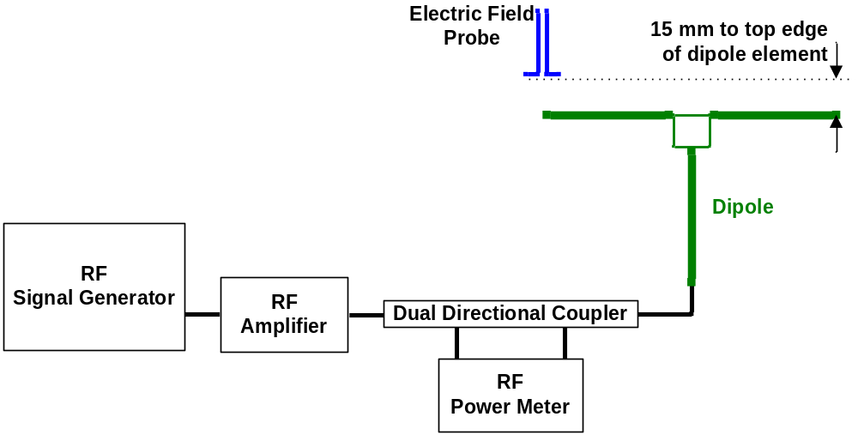
Figure C-9—WD dipole calibration procedure

- Connect equipment as shown in Figure C.1.
- Position the E-field probe at 15 mm distance from the the center of the probe element to the top surface (edge) of the dipole as shown in Figure C.3. The desired measuring channel of the probe shall be aligned for maximum reception of the field generated by the dipole. This may be accomplished by rotating the probe until the maximum value is located.
- Set the power level of the signal generator to a known power, adjusting for return loss input to the dipole at the initial starting frequency, and record the reading from the field probe.
- Set the signal generator frequency to all other frequencies given in Table B.1 that meet the insertion loss, VSWR, balance, and gain specifications given in D.4.
- Record the frequency and signal generator setting at each frequency for use during the actual immunity test.

If the dipole has a broadband matching section, check that the VSWR is within the specified VSWR over the test band. Tune the dipole or adjust the matching section, if necessary, to achieve better matching.

Weighting accuracy validation
The accuracy of the weighting function should be confirmed using appropriate test signals. The spectral weighting accuracy should be confirmed according Table C-7 by inputting sine waves at the specified third-octave frequencies and measuring at the output of the spectral weighting block. Alternatively, the DC output level of the complete weighting may be monitored and compared to the rms sine wave level input over the frequency range. The temporal weighting will slightly increase the relative level readings at the lower frequencies, as shown in right-hand column of the table.
Table C-7 - Spectral weighting response at third-octave frequencies
Frequency  (Hz) | Spectral Weighting  (dB relative to 1 kHz) | Sine Wave Response, Including Temporal Weighting
20.0 | -45.7 | -43.4
25.0 | -40.1 | -38.1
31.5 | -34.8 | -33.0
40.0 | -29.8 | -28.3
50.0 | -25.6 | -24.3
63.0 | -21.6 | -20.5
80.0 | -17.8 | -17.0
100 | -14.6 | -14.0
125 | -11.8 | -11.3
160 | -9.1 | -8.6
200 | -6.9 | -6.6
250 | -5.1 | -4.9
315 | -3.6 | -3.4
400 | -2.3 | -2.2
500 | -1.4 | -1.3
630 | -0.7 | -0.7
800 | -0.3 | -0.3
1000 | 0 | 0.0
1250 | 0.1 | 0.1
1600 | -0.0 | -0.0
2000 | -0.5 | -0.5
2500 | -1.5 | -1.5
3150 | -3.4 | -3.4
4000 | -6.4 | -6.4
5000 | -10.1 | -10.1
6300 | -14.5 | -14.5
8000 | -19.5 | -19.5
10,000 | -24.7 | -24.7
12,500 | -30.3 | -30.3
16,000 | -37.1 | -37.1
20,000 | -43.6 | -43.6

The accuracy of the temporal weighting should be confirmed using the following rectangular pulse test signals, input directly to the spectral/temporal weighting function. Applied pulse rise and fall times should be no greater than 50 μsec, pulse repetition rate should be within 1% of the specified value, and pulse duration within 1% of the specified value (measured between the 50% points on the leading and trailing edges). Weighting Gain is specified relative to the amplitude of the pulse, see 3. (The input signal is assumed to vary from a level of 0 to the amplitude of the pulse.) The stated accuracies shall be maintained over the useful operating dynamic range.

Table C-8 – Weighted gain at sample signal input points
SIGNAL INPUT | WEIGHTING GAIN
0.5 msec pulse, 1000 Hz repetition rate | 0.467 ±3%
1 msec pulse, 100 Hz repetition rate | 0.283 ±5%
0.1 msec pulse, 100 Hz repetition rate | 0.118 ±10%
10 msec pulse, 10 Hz repetition rate | 0.169 ±15%

Calibration of hearing aid probe coil
The Helmholtz coil, built in accordance with IEEE Std 1027 (see D.9), is required to calibrate the hearing aid probe coil. The calibration procedure, from Clause 5 of IEEE Std 1027-1996 is contained in D.9.

Metal parts, including fixtures for holding the probe coil, should not be near the Helmholtz coils during calibration. Connection to the probe coil should only be made by twisted leads or a thin shielded wire. The Helmholtz coils should not be located near sources of H-fields such as transformers.

To calibrate, establish a known H-field at the center of the Helmholtz coils. A constant current should be maintained to the Helmholtz coils at all frequencies of measurement. Insert the probe coil in the field and align its main axis with the field by adjusting its position for maximum output. The coil sensitivity can then be determined at any frequency by using the following equation:

P(f) = 20 log [ Vp(f) / Hc ]

where
P(f) is the probe coil sensitivity versus frequency in dB V/(A/m)
Vp(f) is the output voltage of the probe coil in volts
Hc is the H-field strength generated by the Helmholtz coils in amperes per meter (A/m) P(1000), the probe coil sensitivity at 1000 Hz, should be measured first

The probe coil sensitivity ideally increases at a rate of 6 dB per octave with increasing frequency as follows:

P(f) = P(1000) – 20 log (f / 1000 Hz)
where
P(1000) is the probe sensitivity at 1000 Hz in dB V / (A/m)
f is frequency in hertz

The sensitivity shall not deviate from this characteristic by more than 0.5 dB, as illustrated in Figure 5 of IEEE Std 1027-1996 and shown in Figure C.2.

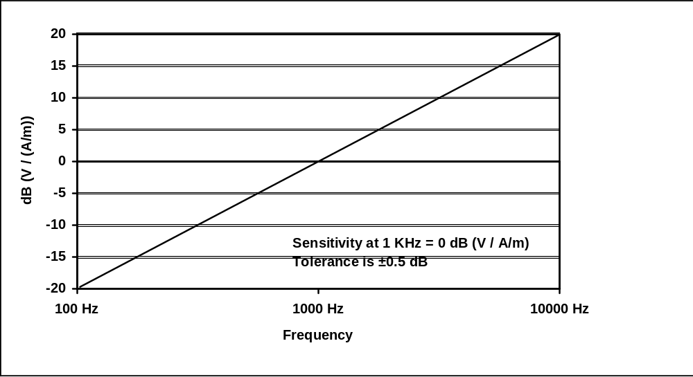
Figure C-11—Probe coil sensitivity
Source: IEEE Std 1027-1996.

Linearity
Check the system for amplitude linearity, vary the current through the Helmholtz coil to establish fields from –50 dB to 0 dB relative to 1 A/m in 10 dB steps. Check that the output varies in corresponding 10 dB steps (± 0.5 dB).

Signal to noise ratio of the calibration system
Set the current in the Helmholtz coils to create a field of –50 dB relative to 1 A/m. Note the output reading of the probe coil. Turn off the current to the Helmholtz coils and ensure the output drops at least 10 dB.

Coil sensitivity

Coil sensitivity—calculation method
It is possible to calculate the probe coil sensitivity from the following series of equations as described in Annex B of IEEE Std 1027-1996:

For an H-field strength of H amperes per meter, the magnetic flux density is given in Equation (C.1) as follows:

B = μH [Wb/m²] (C.1)
where
μ = 4π 10⁻⁷ H/m = permeability of free space

For a coil of area S, the magnetic flux through the coil is given in Equation (C.2) as follows:

φ = B • S [Wb] (C.2)
Faraday’s Law, given in Equation (C.3) as follows, states that the electrical output from a coil placed perpendicularly to a varying field is:

v = N dφ / dt [volts] (C.3)
where
N is the number of turns on the coil

The combining of Equation (C.1), Equation (C.2), and Equation (C.3) for a coil placed perpendicular to the field is given in Equation (C.4) as follows:

v = N μS dH /dt [volts] (C.4)

For a sinusoidally varying H-field, the H-field strength is:

H = Hsin(ωt), [A/m]

where
H is the peak amplitude of the field

Hence

dH / dt = Hωcos (ωt) (C.5)

Therefore, the electrical output from a coil placed perpendicular to a sinusoidal field of H amperes per meter is shown in Equation (C.6) as follows:
v = N μSω Hcos (ωt), [volts] (C.6)

Equation (C.6) shows that the output is proportional to ω, that is, proportional to frequency as evident in Figure C.4.

Coil sensitivity—laboratory calibration
However, for practical multi-layer coils, and certainly for coils with magnetic material cores, better accuracy can be expected by inserting the coil in a known H-field and measuring the output.

One method of establishing a known H-field is to use a pair of Helmholtz calibration coils as shown in D.9. A set of Helmholtz coils consists of two circular coils of equal diameter and equal number of turns parallel to each other along an axis through the center of the coils, separated by a distance equal to the radius of the coils. Thus the two coils of the Helmholtz coil have equal radii and their centers lie on a common axis. For multiple turn coils, the diameter of the winding on each coil is much smaller than the diameter of the coil. The two coils are connected in series aiding in order to produce a nearly uniform H-field in a region surrounding the center point of the axis between the two coils. (The coils can be connected in parallel aiding, but the current in the coils shall be kept equal.)

The use of Helmholtz coils for probe or sensor calibration is summarized as follows:

- Helmholtz coils may be used to volumes with dimensions of 0.6 r (r is the radius of the coil) for highly accurate probe or sensor calibration.
- Helmholtz coils should be used in series-aiding connection, but may be used in parallel-aiding connection if necessary-with extra current controls and precautions.
- Balance the products NI in the two coils for maximum accuracy; (N = number of turns on each coil; I = current in the coils, in amperes).
- Consider Helmholtz coils a primary standard; they can be calibrated by a ruler.

Selection and calibration of acoustic transmission line (Informative)

Selection of acoustic transmission line
Several methods are available for providing an acoustic transmission line from the hearing aid under test to the measurement instrumentation. Undamped transmission line commonly has unacceptably large variation in its transmission loss over frequency. Adding a 1500 Ω damper is recommended to significantly smooth the loss response as a function of frequency. A 1 m damped acoustic transmission line, commonly called a damped “long horn,” is recommended for larger separations. This device is constructed of 600 mm of 2 mm tubing, which connects to the hearing aid. At the end, away from the hearing aid a 680 Ω damper is inserted to smooth the transition to a 400 mm length of 3 mm tubing. At the end of the 3 mm tubing a 330 Ω is inserted and transitions to a 18 mm length of 4 mm tubing. The 4 mm tubing then connects to the ear coupler and measurement instrumentation (see Figure C.3).

Microphone subsystem requirements
The microphone subsystem, which is comprised of the pressure-field microphone, preamplifier, ear coupler, and measuring amplifier shall meet the requirements of 4.7 and 4.71 of ANSI S3.22-2003. The pressure frequency response of the microphone used with the earphone coupler, along with its amplifier and readout device, shall be uniform within ± 1 dB over the frequency range of 200 Hz to 5000 Hz. The calibration of the microphone subsystem shall be accurate at any frequency between 250 Hz and 1000 Hz to within ± 1 dB.

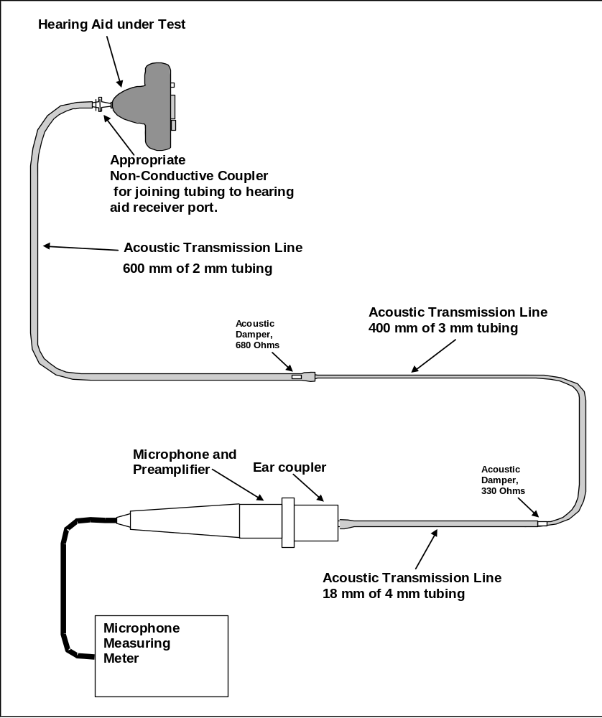
Figure C-13—Construction of 1 m damped "long horn" acoustic transmission line

(normative)
Test equipment specifications

Acoustic damper
Acoustic damper of specified impedance:

330 Ω
680 Ω
1500 Ω

Audio frequency analyzer or wave analyzer
- Frequency range: 20 Hz to 20 kHz
- RBW: 3 Hz to 300 Hz in 1-3-10 steps
- Input amplitude range: 1 mV rms to 30 V rms
- Input impedance: 1 MΩ shunted by up to 30 pF
- Dynamic range: > 80 dB
- Spurious responses: at least 80 dB below input reference level
- Amplitude accuracy: ± 0.5 dB

Detector, Square Law
The square law detector shall meet the following specifications over the frequency range in which they are used. If a detector meets the specification over the entire frequency range of the standard, 698 MHz to 6.0 GHz, it can be used for any system test to this standard. Detectors that cannot meet the specifications over the full frequency range shall be used only over the frequency range for which they meet the following specifications:

Response uniformity to an 80%, 1 kHz amplitude-modulated RF signal over the radio frequency range, as measured at the detector output: ±1.0 dB
Response uniformity to an 80% sine wave amplitude-modulated RF signal, with modulation frequencies from 50 Hz to 10 kHz, as measured at the detector output: ±1.0 dB.
Square law uniformity to an 80%, sine wave amplitude-modulated RF signal over the square law detector’s useful dynamic range shall be demonstrated by an examination of the input-output transfer function, where the input is the peak level in dB of the modulated RF carrier and the output is the rms amplitude in dB of the detected audio frequency signal. The useful dynamic range is the range of input level over which the input-output transfer function follows a best-fit 1:2 slope within ±0.5 dB relative to the input or ±1 dB relative to the output. This range must reach upwards at least to the highest peak input signal level to be tested. The lower end of the range must extend to at least to the lowest steady state average RF signal level to be tested including the effect of the modulation interference factor (MIF).
VSWR: ≤1.75 (return loss of > 11 dB)

Dipole, resonant
The dipoles to be used for these tests are resonant balanced half-wave dipoles tuned for maximum free space radiation in the specified resonant frequency band. Each dipole shall be preliminarily scanned at a
15 mm distance along its axis with a magnetic field probe to check the balance of the currents on the two arms of the radiator. Current amplitude and distribution along each arm shall be within ± 3% between each arm. The gain of the dipole, as measured in an anechoic chamber using the method of identical antennas, is
1.8 dBi, ± 0.5dB. See Figure D.1 and Figure D.2.

Resonant frequency: Between 698 MHz and 6 GHz
Insertion loss: < 0.5 dB over specified bandwidth
VSWR: ≤ 1.92:1 over specified bandwidth (referenced to 50 Ω) (≤10 dB return loss)
Balance: ≤ ±3%
Gain: 1.8 dBi, ± 0.5 dB
Element diameter: 3.58 mm nominal o.d.
NOTE—This is the o.d. of RG-402U semi-rigid coax.

Broadband dipoles

Dipoles for 800 MHz to 950 MHz
For the band from 800 MHz to 950 MHz, a thick dipole (RG-402U, 3.58 mm diameter) cut for resonance between approximately 880 MHz and 900 MHz has a worst-case VSWR ≈ 1.6 in a 50 Ω system
(P_{R} ≤ 5.3%) without any matching section, i.e., only a balun. This is because the fractional bandwidth is relatively small. The resonant length for this dipole is 161.2 mm or approximately 161 mm. This causes the dipole to resonate at ≈ 890 MHz.

Dipoles for 1.6 GHz to 2.5 GHz
WD bands range from 1.6 GHz to 2.5 GHz. This expanded frequency range can be covered by a single dipole, as described in this sub-clause. While one could build a set of tuned dipoles to cover all of the wireless device frequencies, it is probably more economical to build a single broadband dipole for this range. See Figures D-1 and D-2 for examples.
NOTE—The dipole specified in D.4.1.1 for the range 800 MHz to 950 MHz is already a broadband dipole.
Resonant dipoles that are thick, i.e., have length-to-diameter ratios of less than 100, have impedance characteristics that change very slowly with frequency. If these dipoles are mismatched at the resonant frequency, they may be used with acceptable VSWR over wide bands of frequencies, while retaining the characteristics of resonant dipoles. The dipole is tuned to be resonant at the center of the band of wavelengths to be used, and the matching section (often also a balun) is designed to provide transformation from 50 Ω to the geometric mean of the maximum and minimum impedances that is presented by the
feed-point of the dipole.

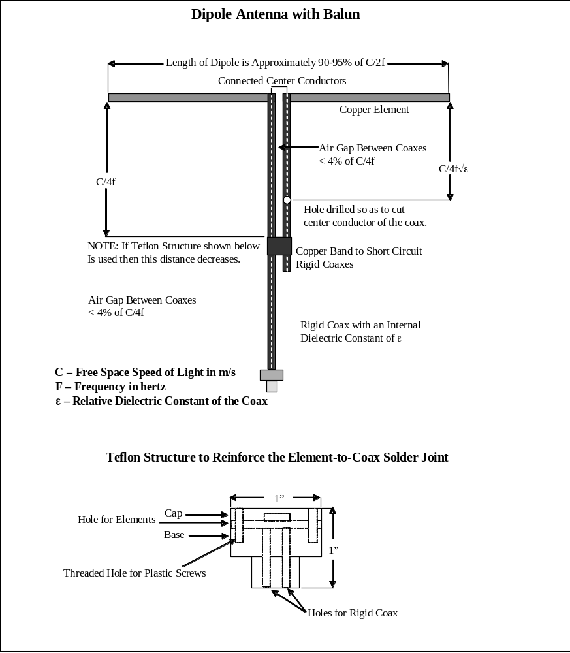

Figure D-15—Balanced dipole antenna

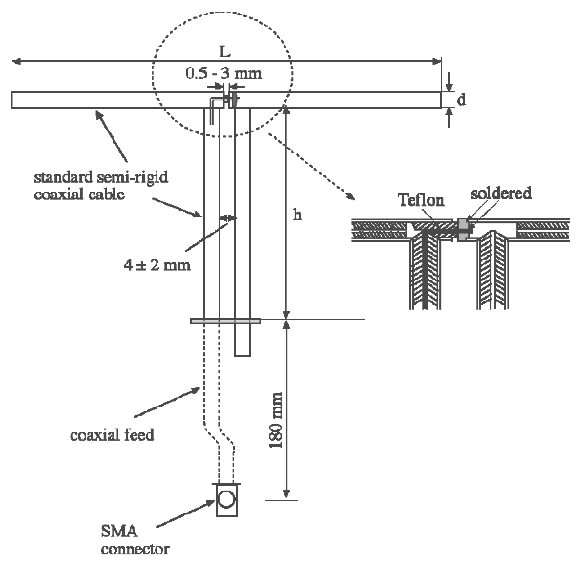

Figure D-17—Mechanical details of the reference dipole

Table D-9—Dipole for 813.5 MHz and 835 MHz, tuned for air
Parameter | Parameter value
Length (L mm) | 161 ª
Diameter (d mm) | 3.58  (e.g., RG-402U)
Height ¼ λ stub (h mm) | 89.8
RL requirement | < –10 dB
Frequency range (MHz) | 790 to 850
VSWR | 1:1.92 ^{b}
Resonant frequency (MHz) | 825
Impedance | Nominal 50 Ω
ª The length of both sides of dipole should be within 2% of each other for all dipoles. (See Table D.1, Table D.2, and Table D.3.)
^{b} The VSWR stated in Table D.1, Table D.2, and Table D.3 is for the resonant frequency.
Table D-10—Dipole for 898.5 MHz, tuned for air
Parameter | Parameter value
Length (L mm) | 149
Diameter (d mm) | 3.58  (e.g., RG-402U)
Height ¼ λ stub (h mm) | 83.3
RL requirement | < –10 dB
Frequency range (MHz) | 870 to 955
VSWR | 1:1.92
Resonant frequency (MHz) | 910
Impedance | Nominal 50 Ω

Table D-11—Dipole for 1880 MHz, tuned for air
Parameter | Parameter value
Length (L mm) | 72
Diameter (d mm) | 3.58  (e.g., RG-402U)
Height ¼ λ stub (h mm) | 41.7
RL requirement | < –10 dB
Frequency range (MHz) | 1745 to 1935
VSWR | 1:1.92
Resonant frequency (MHz) | 1855
Impedance | Nominal 50 Ω

If a dipole made of 3.58 mm diameter stock (RG-402U) is cut to resonate at 1.92 GHz and fed by a 50 Ω to 83 Ω matching transformer/balun, the worst-case VSWR is less than 1.7. This implies reflected power of approximately 6.7%. A resonant frequency of 1.92 GHz in such a thick dipole results from a length of
73.8 mm or approximately 74 mm. Some experimentation may be needed, so the dipole should be cut too long to begin with and shortened as necessary. See Table D.1, Table D.2, and Table D.3 for typical values.
NOTE—Since “lumped-element” transformers are difficult to realize at these frequencies, other approaches are needed. Some approaches, among others, may be transmission line combinations, micro-strip on printed circuit board material, and other similar transformer realizations on PC boards.

If only the bands from 1.6 GHz to 2.5 GHz are to be covered, a thick dipole cut to resonate at 1.85 GHz has a VSWR < 1.5 when operated in a 50 Ω system, resulting in P_{R} ≈ 4%. The physical length of the dipole made of RG-402U resonant at 1.85 GHz is 76.5 mm or approximately 76 mm.

Wireless device lab verification dipoles
Dipoles have proven to be a very accurate method for assessing the conformity of a measurement system; however, target values must be specified.

Dipole validation theoretical modeling
The finite difference time domain (FDTD) method is a numerical algorithm for solving Maxwell’s equations of electromagnetic field interactions in the time domain by converting the problem space into discrete unit cells where the space and time derivatives of the electric and magnetic fields are directly approximated by simple, second-order, accurate, central-difference equations.

The ability of FDTD to calculate radiation patterns, input impedance, and absolute gain for a dipole antenna has been demonstrated. An ideal complex dipole model consisting of the typical radiating and balun elements is constructed using a rectangular Yee cell problem space of XYZ (196,155,262) with a
1.0 mm cubic cell dimension. For the FDTD calculations the dipole is fed at the geometric center of symmetry with a sinusoidal voltage of 20.7 V maximum amplitude to produce an input power of 1.0 W. Results of computation were scaled down to correspond with 100 mW input power (net power after compensating for the return loss).

Dipoles
The dipoles used for this analysis were modeled as resonant balanced half-wave dipoles tuned for maximum free-space radiation in the specified resonant frequency band. There were no additional matching elements except for the standard λ/4 balun to provide transformation from symmetrical to non-symmetrical feed (see Figure D.1). The dimensions for modeling were obtained from the actual dipoles used in SAR system validation (cylindrical structures realized from 3.58 mm thick RG-402U semi-rigid cable).

In practice each dipole should be preliminarily scanned at 15 mm distance along its axis with a magnetic field probe to check the balance of the currents on the two arms of the radiator. Current amplitude and distribution along each arm should be within ± 3% between each arm.

Therefore, graphical presentation of field distribution along the dipole is also provided in this standard.

Conditions for validation
Input signal: CW
Average input power: PIN = 100 mW = 20 dBm (net power after compensating for the return loss)
Separation distance from the top surface of the dipole to the center point of the probe element(s):
d = 15 mm

Conclusion
These values may be used as target values for the dipole calibration procedure in C.5. The target values presented in this standard are the results from theoretical modeling using the FDTD method.

In Column 5 and Column 6 of Table D.4 are presented rms values of the maximum E-field obtained by the FDTD method for the conditions in D.4.1.4.1.1. These values should be used as target values when measuring E-field along the validation dipole.

In Column 7 and Column 8 of Table D.4 are presented rms values of the maximum magnetic field obtained by the FDTD method for the conditions in D.4.1.4.1.1. These values should be used as target values when measuring magnetic field along the validation dipole.

Based on the results in Column 10 and Column 11 of Table D.4 the specifications for the return loss and VSWR of the dipole should remain –10 dB and 1:1.92, respectively.

Gain computation by the FDTD method does not take in account losses in the dipole associated with the resistance and skin effect. These losses have to be subtracted from the theoretically obtained gain values. In the frequency range of 806 MHz to 821 MHz, 790 MHz to 850 MHz, and 896 MHz to 901 MHz, the losses are estimated to be ~0.5 dB, and in the 1880 MHz to 2000 MHz frequency range they are more likely to be 0.6 dB to 0.7 dB. Therefore the required gain for validation dipoles should be specified as 1.8 dB ± 0.5 dB.
NOTE—The separation distance is measured from the top surface of the dipole to the center point of the probe element, and is d = 15 mm.

The electric and magnetic field distributions along the dipoles are illustrated in Figure D.2 and Figure D.4.

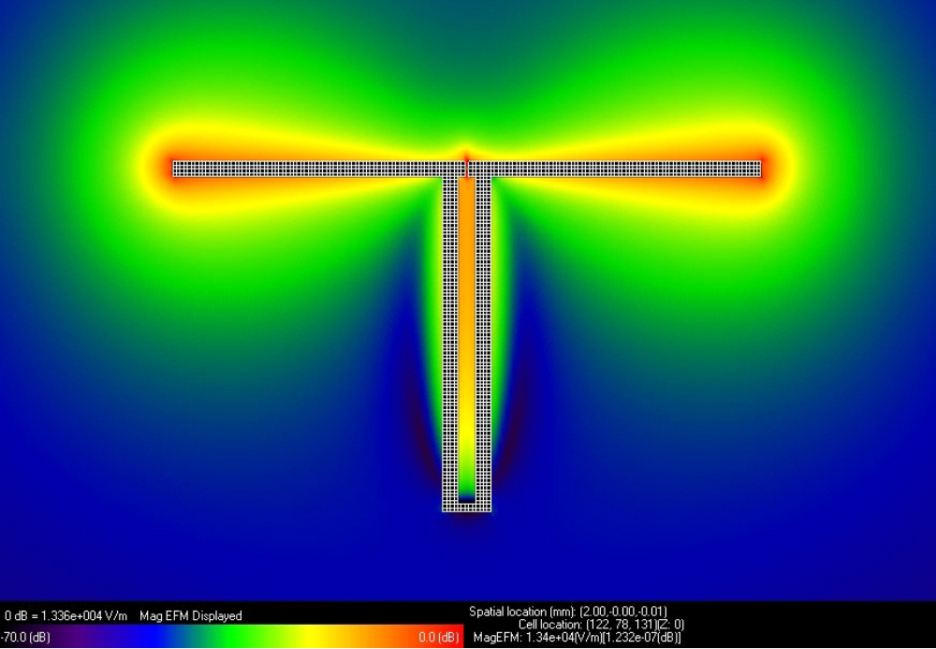
Figure D-19—E-field distribution around λ/2 dipole

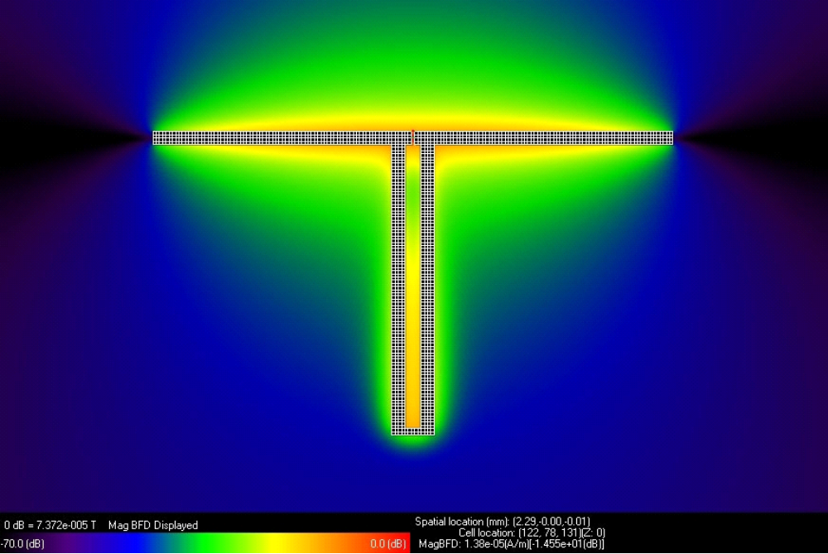
Figure D-21—Magnetic field distribution around λ/2 dipole

As further validation check, Figure D-23and Figure D-24 plots the measured E and H field magnitudes at 15mm from the surface of a 166mm, 835 MHz dipole and an 81mm 1880 MHz dipole, all results normalized to a forward power input of +20 dBm.

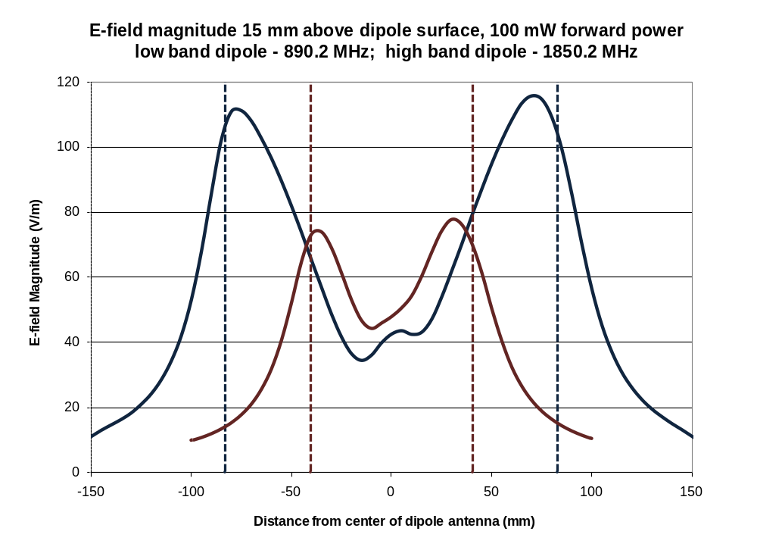
Figure D-23 – E-Field magnitude 15 mm from suface of dipole elements

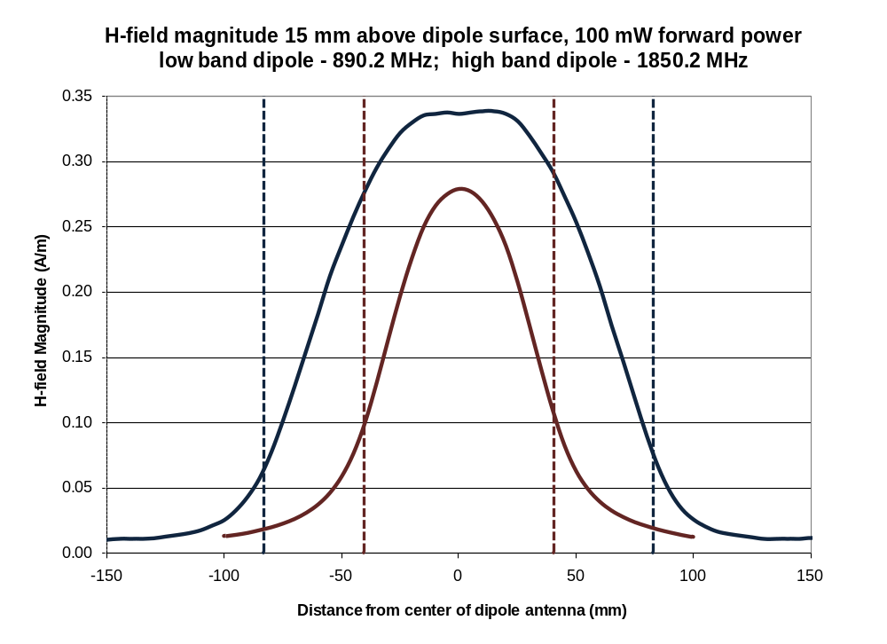
Figure D-24 – H-Field magnitude 15 mm from suface of dipole elements
Table D-12—Sample rms values at 15 mm separation distance
Mod. | Frequency range  (MHz) | Frequency  (MHz) | CW  E  (V/m) | CW  E  (dB V/m) | CW  H  (A/m) | CW  H  (dB A/m) | |Z₀| =  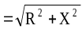  (Ω) | RL  (dB) | VSWR | Gain  (dBi)
CW | 806 to 821  SMR | 813.5 | 126.6 | 42.0 | 0.35 | –9.12 | 75.8 | –10.1 | 1.93 | 2.24
CW | 790 to 850  cellular | 835.0 | 121.6 | 41.7 | 0.34 | –9.37 | 76.3 | –12.1 | 1.66 | 2.29
CW | 896 to 901  SMR | 898.5 | 123.0 | 41.8 | 0.35 | –9.12 | 76.9 | –11.8 | 1.69 | 2.33
CW | 1880 to 2000  PCS | 1880.0 | 98.3 | 39.9 | 0.33 | –9.63 | 89.7 | –10.3 | 1.87 | 2.55
1 | 2 | 3 | 4 | 5 | 6 | 7 | 8 | 9 | 10 | 11

Example planar broadband dipoles
A planar dipole fabricated on a low loss printed circuit board, such as that shown in Figure D.5 and
Figure D.6, is an alternative to a wire dipole like that described in D.4.1, for calibration of field probes used for near field RF measurements per Clause 5. It has the advantages of being readily implemented, is very robust and very cost effective. Construction information is provided for a design in the drawing of
Figure D.6, and Equation (D.1) should be used for other bands above 700 MHz. Performance data is provided in D.4.2.1.

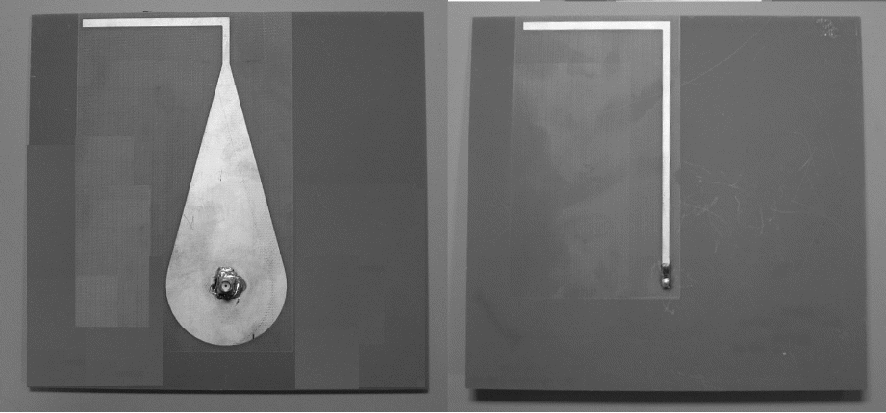
Figure D-25—Front and back sides of planar dipole (dipole ‘B’ in D.4.2 and Figure D.9)

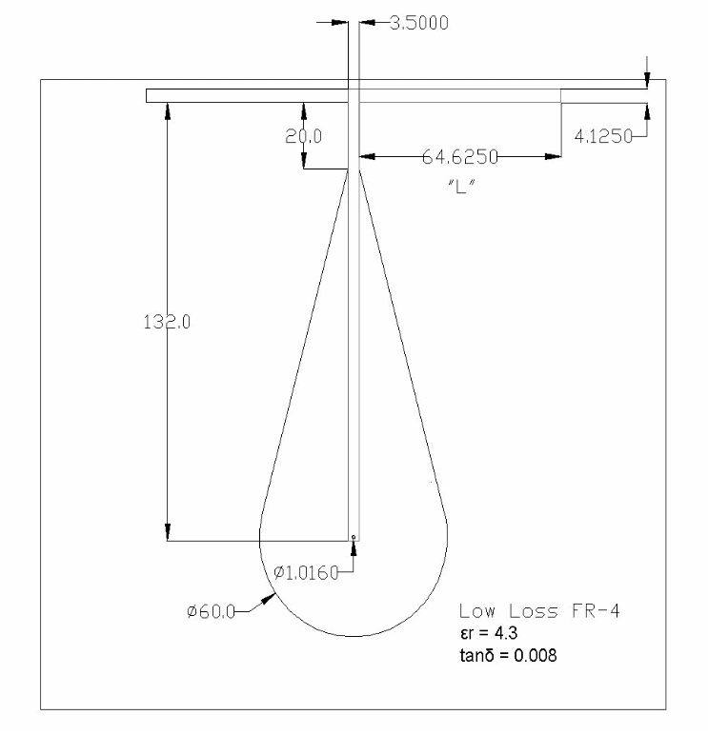
Figure D-27—Dimensions of dipole ‘B’ in D.4.2 and Figure D.9 (in millimeters)
To adapt this design for other bands, the dipole arm length that determines the resonant frequency can be calculated using the following formula given in Equation (D.1):
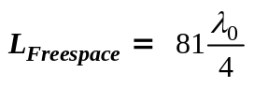 (D.1)
where
L_{Freespace} is the length of dipole arm for tuning in freespace in millimeters (shown as “L”)

An alternate form of the equation follows in Equation (D.2):
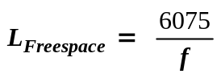 (D.2)

In this form of the equation ƒ is the frequency in megahertz and L_{Freespace} is again in millimeters.

For all frequencies above 700 MHz, the dimensions of the broadband balun (the tapered microstrip section) remain constant.

Example return loss performance data
Only three dipoles were required to cover the frequency range prescribed in B.2. Planar dipole A covers the 813 MHz to 835 MHz range frequencies, planar dipole B covers the 898 MHz frequency, and planar dipole C covers the 1880 MHz frequency.
NOTE—In these examples the dipoles are not exactly tuned for the test frequencies. For better efficiency the dipoles should be more carefully tuned to match their resonant frequency to the test frequency.

Table D-13—RL as a function of frequency
Desired  frequency | Dipole | Measured RL | Low frequency | High frequency | % BW
Desired  frequency | Dipole | Measured RL | –12.75 dB BW |  | % BW
813 | A | –21.287 | 785 | 855 | –8.5%
835 | A | –16.684
898 | B | –14.295 | 895 | 975 | –8.6%
1880 | C | –14.985 | 1790 | 1930 | –7.5%

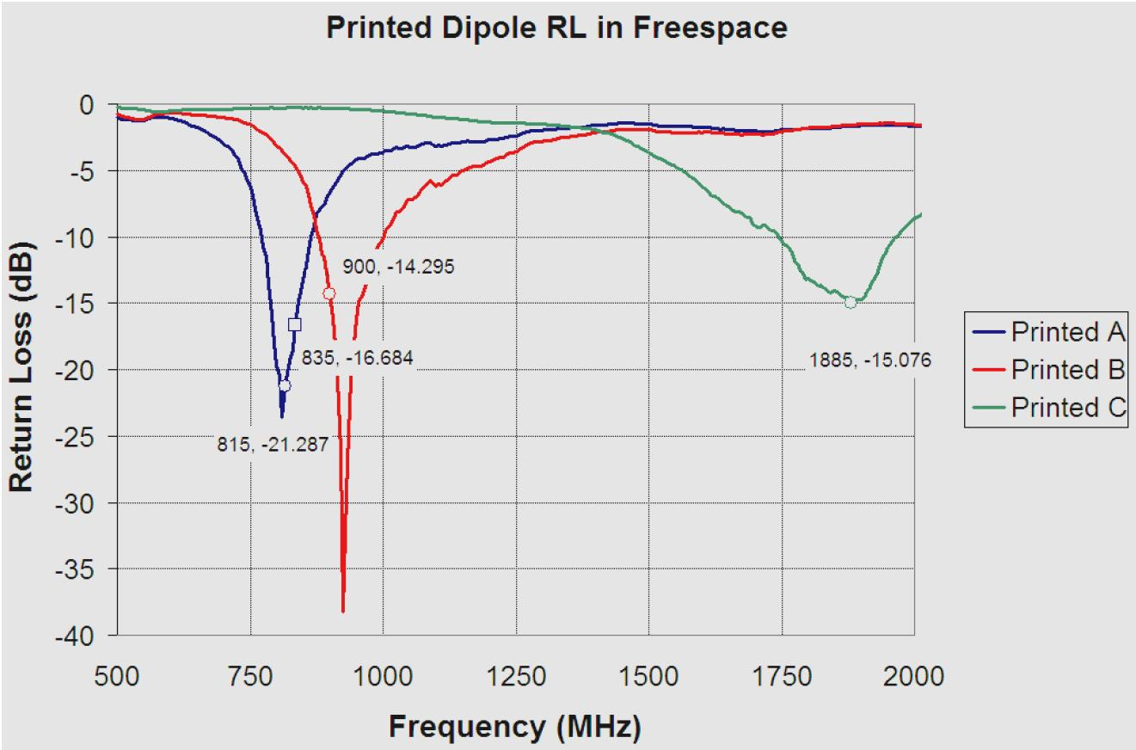

Figure D-29—Example printed dipole tuning

—Dipole balance

Directional coupler

- Directivity: Minimum of 30 dB
- Maximum incident power: Commensurate with RF power amplifier output (see D.13)
- Impedance: 50 Ω
- Insertion loss: 0.2 dB maximum
- VSWR: 1.15 maximum
- Connectors: Type N female
- Frequency range: 698.0 MHz to 6.0 GHz

Filter, spectral weighting
The spectral weighting filter shall conform to the following response curve, which is normalized to 1 kHz. The tolerance relative to 1 kHz shall be within ±1.0 dB at the third octave frequencies of 125 Hz through 5 kHz; within ±2.0 dB at the third octave frequencies outside that range from 50 Hz to 8 kHz; +2, -3 dB at 10 kHz; and <-24 dB below the third octave frequency of 50 Hz and above 10 kHz. The nominal filter curve is indicated for frequencies outside the 50 Hz to 10 kHz range, but no minimum is specified. The response at the frequency extremes may roll off more rapidly than indicated by the nominal curve.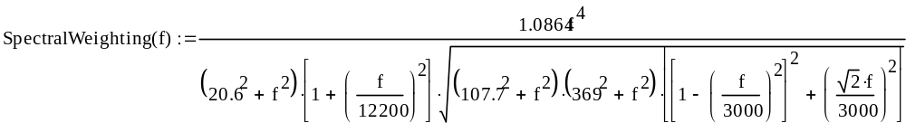
The spectral response function defines high-pass poles at 20.6 Hz (two), 107.7 Hz, and 369 Hz, and low-pass poles at 12.2 kHz (two) and a double-pole low pass (Butterworth response, damping factor of 0.707) at 3 kHz, all normalized to unity gain at 1 kHz. The filter response is graphed in Figure D-32and given numerically in TableDC75.
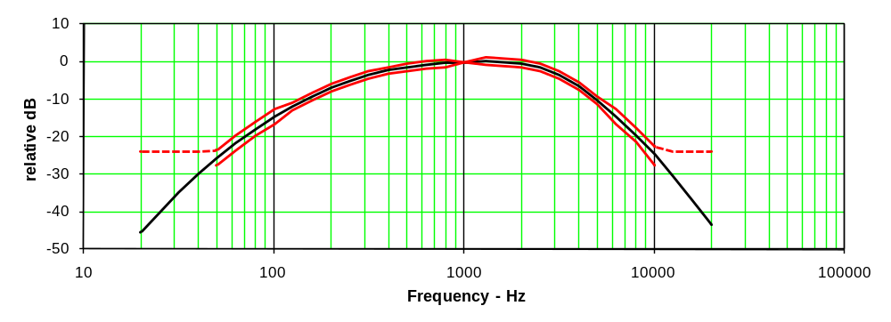
Figure D-32— Spectral weighting response with tolerance bands

Filter, temporal weighting
The spectral weighting is followed by temporal weighting, consisting of rapid rms level detection followed by peak detection having a much longer decay time constant. Described sequentially, the temporal weighting consists of:
a. Squaring of the instantaneous signal amplitude
b. Filtering of the squared signal by a first order low-pass filter having a time constant of 4 msec ±5%
c. Square-rooting of the low-pass filter output
d. Instantaneous peak detection of the square-root output with a 550 msec ±10% decay time.

Hearing aid probe coil
(In accordance with FCC Part 68 and IEEE Std 1027)

Maximum dimensions: 6.55 mm length × 2.29 mm diameter (see Figure D-34)
DC resistance: 900 Ω
Wire size: 51 AWG
Inductance: 140 mH at 1 kHz
Sensitivity: –60.5 dB (V/A/m) at 1 kHz
Sensitivity tolerance: ± 0.5 dB from the characteristics illustrated (See Table D-15)

Table D-15—Hearing aid probe coil limits
Frequency | High limit | Low limit
100 Hz | –19.5 dB | –20.5 dB
10 kHz | 20.5 dB | 19.5 dB

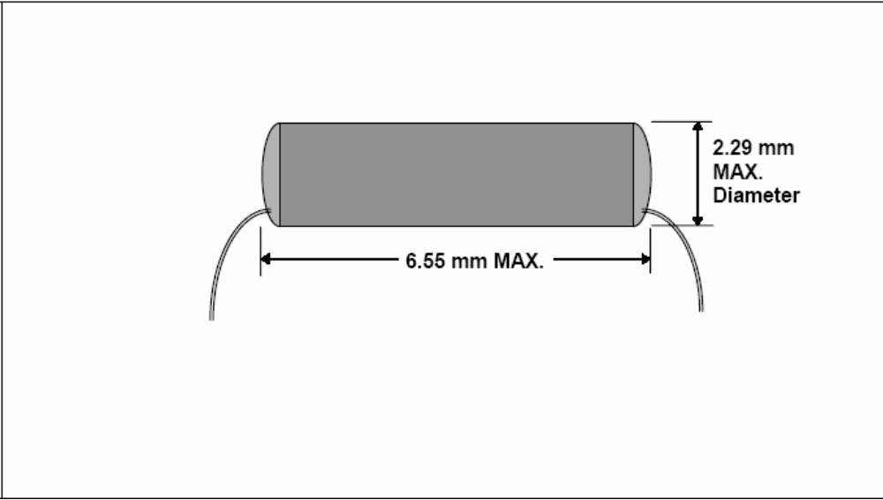
Figure D-34—Typical hearing aid probe coil dimensions

Helmholtz calibration coils
A Helmholtz Coil shall be constructed per D.9.1, Figure D-36, and Figure D-38, may be used in calibration of T-Coil probes.

As an example, dimensions which, with a 100 Ω series resistor, result in a convenient conversions factor and a flat voltage response, within 0.15 dB to 10 kHz, are:

Radius: 71.55 mm
Windings: 10 turns of no. 24 AWG enameled magnet wire
Note – Values given are informative. Other values may be used.

Helmholtz coil magnetic field generation
Helmholtz coils consist of a pair of identical coils wound in a series-aiding fashion, coaxially aligned and spaced a distance apart that is equal to their radius (see Annex F). The magnetic field at the center of such a pair of coils is axially directed with a strength given by the following equation:

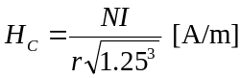
where
H_{c} is the magnetic field strength in amperes per meter
N is the number of turns per coil
I is the current in amperes
r is the coil radius in meters

The previous equation assumes that all the turns on each coil can be considered to lie in the same place and have the same radius. In practice this means that the diameter of the wire bundle is much less than the diameter of the coil.

The coil parameters are such that the magnetic field strength is numerically equal to 100 times the current flowing through the coils. Thus, if a 100 Ω resistor is used to sense the current flow, the magnetic field strength is numerically equal to the voltage across this sensing resistor.

Nonmetallic materials should be used to construct the coil forms, base, and any supporting structure for locating probe coils that are to be calibrated. The method shown in this annex of interconnecting the coils and bringing out the leads to binding posts on the end of the base minimizes any disturbing effects on the desired magnetic field.

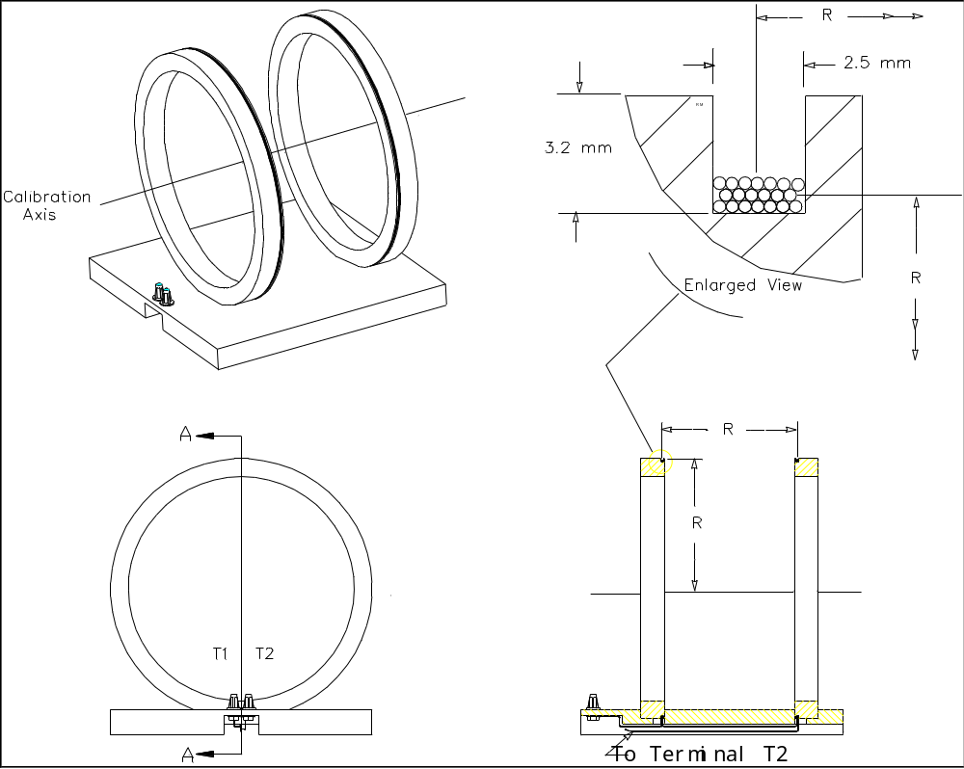

NOTE —Values shows are informative. Other values may be used.

Figure D-36—Helmholtz coil diagram
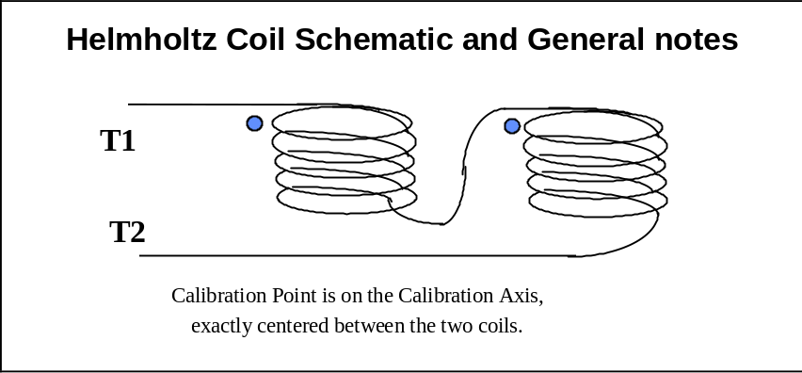
Figure D-38—Helmholtz coil circuit

Probe, near-field, E-field
The E-Field probe should measure total amplitude of the E-Field. A non-isotropic probe may be used, such as a probe with a coaxial cable to allow both frequency and amplitude measurements. For single-axis probes, the initial scan shall be done in all three axes. In these cases the orientation of the probe and routing of the cabling shall be recorded in the test report. The probe, independent of its associated cables shall not perturb the field by more than 1 dB from the measured quantity. Near-field measurements using probes with coaxial cables can perturb the field resulting in higher measurement uncertainty, which must be reflected in the measurement uncertainty calculation..
The diameter of the probe shall be ≤ 10 mm.
The probes shall be calibrated to a measurement uncertainty of no worse than ± 2 dB. Probe calibration in accordance with IEEE Std 1309-2005 is discussed in C.3.

RF cables
Insertion loss: < 1.5 dB over 698 MHz to 6 GHz (or the frequency range being measured.)
VSWR: < 1.5:1 over 698 MHz to 6 GHz (terminated with a 50 Ω load) (or the frequency range being measured.)

RF communications test set
A base station simulator or other means by which the WD may be configured in the required test conditions.

RF power amplifier
- Frequency range: 0.69 GHz to 6.0 GHz (or the frequency range being measured.)
- Power output level and gain: Capable of producing the required field strength within the test volume of the TEM cell using the RF signal generator (described in D.14)
- Linearity: Harmonics of the fundamental carrier frequency shall be at least 30 dB below carrier level (–30 dBc) at the maximum carrier power level used in the test set-up. With this carrier level, the AM distortion of the modulated envelope shall be less than 5% at an AM level of 80%.

RF signal generator
- Frequency range: 0.69 GHz to 6.0 GHz (or the frequency range being measured.)
- Frequency resolution: 100 Hz
- Power output level: Greater or equal to +13 dBm (unmodulated carrier)
- Modulation capability: 0% to 99% AM at 1000 Hz at carrier outputs up to
+7 dBm, both internal and external modulation capability
- Linearity: Harmonics of the fundamental carrier frequency shall be at least 40 dB below carrier level (–40 dBc) at the maximum carrier power level used in the test set-up. With this carrier level, the AM distortion of the modulated envelope shall be less than 5% at an AM level of 80%.
- Non-harmonic spurious: Less than –40 dBc

RF wattmeter
This is for measurement of the directional coupler output. Any RF voltmeter with an input impedance of
50 Ω that can be calibrated in terms of rms (volts may be used as a substitute). Examples are spectrum analyzers, EMI receivers, and RF millivoltmeter instruments.

- Frequency range: 0.69 GHz to 6.0 GHz (or the frequency range being measured.)
- Impedance: 50 Ω
- Amplitude range of input: +20 dBm to +40 dBm (2.236 V rms to 22.36 V rms across 50 Ohms)

T-Coil integrator
For the measurement of ABM1, the intended WD audio frequency magnetic signal, the true magnetic field amplitude of the T-Coil signal is required. The reading must be compensated for the combined effect of the probe and the integrator. A full-band or half-band integrator may be used, so long as the proper compensation is applied to the resulting readings. Either integrator, full-band or half-band, may be used so long as the resulting reading is properly compensated to give the true magnetic field amplitude.

For a broadband measurement of the noise, ABM2, a half-band integration of the probe coil voltage is required.

Full-band integration
For the measurement of audio frequency magnetic signal, a full-band integration of the probe coil voltage output, shown in Figure D.15, is specified, in order to enable measurement of the magnetic field magnitude vs. frequency. This integration, which consists of a downwards-sloping 6 dB/octave equalization, must be maintained accurately over at least the 300 Hz to 3 kHz frequency range of the frequency response masks of 9.2.2. This integration may be applied directly to the buffered probe coil signal, or mathematically in post-processing according to the inverse of the probe coil response defined in Figure C.4. The full-band integration frequency response is shown in Figure D.15, with the resultant integrated probe response to
a constant field magnitude shown in Figure D.16. The resultant sensitivity shall not deviate from the uniform characteristic shown in Figure D.16 by more than 0.5 dB over the frequency range of
300 Hz to 3 kHz.

Half-band integration (T-Coil response)
For the measurement of ABM2, the undesired WD audio frequency magnetic signal, a half-band integration of the probe coil voltage output, shown in Figure D.15, is specified, in order to simulate the magnetic frequency response of a typical hearing aid T-Coil. This integrates only the frequencies above
1 kHz, resulting in a first-order low-pass filter characteristic with a corner frequency of 1 kHz being applied to the probe coil output. This equalization should be maintained over at least a frequency range of 100 Hz to 10 kHz, since the measured noise signal is not limited to the narrower ABM1 bandwidth. This filtering may be applied directly to the buffered probe coil signal, or mathematically in post-processing. The primary calibration of the half-band integrated probe coil response is at 1 kHz. The applied half-band integration frequency response is shown in Figure D.15, and the resultant modified probe response to a constant field magnitude shown in Figure D.16. The resultant sensitivity shall not deviate from the characteristic shown in Figure D.15 by more than 0.5 dB over the frequency range of 300 Hz to 3 kHz and 1 dB over the extended range of 100 Hz to 10 kHz.

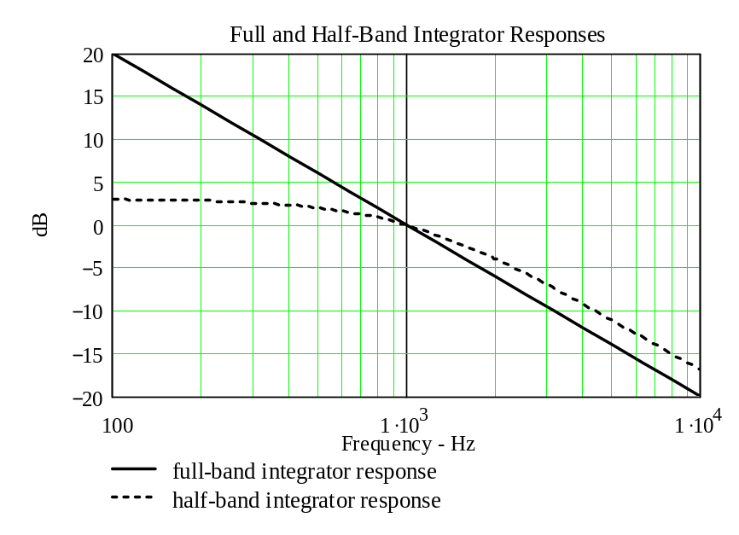
Figure D-40—Full- and half-band integrator responses

Table D-16—Full- and half-band integrator responses at 1/3 octaves in decibels
relative to 1 kHz
Frequency  (Hz) | 315 | 400 | 500 | 630 | 800 | 1000 | 1250 | 1600 | 2000 | 2500 | 3150
Full-band | 10.03 | 7.96 | 6.02 | 4.01 | 1.94 | 0 | –1.94 | –4.08 | –6.02 | –7.96 | –9.97
Half-band | 2.60 | 2.37 | 2.04 | 1.56 | 0.86 | 0 | –1.08 | –2.50 | –3.98 | –5.59 | –7.37
Difference | 7.43 | 5.59 | 3.98 | 2.46 | 1.08 | 0 | –0.86 | –1.58 | –2.04 | –2.37 | –2.59

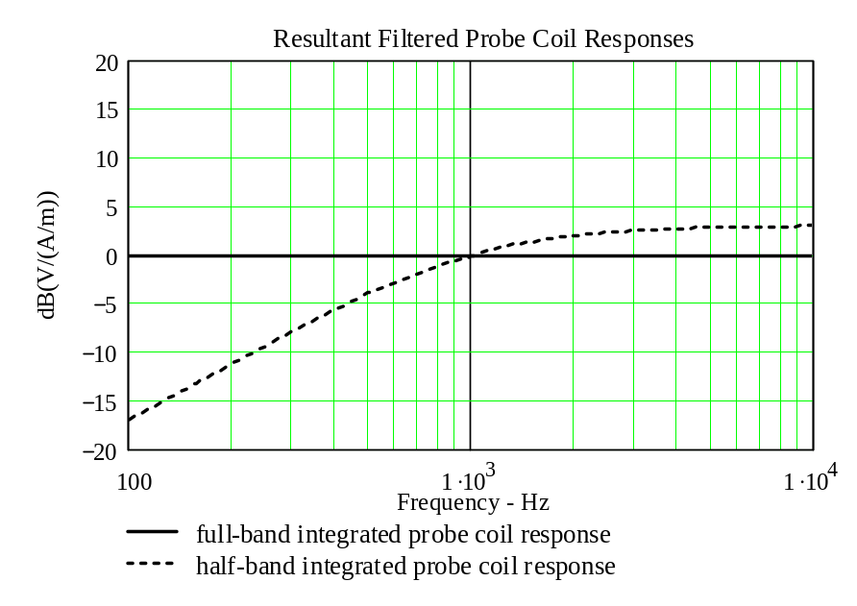
Figure D-42—Resultant filtered probe coil responses

Table D-17—Resultant probe coil responses, dB [V/(A/m)] at 1/3 octaves
in decibels relative to 1 kHz
Frequency  (Hz) | 315 | 400 | 500 | 630 | 800 | 1000 | 1250 | 1600 | 2000 | 2500 | 3150
Full-band | 0 | 0 | 0 | 0 | 0 | 0 | 0 | 0 | 0 | 0 | 0
Half-band | –7.43 | –5.59 | –3.98 | –2.46 | –1.08 | 0 | 0.86 | 1.58 | 2.04 | 2.37 | 2.59

Table D-18—Half-band integrator responses at 1/3 octave frequencies
from 100 Hz to 10 kHz in decibels relative to 1 kHz
Frequency  (Hz) | 100 | 125 | 160 | 200 | 250 | 315 | 400 | 500 | 630 | 800 | 1 000
Half-band  integrator | 2.97 | 2.94 | 2.90 | 2.84 | 2.75 | 2.60 | 2.37 | 2.04 | 1.56 | 0.86 | 0
Resultant  respomse | –17.03 | –15.12 | –13.02 | –11.14 | –9.29 | –7.43 | –5.59 | –3.98 | –2.46 | –1.08 | 0

Frequency  (Hz) | 1 000 | 1 250 | 1 600 | 2 000 | 2 500 | 3 150 | 4 000 | 5 000 | 6 300 | 8 000 | 10 000
Half-band  integrator | 0 | –1.08 | –2.50 | –3.98 | –5.59 | –7.37 | –9.29 | –11.14 | –13.08 | –15.12 | –17.03
Resultant  respomse | 0 | 0.86 | 1.58 | 2.04 | 2.37 | 2.59 | 2.75 | 2.84 | 2.90 | 2.94 | 2.97

TEM cell
- Frequency range: 0.8 GHz to 3.0 GHz
- VSWR over frequency range: < 1.50
- Input impedance: 50 Ω
- Septum height in test region: 2 times to 3 times maximum dimension of hearing aid
- Field uniformity in test region: 0 dB to 6 dB

Voltmeter, DC
The voltmeter used to measure the voltage after the temporal weighting filter shall measure the average level of the output. This output may be further low-pass filtered in order to achieve a more steady reading for demodulated signals having an impulsive character with low repetition rates.
Input impedance: ≥ 100k Ω
Averaging time: Sufficient to maintain the modulation being measured within ± 3%
Accuracy: ± 3% of the indicated value

Voltmeter, true rms
Input impedance: ≥ 100k Ω
Frequency range: 10 Hz to > 10 kHz
Input sensitivity: 0.7 mV or better
Accuracy: ± 3% of the indicated value

(informative)
Sample measurement uncertainty estimates
Measurement uncertainty reflects the quality and accuracy of a measured result as compared to the true value. Such statements are generally required when stating results of measurements so that it is clear to the user of these measurement results that the results may differ when reproduced by different laboratories. Measurement results vary due to the measurement uncertainty of the instrumentation, and measurement technique, even when using this standard for test setups and compliance measurements.

Most uncertainties are calculated using the tolerances of the instrumentation used in the measurement, the measurement setup variability, and the technique used in performing the test. While not generally included, the variability of the equipment under test also figures into the overall measurement uncertainty.

Another component of the overall uncertainty is based on the variability of repeated measurements
(so-called type A uncertainty). This may mean that the various tests may have to be repeated by taking down the test setup and resetting it up so that there is a statistically significant number of repeat measurements to identify this very important aspect of measurement uncertainty. By combining the repeat measurement results with that of the instrumentation chain using the technique contained in NIS 81 and NIS 3003, the overall measurement uncertainty can be estimated.

This annex contains sample calculations and typical values for the tests contained in this standard.

WD near-field emissions measurement uncertainty
This clause gives a sample uncertainty estimation for the WD near-field emission measurement.

Primary uncertainty factors
The following are judged to be the primary contributors affecting measurement uncertainty for this test:

Contributor Influence quantity Type Source of information
RF reflections ± 0.8 dB Specification 6.2.1 (reflections < –20 dB)
Field probe conversion factor ± 1.76 dB Specification C.3
Field probe anisotropy ± 0.5 dB Specification Typical probe manufacturer data
Positioning accuracy ± 1.62 dB Specification E.2.3.1.3
Probe cable placement ± 1.0 dB Specification D.10 and A.2
System repeatability ± 2.0 dB Specification System repeatability is established by performing a series of measurements under equal conditions. For further guidance, consult UKAS M3003.
Repeatability of the WD ± 0.5 dB Std. Dev. Estimate informal

Sample estimation
Table E-19—Near-field measurement uncertainty
WD near-field measurement uncertainty estimation
Contribution | Data  dB | Data  type | Prob.  dist. | Weight | Uncertainty  dB | Notes/comments
RF reflections | 0.8 | Spec | Rect | 1/√3 | 0.46 | Reflections < –20 dB
Field probe conv. factor | 1.76 | Spec | Rect | 1/√3 | 1.02
Field probe anisotropy | 0.5 | Spec | Rect | 1/√3 | 0.29
Positioning accuracy | 1.62 | Accy. | Rect | 1/√3 | 0.94
Probe cable placement | 1.0 | Spec | Rect | 1/√3 | 0.58
System repeatability | 2.0 | Spec | Rect | 1/√3 | 1.15
EUT repeatability | 0.5 | Std. Dev. | Norm. | 1 | 0.5
Combined standard  uncertainty, u_{c}(y) |  |  | Norm. | 1 | 2.03
Expanded uncertainty, U(y) |  |  | Norm. | k = 2 | 4.06

Hearing aid near-field immunity measurement uncertainty
This clause gives a sample uncertainty estimation for the hearing aid near-field immunity measurement.
The sensitivity coefficient for the RF items is 2 because of the square-law response of hearing aids when operating in their linear region. This means that the ratio between the RF level [dB] and IRIL [dB] is close to 2, i.e. a RF-level change of 3 dB will cause an IRIL-change of 6dB.

Primary uncertainty contributors
The following are judged to be the primary contributors affecting measurement uncertainty for this test:

Contributor Influence quantity Type Source of information
RF reflections ± 0.8 dB Specification 6.2.1 (reflections < –20 dB)
Power meter (forward) ± 0.06 dB Specification Typical power meter data
Power meter (reverse) ± 0.06 dB Specification Typical power meter data
Directional coupler ± 1.0 dB Specification Typical acccuracy dir. coup. data
Cable loss ± 1.0 dB Uncertainty Calibration data
Hearing aid loading of antenna TBD Specification D.4 Antenna VSWR ≤ 1.9
Mismatch - directional coupler
to antenna ± 0.19 Specification Calculation for U-shaped distribution
Positioning variation ± 1.62 dB Specification E.2.3.1.3
Acoustic transmission line loss TBD
Microphone ± 1.0 dB Specification Calibration
2 cc coupler TBD
Pre-amplifier ± 1.0 dB Specification Calibration
Frequency analyzer ± 0.5 dB Specification Calibration
System repeatability ± 0.5 dB Std. dev. System repeatability is established by performing a series of measurements under equal conditions. For further guidance, consult UKAS M3003.
Repeatability of the hearing aid TBD
The following factors are assumed to be negligible if the conditions listed are met:

Ambient signals: Assumes an RF shielded environment.
Ambient environment: Assumes temperature, humidity and other environmental parameters are within normal laboratory tolerances.

Sample estimation
Table E-20—Hearing aid immunity measurements
Hearing aid near-field immunity measurement uncertainty estimation
Contribution | Data  dB | Data  type | Prob.  dist. | Weight | Uncertainty  dB | Notes/comments
RF reflections | ± 0.8 | Spec | Rect | 2/√3 | ± 0.92 | Reflections < –20 dB
Power meter (forward) | ± 0.06 | Spec | Rect | 2/√3 | ± 0.069 | VSWR ≤ 1.08, Γ ≤ 0.04
Power meter (reverse) | ± 0.06 | Spec | Rect | 2/√3 | ± 0.069 | VSWR ≤ 1.08, Γ ≤ 0.04
Directional coupler | ± 1.0 | Spec. | Rect | 2/√3 | ± 1.15 | VSWR ≤ 1.15, Γ ≤ 0.07
Cable loss | ± 1.0 | Uncert’y | Norm. | 1 | ± 1.0
Hearing aid loading of ant. | — | — | — | — | — | VSWR ≤ 1.9, Γ ≤ 0.31
Mismatch | ± 0.19 | Spec. | U-shaped | 2/√2 | ± 0.27 | 20Log(1 ± Γ₁Γ₂)
Positioning accuracy | ± 1.62 | Spec. | Rect. | 2/√3 | ± 1.87 | E.2.3
Acoustic transmission line | — | — | — | — | — | TBD
Microphone | ± 1.0 | Spec. | Rect. | 1/√3 | ± 0.58
2 cc coupler | — | — | — | — | — | TBD
Pre-amplifier | ± 1.0 | Spec. | Rect. | 1/√3 | ± 0.58
Frequency analyzer | ± 0.5 | Spec. | Rect. | 1/√3 | ± 0.29
System repeatability | ± 0.5 | Std. Dev. | Norm. | 1 | ± 0.5
EUT repeatability | — |  |  | — | — | TBD
Combined standard  uncertainty, u_{c}(y) |  |  | Norm. | 1 | 2.79
Expanded uncertainty, U |  |  | Norm. | 2 | 5.57

Positioning variability

Resonant dipole field gradients
To measure the quantities reported in this sub-clause, a resonant dipole was used having the following characteristics with a 1 mW net input power. The quantities given are scaleable to adjust for the actual power used in an immunity test.

At 1900 MHz and 15 mm separation distance
The maximum E-field is 33.3 V/m, which is located 33 mm from the center of the dipole. The H-field at this point is 878 μA/m. So the field impedance is 37.93 kΩ. The field varies by 10% 1 mm from center in the tangential direction and by 20% 2 mm from center.

The maximum H-field is 93.7 mA/m, which is located at the center of the dipole. The E-field at this location is 4.19 V/m. The field impedance is 44.74 Ω at this location. The field variation is the same as that given for the E-field.

At 1900 MHz and 20 mm separation distance
The maximum E-field is 13.9 V/m, which is located 30 mm from the center of the dipole. The H-field at this point is 17 mA/m. The field impedance is 817.65 Ω at this point. The field varies by 10% 3 mm from center in the tangential direction and by 20% 6 mm from center.

The maximum H-field is 34 mA/m, which is located at the center of the dipole. The E-field at this location is 7.0 V/m. The field impedance is 205.88 Ω at this location. The field variation is the same as that given for the E-field.

Uncertainty due to positioning variability
If the immunity test is performed at 15 mm from the dipole and the positioning system has a tolerance of
± 2 mm a variation of ± 17% can be expected. Converting ± 17% to decibels yields a ± 1.62 dB uncertainty due to positioning accuracy. For an uncertainty of ± 2.0 dB, a variation of ± 21% is required. This equates to a distance between readings of less than 2.5 mm.

ANSI C63.19-2007 requires the use of a color monitor (and color printer)
to view many of the graphics contained in this standard.
Color is essential to the understanding of the graphics.
ANSI C63.19-2007 requires the use of a color monitor (and color printer)
to view many of the graphics contained in this standard.
Color is essential to the understanding of the graphics.
ANSI C63.19-2007 requires the use of a color monitor (and color printer)
to view many of the graphics contained in this standard.
Color is essential to the understanding of the graphics.
ANSI C63.19-2007 requires the use of a color monitor (and color printer)
to view many of the graphics contained in this standard.
Color is essential to the understanding of the graphics.
ANSI C63.19-2007 requires the use of a color monitor (and color printer)
to view many of the graphics contained in this standard.
Color is essential to the understanding of the graphics.
ANSI C63.19-2007 requires the use of a color monitor (and color printer)
to view many of the graphics contained in this standard.
Color is essential to the understanding of the graphics.
ANSI C63.19-2007 requires the use of a color monitor (and color printer)
to view many of the graphics contained in this standard.
Color is essential to the understanding of the graphics.
ANSI C63.19-2007 requires the use of a color monitor (and color printer)
to view many of the graphics contained in this standard.
Color is essential to the understanding of the graphics.
ANSI C63.19-2007 requires the use of a color monitor (and color printer)
to view many of the graphics contained in this standard.
Color is essential to the understanding of the graphics.
ANSI C63.19-2007 requires the use of a color monitor (and color printer)
to view many of the graphics contained in this standard.
Color is essential to the understanding of the graphics.
ANSI C63.19-2007 requires the use of a color monitor (and color printer)
to view many of the graphics contained in this standard.
Color is essential to the understanding of the graphics.
ANSI C63.19-2007 requires the use of a color monitor (and color printer)
to view many of the graphics contained in this standard.
Color is essential to the understanding of the graphics.
ANSI C63.19-2007 requires the use of a color monitor (and color printer)
to view many of the graphics contained in this standard.
Color is essential to the understanding of the graphics.
ANSI C63.19-2007 requires the use of a color monitor (and color printer)
to view many of the graphics contained in this standard.
Color is essential to the understanding of the graphics.
ANSI C63.19-2007 requires the use of a color monitor (and color printer)
to view many of the graphics contained in this standard.
Color is essential to the understanding of the graphics.
ANSI C63.19-2007 requires the use of a color monitor (and color printer)
to view many of the graphics contained in this standard.
Color is essential to the understanding of the graphics.
ANSI C63.19-2007 requires the use of a color monitor (and color printer)
to view many of the graphics contained in this standard.
Color is essential to the understanding of the graphics.
ANSI C63.19-2007 requires the use of a color monitor (and color printer)
to view many of the graphics contained in this standard.
Color is essential to the understanding of the graphics.
ANSI C63.19-2007 requires the use of a color monitor (and color printer)
to view many of the graphics contained in this standard.
Color is essential to the understanding of the graphics.
ANSI C63.19-2007 requires the use of a color monitor (and color printer)
to view many of the graphics contained in this standard.
Color is essential to the understanding of the graphics.
ANSI C63.19-2007 requires the use of a color monitor (and color printer)
to view many of the graphics contained in this standard.
Color is essential to the understanding of the graphics.
ANSI C63.19-2007 requires the use of a color monitor (and color printer)
to view many of the graphics contained in this standard.
Color is essential to the understanding of the graphics.
ANSI C63.19-2007 requires the use of a color monitor (and color printer)
to view many of the graphics contained in this standard.
Color is essential to the understanding of the graphics.
ANSI C63.19-2007 requires the use of a color monitor (and color printer)
to view many of the graphics contained in this standard.
Color is essential to the understanding of the graphics.
ANSI C63.19-2007 requires the use of a color monitor (and color printer)
to view many of the graphics contained in this standard.
Color is essential to the understanding of the graphics.
ANSI C63.19-2007 requires the use of a color monitor (and color printer)
to view many of the graphics contained in this standard.
Color is essential to the understanding of the graphics.
ANSI C63.19-2007 requires the use of a color monitor (and color printer)
to view many of the graphics contained in this standard.
Color is essential to the understanding of the graphics.
ANSI C63.19-2007 requires the use of a color monitor (and color printer)
to view many of the graphics contained in this standard.
Color is essential to the understanding of the graphics.
ANSI C63.19-2007 requires the use of a color monitor (and color printer)
to view many of the graphics contained in this standard.
Color is essential to the understanding of the graphics.
ANSI C63.19-2007 requires the use of a color monitor (and color printer)
to view many of the graphics contained in this standard.
Color is essential to the understanding of the graphics.
ANSI C63.19-2007 requires the use of a color monitor (and color printer)
to view many of the graphics contained in this standard.
Color is essential to the understanding of the graphics.
ANSI C63.19-2007 requires the use of a color monitor (and color printer)
to view many of the graphics contained in this standard.
Color is essential to the understanding of the graphics.
ANSI C63.19-2007 requires the use of a color monitor (and color printer)
to view many of the graphics contained in this standard.
Color is essential to the understanding of the graphics.
ANSI C63.19-2007 requires the use of a color monitor (and color printer)
to view many of the graphics contained in this standard.
Color is essential to the understanding of the graphics.
ANSI C63.19-2007 requires the use of a color monitor (and color printer)
to view many of the graphics contained in this standard.
Color is essential to the understanding of the graphics.
ANSI C63.19-2007 requires the use of a color monitor (and color printer)
to view many of the graphics contained in this standard.
Color is essential to the understanding of the graphics.
ANSI C63.19-2007 requires the use of a color monitor (and color printer)
to view many of the graphics contained in this standard.
Color is essential to the understanding of the graphics.
ANSI C63.19-2007 requires the use of a color monitor (and color printer)
to view many of the graphics contained in this standard.
Color is essential to the understanding of the graphics.
ANSI C63.19-2007 requires the use of a color monitor (and color printer)
to view many of the graphics contained in this standard.
Color is essential to the understanding of the graphics.
ANSI C63.19-2007 requires the use of a color monitor (and color printer)
to view many of the graphics contained in this standard.
Color is essential to the understanding of the graphics.
ANSI C63.19-2007 requires the use of a color monitor (and color printer)
to view many of the graphics contained in this standard.
Color is essential to the understanding of the graphics.
ANSI C63.19-2007 requires the use of a color monitor (and color printer)
to view many of the graphics contained in this standard.
Color is essential to the understanding of the graphics.

Figure E-44—Example of perpendicular field variation

WD audio band measurement uncertainty
This clause gives sample uncertainty estimation for the WD ABM signal measurement.

Primary uncertainty factors
Contributor Influence quantity Type Source of information
RF reflections ± 0.8 dB Specification 8.2.1
Acoustic noise ± 0.8 dB Specification 8.2.1
Probe coil sensitivity ± 0.5 dB Specification D.8
Reference signal level ± 0.5 dB Specification Calibration
Positioning accuracy ± 1.62 dB Specification E.2.3.1.3
Cable loss ± 1 dB Uncertainty Calibration
Frequency analyzer ± 0.5 dB Specification Calibration
System repeatability ± 0.5 dB Specification Estimate
Repeatability of the WD ± 0.5 dB Std. dev. Estimate

Sample estimation
Table E-21—Sample WD uncertainty estimate
Contribution | Data (dB) | Data (%) | Data type | Probability distribution | Divisor | Std. uncertainty (%) | Std. uncertainty (dB)
RF reflections | 0.80 | 20.2 | Specification | Rectangular | √3 | 11.7
Acoustic noise | 0.80 | 20.2 | Specification | Rectangular | √3 | 11.7
Probe coil sensitivity | 0.50 | 12.2 | Specification | Rectangular | √3 | 7.0
Reference signal level | 0.50 | 12.2 | Specification | Rectangular | √3 | 7.0
Positioning accuracy | 1.62 | 45.2 | Specification | Rectangular | √3 | 26.1
Cable loss | 1.00 | 25.9 | Uncertainty | Normal | 2 | 12.9
Frequency analyzer | 0.50 | 12.2 | Specification | Rectangular | √3 | 7.0
System repeatability | 0.50 | 12.2 | Standard deviation | Normal | 1 | 12.2
Repeatability of the WD | 0.50 | 12.2 | Standard deviation | Normal | 1 | 12.2
Combined standard uncertainty u_{c} |  |  |  | Normal |  | 39.6% | 1.45 dB
Expanded uncertainty (coverage factor = 2) U |  |  |  | Normal  (K=2) |  | 79.2% | 2.53 dB

(informative)
Use of Helmholtz coils for calibration
This paper was presented at the 1995 IEEE Symposium on Electromagnetic Compatibility in Atlanta, GA. Some typographical errors were discovered in the equations in the original published copy. It is therefore reproduced here, with typographical corrections, for the convenience of the reader.

Helmholtz Coils for Calibration of Probes and Sensors:
Limits of Magnetic Field Accuracy and Uniformity

Abstract—Helmholtz coils have been around us for years, but few people now seem to understand their capabilities. The paper explains the accuracy and field uniformity limits of Helmholtz coils for use as a calibration standard for magnetic field probes and sensors. The magnetic field generation accuracy depends on the accuracy with which Helmholtz coils are constructed and the accuracy with which the current through them is maintained. The user is shown how to determine the accuracy of the generated magnetic field based on physical measurements of distance or spacing between the coils, their radii, the thicknesses of the windings on each coil and number of turns. Ways to estimate the maximum usable frequency and minimum space needed around them are given. Procedures are given so that the user may determine the field uniformity versus volume around the center point of the set of coils, and thus determine the coil characteristics needed to calibrate a particular probe or sensor. Or, if a given Helmholtz coil set can be used for calibration of a given sensor.

Introduction
Helmholtz coils have been in use for several lifetimes for calibrating magnetic field sensors or probes. More recently, they have been put to work doing low-frequency magnetic field immunity tests. A few years ago, the author presented a paper in England (see [1] in F.5) on the use of Helmholtz coils for immunity testing. The need for that paper became apparent when listening to discussions of Helmholtz coils in test seminars and standards committees. No one seemed to understand the accuracy with which Helmholtz coils could produce magnetic fields and the trade-offs between the field uniformity and the size of the device under test (DUT). Guesses were made as to how large a device could be tested in a pair of Helmholtz coils, and a cubic volume having dimensions of one-third of the coil radius was often suggested, but wholly incorrect, since this dimension came from TEM (Crawford) cell use.

Now Helmholtz coils are again being considered as one of several methods for calibrating low frequency magnetic field probes and sensors in IEEE Std 1309. It appears that a clear and easy method is needed for a user to assess the expected calibration accuracy of a set of Helmholtz coils and the field uniformity versus size of the DUT, which leads to the size of the Helmholtz coils needed. The size of the coils and field strength required also impact the maximum frequency of calibration and the size of obstruction-free laboratory space needed to assure minimal environmental interaction.

In sensor and magnetometer calibration it is important to obtain the utmost in field uniformity. To make best use of Helmholtz coils for calibration of sensors, the metrologist needs to know the size and shape of the uniform field region of given precision within a set of Helmholtz coils. In this paper, equations are developed for use in determining the size and shape of regions of specified field uniformity in standard Helmholtz coil sets defined below. Regions of commonly used values of uniformity are tabulated, and graphical data and formulas are given that allow the arbitrary selection of uniformity, within reason, and produce dimensions of the uniform region.

The work reported in this paper is part of a larger project to fully understand and characterize the sources of error in magnetic fields generated by Helmholtz coils. There are other structures for producing very uniform magnetic fields, e.g., the “Rubens’ Coil” (see [2] in F.5), but the Helmholtz coils are the simplest to manufacture and characterize.

In a pair of Helmholtz coils, the accuracy of the magnetic fields produced within them is primarily affected by the accuracy with which they are constructed and the accuracy with which the current driving them is known. Secondarily, the accuracy is also affected by the equality and uniformity of the driving currents in the two coils. These secondary effects usually arise because of the frequency of operation and the nearness of large metallic (magnetic) surfaces.

Definition. A set of Helmholtz coils consists of two circular coils of equal diameter and equal number of turns parallel to each other along an axis through the center of the coils, separated by a distance equal to the common radius of the coils. For multiple turn coils, the diameter of the winding on each coil is much much smaller than the diameter of the coil. The two coils are connected in series aiding in order to produce a nearly uniform magnetic field in a region surrounding the center point of the axis between to two coils. (The coils can be connected in parallel aiding, but the current in the coils shall be kept equal.) This arrangement is shown in Figure F.1.

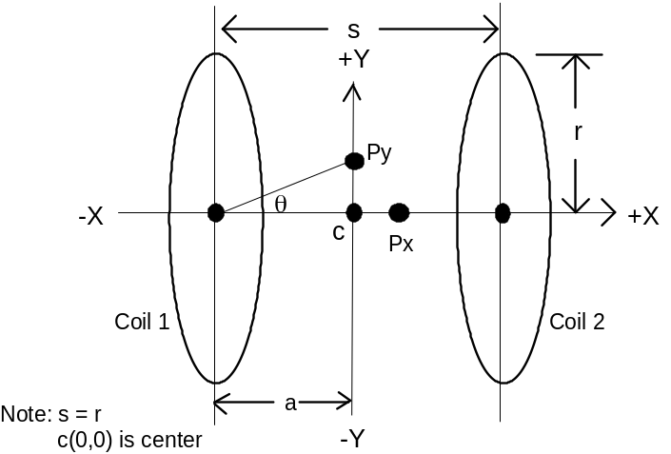
Figure F-46—Helmholtz coil arrangement

Axial field-strength accuracy
Constructional features such as the radii of the coils and their spacing have a direct effect as can be seen from Equation (F.1) (see [3] in F.5) of the axial magnetic field strength, H_{x} in A/m, versus coil size, spacing, number of turns, and current. This equation gives the field strength at a point on the common axis of the two coils, P_{x} on the X-axis in Figure F.1 as follows:
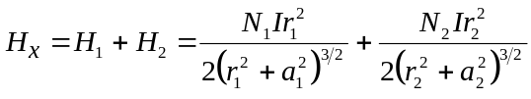 (F.1)
According to the definition of Helmholtz coils, r₁ = r₂ = r, N₁ = N₂ = N and 2a₁ = 2a₂ = s = r, so that after some manipulation, Equation (F.1) becomes:
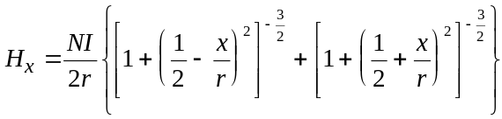 (F.2)
where
N is the number of turns on each coil
r is the radius of each coil (meters)
x is the axial position of the magnetic field, in meters from the center of the coil set
I is the current in the coils (amperes)

For the special position at the center of the coil set where x = 0, the magnetic field is given by
Equation (F.3).
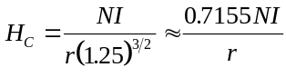 (F.3)
The approximation using the four-digit constant (0.7155) is less than 0.006% low, i.e., the error is less than 60 parts per million. Neglecting this small error, the error in H_{c} caused by dimensional, constructional, and current variability errors may be found from Equation (F.4), which is also found in (see [5] in F.5).
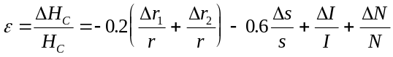 (F.4)
From this relationship, you can see that errors in the coil current and the number of turns are most serious, an error in the coil spacing is less serious, and an error in the coil radius is least serious.

Coil radius and spacing error effects
Table F-22 shows some errors in dimensions that cause errors of 1%, 2%, and 5% in Hc. It is apparent in Fquation (F.4) that equal and opposite errors in the radius of the coils offset each other and not affect the magnetic field. This is correct for points on the center line of the coils; but for fields radially off of the center line, the field uniformity is no longer symmetrical either side of the center of the coil set (discussed later in the paper). The important issue is that the coils can be measured with a “ruler” and an error as large as 2% in coil radius or 1.6% in coil spacing are very obvious for coils of practical dimensions. This is one of the reasons that Helmholtz coils have for years had almost the status of primary standards. When measuring the radius of the coils, measure the diameter from the center of the winding through the center of the coil to the center of the winding at the other end of the diameter and divide by two.

Table F-22—Errors in H_{c} versus errors in r₁, r_{2,} and s
Dimension | ε = 1  (%) | ε = 2  (%) | ε = 5  (%)
r₁ | 5 | 10 | 25
r₂ | 5 | 10 | 25
r₁ + r₂ | 2.5 | 5 | 12.5
S | 1.66 | 3.33 | 8.33

Coil current and turns errors
Errors in coil turns and coil current are more serious, not only because they directly affect the magnetic field on a one-to-one basis, but because they are harder to measure accurately. There can also be errors brought about by unequal coil currents and an unequal number of coil turns, which require special methods to avoid.

Coil current errors are dependent on the accuracy and resolution (precision) of the current measuring device or current meter. Now-a-days ac and dc current meters can be much more accurate than they once were. There are current meters available that have accuracies better than 0.4% and resolutions better than 0.00005%, but there are also many available that are much worse. Do not “cut corners” when acquiring the current meter.

Coil turns errors may be determined directly or indirectly. If there are more than two or three turns on each coil, it is difficult to count them and indirect measurements may have be made to determine how much wire is on the coil. The measurement errors can add up to large amounts in these indirect measurements. It is therefore best to assure that the coil manufacturer has counted the turns correctly during construction of the coils. Short of that, it is important to know that there are an integral number of turns on each coil.

An integral number of turns allows a choice of two methods to determine the number of turns. One, a coil resistance measurement easily determines how many coil turns there are since the coil resistance is proportional to the number of turns. While a resistance measurement might not be sufficiently accurate to determine if there are a certain number of whole turns on the coil, such a measurement tells how many turns are there if one has a priori knowledge that there are an integral or whole number of turns on the coil; i.e., the leads come out of the coil at the same point on the circumference. Two, a current probe measurement of the product NI easily gives the number of turns by comparison with the input current to the coil, if it is known that there are an integral number of turns on the coil.

The last term in Equation (F.4), the turns error, may be modified to account for errors in the number of turns on each of the individual coils. Replace ΔN/N with 0.5(ΔN₁/N + ΔN₂/N), where N is the design number of turns. This shows that the error in the axial magnetic field is half that of the turns error in each of the coils. Again, if one coil is too small and the other too large by the same error, the center point magnetic field is not affected, but the symmetry of the uniform field volume is distorted.

Current and turns errors in parallel-fed coils. There are situations in which it is necessary to feed the coils in parallel. This occurs at higher frequencies where the impedance of the coil is large enough to make it difficult to drive the necessary current through the coils when they are connected in series aiding. Use this parallel-aiding connection only when absolutely necessary.

When the coils are connected in parallel-aiding, the two coil currents shall be kept equal and in phase. To do this, they shall come from the same generator through phase-matched paths and be independently adjustable. To evaluate the errors caused by this connection, replace the last two terms in Equation (F.4) with a new last term, as shown in Equation (F.5), in which N is the design value and I is the intended current.
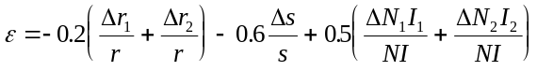 (F.5)
This shows that the products NI are what shall be controlled and kept as accurate and as equal as possible. If a current probe is connected around each coil, the value of NI in both coils can be set equally and accurately within the resolution and accuracy of the current probe and voltmeter combination used. The last term of Equation (F.5) now becomes (ΔI_{cpa}/I + ΔI_{cpr}/I), where ΔI_{cpa}/I is the accuracy of the probe and voltmeter, Δ_{Icpr}/I is their resolution, and the coefficient 0.5 becomes unity. If a precision current meter is used to set the current in one coil and the current probe-voltmeter technique is used to bring NI to equality in both coils, the last term of Equation (F.5) becomes (ΔI/I + 0.5ΔI_{cpr}/I), where ΔI/I is the error in the current meter. For example, if the current accuracy is 0.4% and the resolution of the current probe-voltmeter is 0.01%, then the total error in H_{x} is 0.405%. The inequality of NI in both coils is the resolution of the current probe-voltmeter. This technique can produce a more symmetrical uniform field volume than individually adjusting the coil currents when the coils shall be fed in parallel, and is my recommended approach.

Radial field-strength

Calculating radial field strength
Equation (F.6) gives the radial magnetic field strength, H_{ρ}, at a point off of the coil-axis, e.g., P_{y} in
Figure F.1. When y/r is zero, this equation gives results identical to Equation (F.2), and when x/r is also zero, it gives results identical to Equation (F.3). This equation may be used to compute the magnetic field strength anywhere in the space between the coils and its results are plotted in Figure F.2. Figure F.2 is a normalized plot of field strength relative to center, ΔH/H_{c}, versus the axial distance from center, x/r, for several values of radial distance from center, y/r.
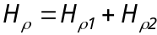 (F.6)

H_{ρ1} is the field contribution from coil 1 and H_{ρ2} is the field contribution from coil 2.
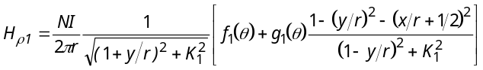 (F.6a)
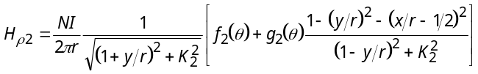 (F.6b)

where
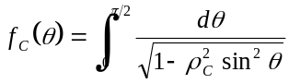 (F.7)
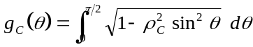 (F.8)
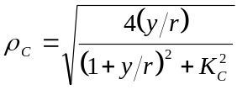 (F.9)
The subscript c is 1 for coil #1 and 2 for coil #2
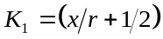 (F.10a)
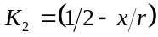 (F.10b)

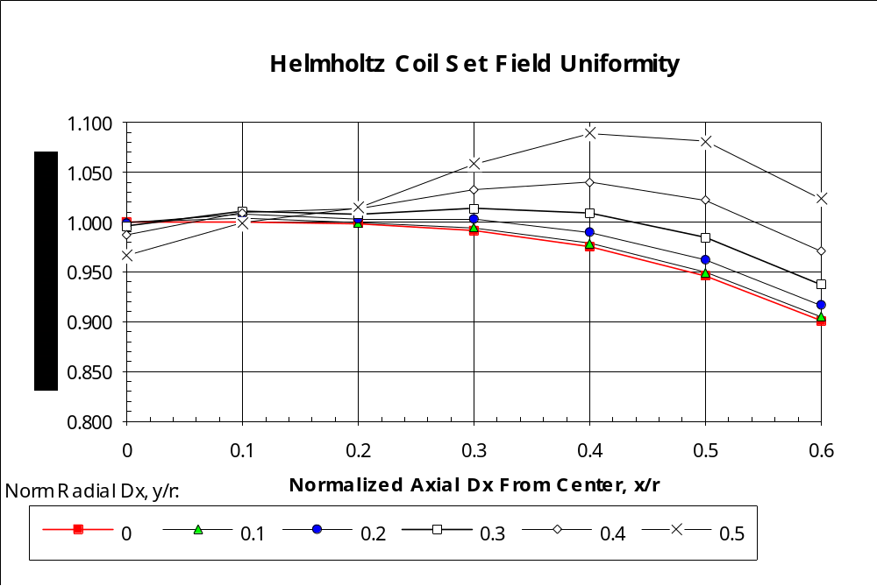
Figure F-48—Normalized magnetic field strength computed from Equation (F.6)

Determining coil size
Table F-23 shows the normalized x and y values for field uniformity of 1%, 2%, 5%, and 10%.

Table F-23—Normalized radii for several values of field uniformity (ΔH/H_{c})
Unif. | 1% | 2% | 5% | 10%
± x/r | 0.3 | 0.4 | 0.5 | 0.6
± y/r | 0.3 | 0.4 | 0.4 | 0.5

From Table F-23 one can determine the size of coils needed for a particular maximum field-strength uncertainty based on the size of the DUT. Each volume is ellipsoidal or cylindrical, approximately, centered on the center point of the Helmholtz coil set, and x/r and y/r are the normalized radii of the ellipsoid. These radii represent half of the maximum dimensions of the DUT relative to the radius of the coils. To find the radii of Helmholtz coils needed for a DUT of a given size, divide the dimensions of the DUT by twice the values in Table F-23. For example, if a magnetic field probe is made up of three orthogonal loops each 200 mm in diameter, and it is desired to keep each loop in the 1% uncertainty or field uniformity volume, the minimum radius of the Helmholtz coils shall be r = 20/(2 × 0.3) = 333.3 mm. The diameter of both coils should be 0.67 m or greater.

Maximum frequency of operation
To assure that the magnetic fields within the Helmholtz coil set remain as uniform as possible, the upper frequency of use should be limited such that the current around the circumference of both coils stays constant, and the electric and magnetic fields induced by the intended alternating magnetic field are small enough to be neglected (see [5] in F.5). A further limit is that the frequency of operation should be well below the self-resonance frequency of the coils. A practical limiting frequency is the frequency at which the impedance of the coils is so high that they are difficult to drive. This last limit is the lowest in frequency and is the one that usually prevails. The hierarchy of these limits are shown in Table F-24 and discussed below.

Table F-24—Upper frequency limit
1 | Length of wire in coils | Highest frequency
2 | Secondary field effects | Lower than 1
3 | Self resonance | Lower than 2
4 | Fall-off of drive current | Lowest frequency

The frequency at which the currents around the circumference of the coils stays constant is the highest of the possible limiting frequencies. At this frequency the length of the wire in each of the coils is no longer than 0.15 λ or 0.10 λ. Since it is the highest of the limiting frequencies, it is of little practical importance.

From Maxwell’s equations, we know that an alternating magnetic field generates an alternating electric field, which in turn, generates another alternating magnetic field, etc. Thus when an ac magnetic field is intentionally created by a pair of Helmholtz coils, it generates a series of electric and magnetic fields in the same test volume where the uniform magnetic fields are desired. Also, since the Helmholtz coils do not usually have an electric shield, they directly generate an electric field that also generates a secondary magnetic field, etc. The magnitude of these effects increases with increasing frequency. The frequency at which these effects cannot be neglected is lower than the highest limiting frequency discussed above, but much higher than the self-resonance frequency of the coils (see [5] in F.5).

The self-resonance frequency of the coils is given by the familiar equation f₀ = 1/(2π√LC). The inductance L of the coils is easily calculated, but C is the stray capacitance of the coils and is not easily calculated. It could be modeled by the Method of Moments. This frequency is much lower than the other two limiting frequencies, and it is a limit primarily because the coils are extremely difficult to drive at this frequency since it is a parallel resonance.

A practical maximum frequency is reached before the coils begin to approach resonance. About two orders of magnitude below the self-resonance frequency of the coils is the frequency where for a given generator power, the drive current begins to fall off. The impedance (mostly reactance) of the coils increases with increasing frequency so that more and more generator power is required to maintain the nominal magnetic field. The frequency at which the generator power shall be doubled (3 dB) to maintain the desired coil current is often referred to as the bandwidth or corner frequency of the Helmholtz coil set. It is probably reasonable to set the practical upper frequency no higher than the frequency where the generator power would have to be 10 times its level at low frequencies. The term generator used here includes any power amplifier needed to produce the required coil current, so that a factor of 10 increase in generator power may be too extravagant, i.e., the cost of the higher-powered amplifier may be prohibitive. The effect is given in Equation (F.11).
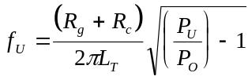 , Hz (F.11)
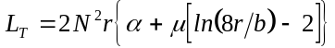 , H (Series-connected) (F.12)
where
α is the mutual inductance factor, 0.494 × 10⁻⁶ for Helmholtz coils (see [5] in F.5)
b is the effective radius of the coil winding (meters) (see Figure F.3)
R_{g} is the generator source impedance (ohms)
R_{c} is the total resistance of both coils (ohms)
P_{u}/P_{o} is the ratio of the generator power at the upper frequency to the generator power at low frequencies

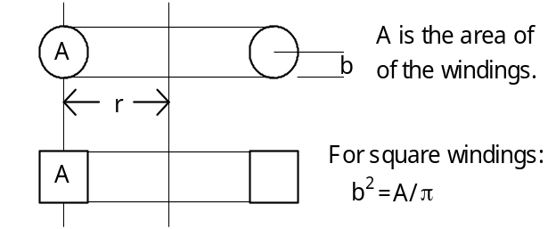

Figure F-50—Alternative coil winding configurations

Effect of loading
A large DUT made of magnetic material may load the coils and concentrate the fields in its vicinity. If inserting the DUT into the test space within the Helmholtz coil set causes the coil current to change by more than a few per cent, it should be suspected that the field is distorted and may not be accurate even after returning the coil current to the correct value. The coil current should always be set with the system empty and then reset to the original value after the DUT is inserted. If field distortion is suspected, a larger set of Helmholtz coils should be used.

Using the Helmholtz coil set inside of a shielded enclosure that is too small affects the accuracy of the fields. If a shielded enclosure is used, its smallest dimension shall be more than 6.7 r to prevent loading of the system and distortion of the fields. This dimension may also be used to determine how far away from the Helmholtz coils large metallic objects should be.

Summary
The use of Helmholtz coils for probe or sensor calibration is summarized as follows:

- Helmholtz coils may be used to volumes with dimensions of 0.6 r for highly accurate probe or sensor calibration.
- Helmholtz coils should be used in the series-aiding connection, but may be used in the
parallel-aiding connection if necessary—with extra current controls and precautions.
- Balance the products NI in the two coils for maximum accuracy.
- Consider Helmholtz coils a primary standard; they can be calibrated by ruler.

References
[1] Bronaugh, E. L., “Helmholtz coils for EMI immunity testing: stretching the uniform field area,” Electromagnetic Compatibility, Seventh International Conference on EMC, Pub. no. 326, Institution of Electrical Engineers, York, UK, 1990, pp 169–172.
[2] Rubens, S. M., “Cube-surface coil for producing a uniform magnetic field,” Review of Scientific Instruments, vol. 16, no. 9, Sept. 1954, pp 243–245.
[3] Loeb, L. B., Fundamentals of Electricity and Magnetism, 3rd Ed., Dover Publications, Inc., NY, 1961, pp 56–62.
[4] Van Bladel, Electromagnetic Fields, McGraw-Hill, Inc., NY, 1964, pp 155–156.
[5] Millanta, L. M., et al., “Helmholtz coils: static and frequency-dependent performance limitations.”

(informative)
Limits in linear units
This annex provides the limits from Clause 8 in linear units as a convenience for users of this standard.

Hearing aid immunity limits
Table G.1—Hearing aid immunity categories using dipole illumination, in linear units
Category | Hearing aid RF parameters  (hearing aid must maintain < 55 dB IRIL interference level  and < 6 dB gain compression)
Near field | E-field immunity  (CW) |  | H-field immunity  (CW)
Category M1/T1 | 31.6 to 56.2 | V/m | 0.071 to 0.126 | A/m
Category M2/T2 | 56.2 to 100.0 | V/m | 0.126 to 0.224 | A/m
Category M3/T3 | 100.0 to 177.8 | V/m | 0.224 to 0.398 | A/m
Category M4/T4 | > 177.8 | V/m | > 0.398 | A/m

Table G.2—Hearing aid immunity categories using GTEM illumination, in linear units
Category |  | Hearing aid RF parameters  (hearing aid must maintain  < 55 dB IRIL interference level  and < 6 dB gain compression)
Near field | E-field immunity  (CW)
Category M1/T1 |  |  | 14.1 to 25.1 | V/m
Category M2/T2 |  |  | 25.2 to 44.7 | V/m
Category M3/T3 |  |  | 44.7 to 79.4 | V/m
Category M4/T4 |  |  | > 79.4 | V/m

WD emission limits
Table G.3—Telephone near-field categories in linear units
Category | Telephone RF parameters  < 960 MHz
Near field | E-field emissions
Category M1 | 316.2 to 562.3 | V/m
Category M2 | 177.8 to 316.2 | V/m
Category M3 | 100.0 to 177.8 | V/m
Category M4 | < 100.0 | V/m

Category | Telephone RF parameters  > 960 MHz
Near field | E-field emissions
Category M1 | 100.0 to 177.8 | V/m
Category M2 | 56.2 to 100.0 | V/m
Category M3 | 31.6 to 56.2 | V/m
Category M4 | < 31.6 | V/m

(informative)
U.S. Frequency bands
This annex provides the U.S. frequency bands of that are of primary interest for this standard. It was the intent of the committee to provide recommendations that would give high levels of protection for hearing aids used with devices operating in these frequency bands.

CMRS Bands in the US
This sub-clause presents the US commercial mobile radio services (CMRS) frequency plan. For the purposes of this document high levels of immunity are required in the spectrum regions allocated for mobile device transmission. It is in these frequency bands that mobile devices have the potential for creating high field strengths in close proximity to a hearing aid.

In the US most CMRS are provided through systems operating in the 800 and 1900 MHz bands. These bands are commonly called the cellular bands for 800 MHz, Figure H-1, and the personal communications services (PCS) band, for the 1900 MHz service, Figure H-2. Each band is broken into blocks with paired transmit and receive frequencies, separated by a guard band. Through auctions, licenses have been assigned to service providers for each block in the various geographic areas of the US.

These bands are regulated by the Federal Communications System (FCC) under FCC Part 22 (47CFR22) for the cellular band and FCC Part 24 (47CFR24) for the PCS band. To a lesser but important degree, FCC Part 90 (47CFR90), private land mobile services, are also used.

New spectrum has been identified and the service rules are currently being written by the FCC for third generation cellular networks. These services are being called Advanced Wireless Services (AWS) by the FCC, Figure H-3. A major feature of AWS services is that they are designed to provide high voice/data integration and support many enhanced data services. As third generation networks are deployed, transmitting data of the type contemplated in this report will become increasingly easy. An important criteria in selecting a solution is to assure that the solution adopted will seamlessly move one third generation networks as they are deployed.
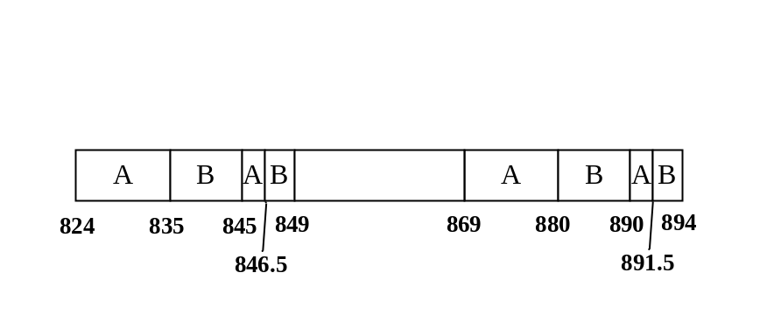
Figure H-52 - Band Plan for US Cellular Band
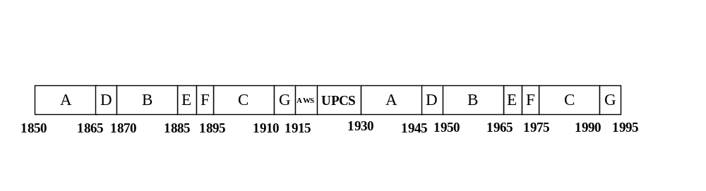
Figure H-54 – Band Plan for US PCS Band
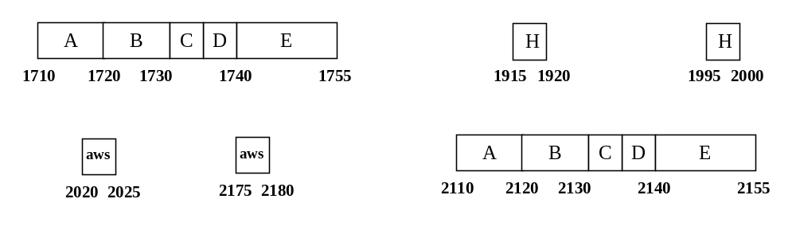
Figure H-56 – Band Plan for US AWS Band

New and emerging services
Several new services are in the process of being approved or deployed. Table H-25 lists those of most interest for this standard.

Table H-25 – New Services
Band | Frequency | Transmit Power | Service
Land Mobile | 698-746, 747-762 and 777-792 MHz Bands | 3W | Mobile / Fixed
Advanced Wireless Services  |(AWS) | 1710 – 1755 MHz | 1W | Mobile (IMT / 3G)
Advanced Wireless Services  |(AWS) | 2155 – 2175 MHz | 1W | Mobile (IMT / 3G)
Mobile | 2.5 - 2.689 GHz | 2W | Mobile (IMT/3G)
Land Mobile | 3650 - 3700 MHz | 1W/25MHz eirp | Broadband wireless
Land Mobile | 4940 - 4990 MHz | 2W | Public Safety
Of particular interest is the 700 MHz public safety band. Figure H-4, Figure H-5 and Figure H-6 give the frequency and channel allocation for this band.

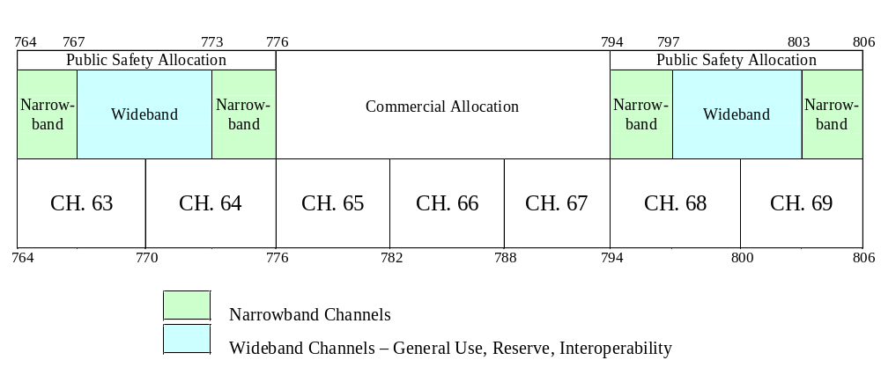
Figure -H-58 – 700 MHz public safety band

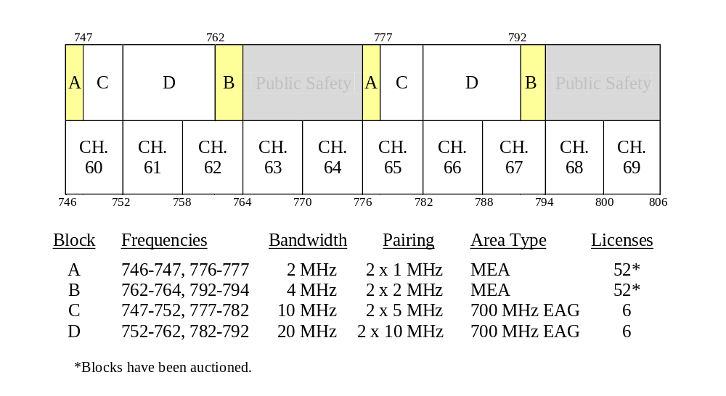
Figure H-60 – Upper 700 MHz band
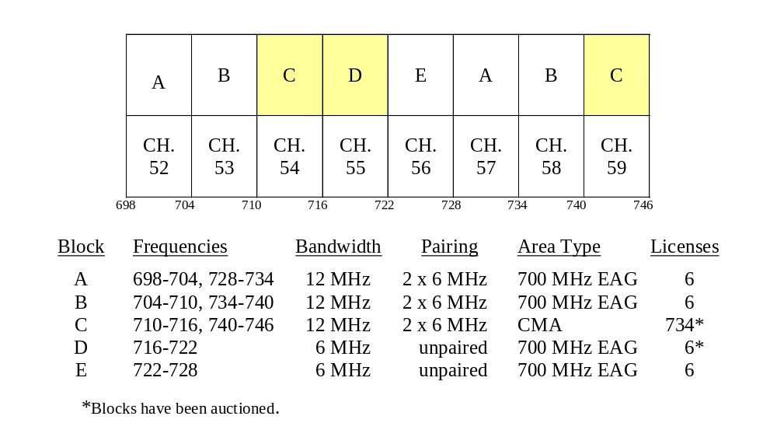
Figure H-62 – Lower 700 MHz band

(informative)
RF envelope comparison for U.S. WD systems

Introduction
The purpose of this annex is to outline the similarities and differences between the current cellular systems being used in the U.S. The discussion is tailored towards the information that is pertinent to the issue of hearing aid compatibility, when addressing the issue of interference to hearing aids from digital cellular phones. There is one major analog and several digital cellular systems on the air currently in the U.S. They are advanced mobile phone systems (AMPSs) (IS-91A), NADC (IS-136), PCS1900 (JTC007), iDEN, and CDMA (IS-95). The following discussion will review each of these systems, highlighting their operation as it relates to the time domain transmitter signatures. Table 26 shows a summary of the relevant parameters of each of these systems.

Table 26—Relevant parameters for time domain transmitter signatures
Characteristic | IS-91A  Analog | IS-136  800 MHz TDMA  (NADC) | 800 MHz GSM | JT C007  1900 MHz PCS | IS-95  800 MHz CDMA | iDEN
Transmit frequency (MHz) | 824–849 | 824–849 | 890–915 | 1850–1990 | 824–849 | 806–821  896–901
Peak transmitter power (mw) | 600 | 600 | 2000 | 1000 | 250 | 600
Lowest transmitter power (mw) | 7 | 0.4 | 20 | 20 | < 0.001 | 0.3
Average transmitter power (mw) | 600 | 200 | 235 | 118 | varies | 100 (1:6 duty cycle  200 (2:6 duty cycle)
Pulse repetition (pulses/sec) | N/A | 50 | 217 | 217 | varies | 11 (1:6 duty cycle)  22 (2:6 duty cycle)
Pulse width (msec) | N/A | 6.7 | 0.6 | 0.6 | varies | 15
Time between pulses (msec) | N/A | 13.4 | 4 | 4 | varies | 75 (1:6 duty cycle)  30 (2:6 duty cycle)
Modulation in pulse | FM | pi/4 QPSK(1) | GM SK(2) | GM SK(2) | OQPSK(3) | QUAD 16-QAM
Power control | Base station only | Base station only | Base station only | Base station only | Base and mobile | Mobile
- pi/4 QPSK modulation has eight modulation phase states, which travel in an irregular path between states, resulting in a small of AM content.
- GMSK modulation has four modulation phase states which travel in a circular path between states, resulting in no AM content.
- OQPSK modulation has four modulation phase states which travel in an irregular path between states thus resulting in a large AM content.

AMPS
The advanced mobile phone system that is used in the U.S. is classified as an analog system because the transmitter is on for the full duration of the phone call and the transmitter is Frequency Modulated using an analog representation of the voice signal. Although the base station has control over the subscriber unit’s transmitter power, the power level can change only every few seconds. The transmitter is turned off for approximately 75 ms during a “handoff” from one channel to another, i.e., when switching from a signaling channel to a voice channel, or from one voice channel to another.

NADC
The North American digital cellular system is a TDMA system in that each user has one of three time slots to transmit in. There are three time slots allocated for each channel. The frame repetition rate is 50 Hz, thus making any given subscriber unit transmit 50 pulses every second, each pulse being 6.7 ms long. The modulation during the pulse is 1/4 quadrature phase shift keying (QPSK). This means that the modulation is essentially phase modulation, but as the modulation phase state moves from one state to another, it does change in amplitude. This results in some amount of AM present on the PM signal in the pulse. Thus one needs to talk about peak power in the pulse and separately average power in the pulse, as well as overall average power. The ramp up and ramp down times of the transmitter are fairly rapidly, thus the average power is very close to 1/3 of the peak power. The transmitter power is controlled by the base station, and can change only every several pulses in 4 dB steps.

Measuring overall average transmitter power is difficult with many power meters because their sampling time is not correlated to the pulse rate, and they may sample a slightly different number of “on” pulses during successive measurements. The best meters to use are the older bolometer type analog meters, which will perform a long time average, or diode detector type meters that can discern between on and off time of the pulse.

GSM and PCS
The European 900 MHz GSM system is essentially identical to the U.S. 1900 MHz PCS system. The major differences are the frequencies of operation, and that the PCS system has a transmitter power of 1.0 W in the burst versus 2.0 W for GSM. The PCS system is a TDMA system in that each user has one of eight time slots to transmit in. There are eight time slots allocated for each channel. The repetition rate is 217 Hz, thus making any given subscriber unit transmit 217 pulses every second, each pulse being 0.6 ms long. The modulation during the pulse is Gaussian minimum shift keying (GMSK). This means that the modulation is phase modulation where the modulation phase state travels in a circle around the origin. This results in a flat power curve in the burst. Also there is some ramp-up and ramp-down time allowed for the transmitter, thus making the overall average power slightly less than 1/8 of the average power in the pulse. A factor of 8.5 is recommended when estimating overall average power compared to peak power. The transmitter power is controlled by the base station, and can change by one 2 dB power step every 60 ms. Figure I.1 shows the waveform of a single 0.6 ms pulse.

CDMA
The CDMA system is the most complicated of all of these digital systems. CDMA has time slots, power control groups, modulation symbols, code symbols and chips all as part of the time varying envelope description. Figure I.2 shows the transmitter on/off pulsing timings, and Figure I.3 shows the time varying envelope in the pulse. There are 16 power control groups occurring in every 20 ms time slot, thus making for 800 1.25 ms long power control groups every second. A power control group is the basic unit of transmission time. Phones may transmit for 1, 2, or 16 successive power control groups. The phone may transmit during 2, 4, 8, or 16 power control groups of each time slot, thus making for the eighth rate, quarter rate, half rate, and full rate VOCODER rates, respectively. The VOice COder DEcodeR (VOCODER) rate chosen for any given time slot depends on the amount of data to be sent, which is directly related to the amount of voice activity. Data in the power control group is always sent at a rate of 9.6 kb/s. Each bit is subdivided into 128 “chips,” thus making for 1.228 chips/s.
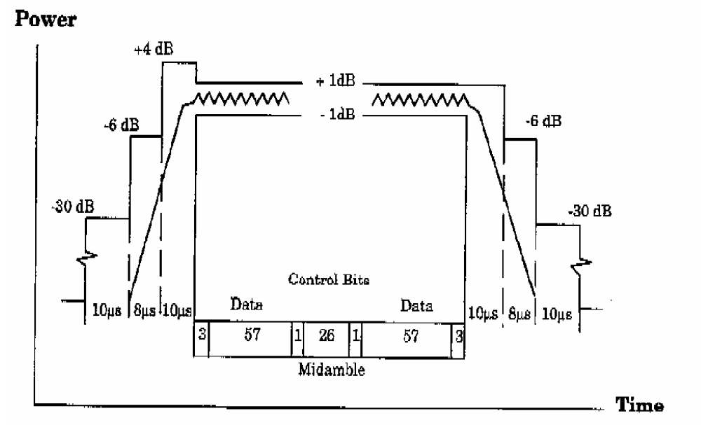
Figure I.I-64—GSM power burst

The modulation is offset QPSK, where the modulation phase state travels an irregular path from one state to another, thus the modulation envelope has a large amount of AM component in the power control group (transmit burst). However this AM component is occurring at the 1.2228 MHz chip rate, and is thus much above the audio band. Since all subscriber units on a given channel are transmitting during the same power control group(s), the transmitter power is controlled to an accuracy of ± 1 dB. Even the power control group that the subscriber unit will transmit in during the next frame is randomized so that there is a uniform distribution of portables transmitting in all power control groups.

Additionally all subscriber units have two sources of power control. One is the base station that will make fine adjustments (closed loop power control), the other is the subscriber unit itself that will make coarse adjustments (open loop power control) based on the incoming receive signal strength. The base station may command a change of 1 dB in power at every power control group (1.25 ms), and over a power range of
24 dB. Open loop power control occurs much slower. Open loop power control may have to be disabled by means of a hardware change in some if not all manufacturers’ phones for the purposes of testing hearing aids. The problem with not disabling open loop power control is that since the subscriber unit operates in the same frequency band as the AMPS system, the subscriber unit will receive the AMPS signals and thus adjust its transmitter power in response to the level of those incoming signals, even in test mode.

iDEN
The iDEN integrated digital enhanced network is used to provide telephony, rapid access two-way dispatch, messaging, paging, circuit data, and packet data services in a single handset using a basic time division multiplexed 90 ms frame comprised of six time slots. Telephone service is provided using either one or two time slots per frame at the discretion of the network provider. The suppressed carrier modulation format utilizes four strategically spaced 16-QAM (quadrature amplitude modulation) subcarriers to transmit a 64 kb/s digital signal using a highly linear power amplifier to limit unwanted emissions and provide power control in steps as small as 1 dB. This digital data rate supports up to six voice channels in a 25 kHz RF channel bandwidth.

The power of the transmitter is normally stated as pulse average power (i.e., the power measured over the duration of the voice signal, and excludes a short duration preamble transmitted within the voice signal during the 15 ms period), as this is the significant parameter for telephony coverage area design.

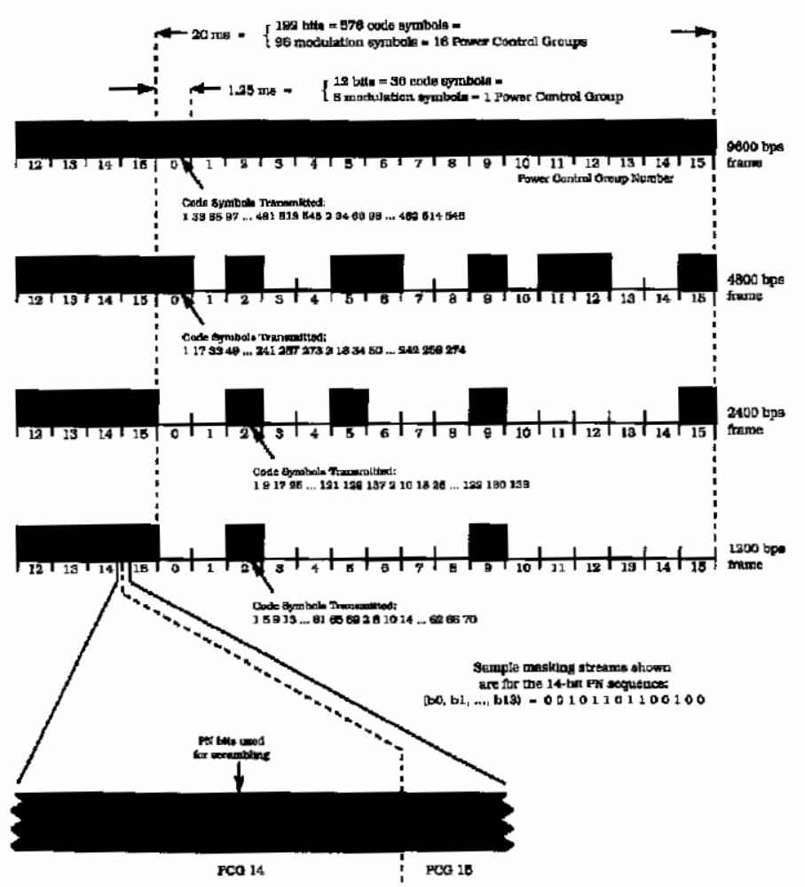

Reprinted with permission from The Telecommunications Industry Association, TIA/EIA/IS-95-A,
pp. 5–21, © 1995.
Figure I.I-66—Reverse CDMA channel variable data rate transmission example

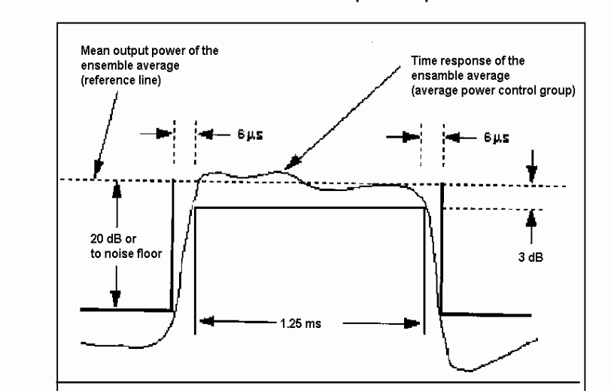
Figure I.I-68—CDMA power control group envelope mask transmission envelope mask (average gated power control group)

OFDM
Orthogonal Frequency-Division Multiplexing (OFDM) is a digital multi-carrier modulation scheme, which uses a large number of closely-spaced orthogonal sub-carriers. OFDM is essentially identical to Coded OFDM (COFDM). Each sub-carrier is modulated with a conventional modulation scheme (such as quadrature amplitude modulation) at a low symbol rate, maintaining data rates similar to conventional single-carrier modulation schemes in the same bandwidth. In practice, OFDM signals are generated and detected using the Fast Fourier transform algorithm.
OFDM has developed into a popular scheme for wideband digital communication, for wireless as well as over copper wires.
The primary advantage of OFDM over single-carrier schemes is its ability to cope with severe channel conditions — for example, attenuation of high frequencies in a long copper wire, narrowband interference and frequency-selective fading due to multipath — without complex equalization filters. Channel equalization is simplified because OFDM may be viewed as using many slowly-modulated narrowband signals rather than one rapidly-modulated wideband signal. Low symbol rate makes the use of a guard interval between symbols affordable, making it possible to handle time-spreading and eliminate inter-symbol interference (ISI).

Orthogonality
In OFDM, the sub-carrier frequencies are chosen so that the sub-carriers are orthogonal to each other, meaning that cross-talk between the sub-channels is eliminated and inter-carrier guard bands are not required. This greatly simplifies the design of both the transmitter and the receiver; unlike conventional FDM, a separate filter for each sub-channel is not required.
The orthogonality also allows high spectral efficiency, near the Nyquist rate. Almost the whole available frequency band can be utilized. OFDM generally has a nearly 'white' spectrum, giving it benign electromagnetic interference properties with respect to other co-channel users.
The orthogonality allows for efficient modulator and demodulator implementation using the FFT algorithm. Although the principles and some of the benefits have been known since the 1960s, OFDM is popular for wideband communications today by way of low-cost digital signal processing components that can efficiently calculate the FFT.
OFDM requires very accurate frequency synchronization between the receiver and the transmitter; with frequency deviation, the sub-carriers shall no longer be orthogonal, causing inter-carrier interference (ICI), i.e. cross-talk between the sub-carriers. Frequency offsets are typically caused by mismatched transmitter and receiver oscillators, or by Doppler shift due to movement. Whilst Doppler shift alone may be compensated for by the receiver, the situation is worsened when combined with multipath, as reflections will appear at various frequency offsets, which is much harder to correct. This effect typically worsens as speed increases, and is an important factor limiting the use of OFDM in high-speed vehicles. Several techniques for ICI suppression are suggested, but they may increase the receiver complexity

(informative)
Explanation of rationale used in this standard
The testing prescribed in this standard has been designed without a simulated or actual human to facilitate test repeatability of measurement as well as ease of use. The performance criteria, as outlined in Clause 9, have been determined to reflect a good correlation of measured emissions with actual use.

Validation of this specification accounted for actual in situ testing. The validation process verified test procedures and limits in a non-human test regime. These verification steps included specified testing and clinical trials as well as phone near-field and in situ comparisons.

(informative)
Bibliography
- “Accurate power measurements in digital RF communications,” Wireless Design and Development, Nov. 1996.
- “Analysis of peak power in GSM and CDMA digital cellular systems,” Microwave Journal, Oct. 1996.
- ANSI C63.2-1996, American National Standard for Instrumentation—Electromagnetic Noise and Field Strength, 10 kHz to 40 GHz—Specifications.
- ANSI C63.5-2004, American National Standard for Electromagnetic Compatibility—Radiated Emission Measurements in Electromagnetic Interference (EMI) Control—Calibration of Antennas (9 kHz to 40 GHz).

- ANSI S3.5-1997, American National Standard, Methods for the Calculation of the Speech Intelligibility Index.
- ANSI S3.7-1995, American National Standard Method for Coupler Calibration of Earphones.
- ANSI S3.25-1979, American National Standard, Occluded-Ear Simulator.
- ANSI/ASA S3.25-2009 - American National Standard for an Occluded Ear Simulator
- Berger, H. S., “Compatibility between hearing aids and wireless devices,” Electronic Industries Forum, Boston, MA, May 1997.
- Berger, H. S., “Hearing aid and cellular phone compatibility: Working toward solutions,” Wireless Telephones and Hearing Aids: New Challenges for Audiology, Gallaudet University, Washington, DC, May 1997 (to be reprinted in the American Journal of Audiology).
- Berger, H. S., “Hearing aid compatibility with wireless communications devices,” IEEE International Symposium on Electromagnetic Compatibility, Austin, TX, Aug. 1997.
- Bronaugh, E. L., “Simplifying EMI immunity (susceptibility) tests in TEM cells,” in the IEEE International Symposium on Electromagnetic Compatibility Symposium Record, Washington, DC, pp. 488–491, Aug. 1990.
- Byme, D., and Dillon, H., “The National Acoustics Laboratory (NAL) new procedure for selecting the gain and frequency response of a hearing aid,” Ear and Hearing, 7, pp. 257–265, 1986.
- CISPR/TR 16-4-1, Specification for Radio Disturbance and Immunity Measuring Apparatus and Methods—Part 4-1: Uncertainties, Statistics and Limit Modelling—Uncertainties in Standardized EMC Tests.
- CISPR 16-4-2, Specification for Radio Disturbance and Immunity Measuring Apparatus and Methods—Part 4-2: Uncertainties, Statistics and Limit Modelling—Uncertainty in EMC Measurements.
- CISPR/TR 16-4-4, Specification for Radio Disturbance and Immunity Measuring Apparatus and Methods—Part 4-4: Uncertainties, Statistics and Limit Modelling—Statistics of Complaints and a Model for the Calculation of Limits.
- Code of Federal Regulations Title 47 Part 2 (47CFR2), Frequency Allocations and Radio Treaty Matters; General Rules and Regulations.
- Code of Federal Regulations Title 47 Part 6 (47CFR6), Subpart C, Access to Telecommunications Service, Telecommunications Equipment, and Customer Premises Equipment by Persons with Disabilities.
- Code of Federal Regulations Title 47 Part 15 (47CFR15), Radio Frequency Devices.
- Code of Federal Regulations Title 47 Part 20 Section 19 (47CFR20.19), Hearing Aid-Compatible Mobile Handsets.
- Code of Federal Regulations Title 47 Part 27 (47CFR27) Miscellaneous Wireless Communication Services
- Code of Federal Regulations Title 47 Part 90 (47CFR90), Subpart S, Specialized Mobile Radio Services.

- Crawford, M. L., “Measurement of electromagnetic radiation from electronic equipment using TEM transmission cells,” U.S. Department of Commerce, National Bureau of Standards, NBSIR 73-306, Feb. 1973.
- Crawford, M. L., and Workman, J. L., “Using a TEM cell for EMC measurements of electronic equipment,” U.S. Department of Commerce, National Bureau of Standards, Technical Note 1013, July 1981.
- Cellular Telecommunications and Internet Association (CTIA) Performance Evaluation Standard for 800 MHz AMPS and Cellular/PCS CDMA Dual Mode Wireless Subscriber Stations, 2003, Revision 3.21.
- EHIMA GSM Project, Development phase, Project Report (Part I), Revision A. Technical-Audiological Laboratory and Telecom Denmark, Oct. 1993.
- EHIMA GSM Project, Development phase, Project Report (Part II), Technical-Audiological Laboratory and Telecom Denmark, June 1994.
- EHIMA GSM Project Final Report, Hearing Aids and GSM Mobile Telephones: Interference Problems, Methods of Measurement and Levels of Immunity. Technical-Audiological Laboratory and Telecom Denmark, 1995.
- EIA RS-504-1983, Magnetic Field Intensity Criteria for Telephone Compatibility with Hearing Aids.
- “GSM basics: An introduction,” Microwave Journal, Oct. 1996.
- GSM Technical Overview, Roadmap. Motorola document T-325AP, Sept. 1994.
- HAMPIS Report, Comparison of mobile phone electromagnetic near field with an up scaled electromagnetic far field, using hearing aid as reference, 21 Oct. 1999.
Hearing Aids/GSM, Report from OTWIDAN, Technical-Audiological Laboratory and Telecom Denmark, Apr. 1993.
- IEC 60118-1, Hearing Aids—Part 1: Hearing Aids with Induction Pick-Up Coil Input.
- IEC 60118-4-1981, Methods of Measurement of Electroacoustical Characteristics of Hearing Aids—Part 4: Magnetic Field Strength in Audio-Frequency Induction Loops for Hearing Aid Purposes.
- IEC 60118-13-2004, Ed. 2.0, Electroacoustics—Hearing aids—Part 13: Electromagnetic compatibility (EMC).
- IEC 60318-1 (1998-07), Ed. 1.0, Electroacoustics—Simulators of human head and ear—Part 1: Ear simulator for the calibration of supra-aural earphones.
- IEC 60318-2 (1998-08), Ed. 1.0, Electroacoustics—Simulators of human head and ear—Part 2: An interim acoustic coupler for the calibration of audiometric earphones in the extended high-frequency range.
- IEC 60318-3 (1998-08), Ed. 1.0, Electroacoustics—Simulators of human head and ear—Part 3: Acoustic coupler for the calibration of supra-aural earphones used in audiometry.
- IEC 60318-4, Electroacoustics – Simulators of human head and ear - Part 4: Occluded-ear simulator for the measurement of earphones coupled to the ear by means of ear inserts (Revision of IEC 60711:1981)
- IEC 60318-5, Electroacoustics – Simulators of human head and ear - Part 5: 2 cm³ coupler for the measurement of hearing aids and earphones coupled to the ear by means of ear inserts (Replaces IEC 60126:1973)
- IEC 61000-4-20 (2003-01), Electromagnetic compatibility (EMC)—Part 4-20: Testing and measurement techniques—Emission and immunity testing in transverse electromagnetic (TEM) waveguides.
- IEC 61094-1 (1992-06), Measurement microphones—Part 1: Specifications for laboratory standard microphones.
- IEC 61094-2, Measurement Microphones—Part 2: Primary Method for Pressure Calibration of Laboratory Standard Microphones by the Reciprocity Technique.
- IEC 61094-3, Measurement Microphones—Part 3: Primary Method for Free-Field Calibration of Laboratory Standard Microphones by the Reciprocity Technique.
- IEC 61094-4, Measurement Microphones—Part 4: Specifications for Working Standard Microphones.
- IEEE 100™, The Authoritative Dictionary of IEEE Standards Terms, Seventh Edition.,
- IEEE Std 149™-1979, IEEE Standard Test Procedures for Antennas.
- IEEE Std 299™-1991, IEEE Standard for Measuring the Effectiveness of Electromagnetic Shielding Enclosures.
- IEEE Std 661™-1979, IEEE Standard Method for Determining Objective Loudness Ratings of Telephone Connections.
- IEEE Std 1028™-1996, IEEE Recommended Practice for RF Absorber Performance Evaluation in the Range 30 MHz to 5 GHz.
- ITU-T Recommendation P.79, Calculation of Loudness Ratings for Telephone Sets.
- ITU-T, Blue Book, Volume V, P.37, Telephone Transmission Quality Series P Recommendations, Recommendation, Magnetic Field Strength around the Earcap of Telephone Handsets which Provide for Coupling to Hearing Aids.
- ITU-T, Blue Book, Volume V, P.50-1993, Telephone Transmission Quality Series P Recommendations, Recommendation, Artificial Voices.
- Joyner, K. H., et al., Interference to hearing aids by the new digital mobile telephone system, Global System for Mobile (GSM) Communication Standard, National Acoustic Laboratory, Australian Hearing Series, Sydney, Australia, 1993.
- Joyner, K. H., et al., Interference to hearing aids by the digital mobile telephone system, Global System for Mobile Communications (GSM), NAL Report #131, National Acoustic Laboratory, Australian Hearing Series, Sydney, Australia, 1995.
- Julstrom, S., Kozma-Spytek, L. & Isabelle, S. (January 11, 2006) Magnetic Performance Requirements for Wireless Device/Hearing Aid Telecoil Mode Compatibility. Submission for the record in Federal Communications Commission proceeding WT Docket No. 06-203.
- Kecker, W. T., Crawford, M. L., and Wilson, W. A., “Construction of a transverse electromagnetic cell” U.S. Department of Commerce, National Bureau of Standards, Technical Note 1011, Nov. 1978.
- Königstein, D., and Hansen, D., “A new family of TEM cells with enlarged bandwidth and optimized working volume,” in the Proceedings of the Seventh International Symposium on EMC, Zurich, Switzerland, pp. 127–132, Mar. 1987.
- Kuk, F., and Hjorstgaard Nielson, K., “Factors affecting interference from digital cellular telephones,’” Hearing Journal, 50:9, pp. 32–34, 1997.
- Levitt, H., Kozma-Spytek, L., and Harkins, J., “In-the-ear measurements of interference in hearing aids from digital wireless telephones,” Seminars in Hearing, 26(2), pp. 87–98, 2005.
- Ma, M. A., and Kanda, M., “Electromagnetic compatibility and interference metrology,” U.S. Department of Commerce, National Bureau of Standards, Technical Note 1099, pp. 17–43, July 1986.
- Ma, M. A., Sreenivasiah, I., and Chang, D. C., “A method of determining the emission and susceptibility levels of electrically small objects using a TEM cell,” U.S. Department of Commerce, National Bureau of Standards, Technical Note 1040, July 1981.
- McCandless, G. A., and Lyregaard, P. E., “Prescription of gain/output (POGO) for hearing aids,” Hearing Instruments, 1, pp. 16–21, 1983.
- Richard, M., Kanda M., Bit-Babik, G., DiNallo, C., Chou, C. K., “A rugged microstrip printed dipole reference for SAR system verification,” IEEE MTT-S International Microwave Symposium, Seattle, WA, June 2–7, 2002.
- Skopec, M., “Hearing aid electromagnetic interference from digital wireless telephones,” IEEE Transactions on Rehabilitation Engineering, vol. 6, no. 2, pp 235–239, June 1998.
- Technical Report, GSM 05.90, GSM EMC Considerations, European Telecommunications Standards Institute, Jan. 1993.
- TIA/EIA/IS-55-A (Sept. 1993), Recommended Minimum Performance Standards for 800 MHz Dual-Mode Mobile Stations.
- TIA/EIA/IS-91 (Oct. 1994), Mobile Station—Base Station Compatibility Standard for 800 MHz Analog Cellular.
- TIA-1083 (March 2007), Telecommunications - Telephone Terminal Equipment - Handset Magnetic Measurement Procedures and Performance Requirements
- TIA/EIA TSB31-A Part 68 (Mar. 1992), Rationale and Measurement Guidelines.
- TIA TSB-31-C-1 (Feb 2009), Telecommunications - Telephone Terminal Equipment - Rationale and Measurement Guidelines for U.S. Network Protection, Addendum 1
- Victorian, T. A., “Digital cellular telephone interference and hearing aid compatibility—An update,” Hearing Journal, 51:10, pp. 53–60, 1998.
- Winch, R. P., Electricity and Magnetism. Prentice-Hall: Englewood Cliffs, NJ, 1967.
- Wong, G. S. K., and Embleton, T. F. W., eds., AIP Handbook of Condenser Microphones: Theory, Calibration and Measurements. AIP Press.

The current version of this standard provides detailed procedures up to 3 GHz, ahough the scope has been expanded up to 6GHz. The guidance provided goes as far as well researched methods are available and covers the primary bands relative to this issue.
For information on references, see Clause 2.
ANSI publications are available from the Sales Department, American National Standards Institute, 25 West 43rd Street, 4th Floor, New York, NY 10036, USA (http://www.ansi.org/).
U.S. Regulatory Guides are available from the Superintendent of Documents, U.S. Government Printing Office, P.O. Box 37082, Washington, DC 20013-7082, USA (http://www.access.gpo.gov/).
U.S. Regulatory Guides are available from the Superintendent of Documents, U.S. Government Printing Office, P.O. Box 37082, Washington, DC 20013-7082, USA (http://www.access.gpo.gov/).
IEC publications are available from the Sales Department of the International Electrotechnical Commission, Case Postale 131, 3, rue de Varembé, CH-1211, Genève 20, Switzerland/Suisse (http://www.iec.ch/). IEC publications are also available in the United States from the Sales Department, American National Standards Institute, 11 West 42nd Street, 13th Floor, New York, NY 10036, USA.
The IEEE standards or products referred to in this clause are trademarks of the Institute of Electrical and Electronics Engineers, Inc.
IEEE publications are available from the Institute of Electrical and Electronics Engineers, 445 Hoes Lane, Piscataway, NJ 08855-1331, USA (http://standards.ieee.org/).
ISO publications are available from the ISO Central Secretariat, Case Postale 56, 1 rue de Varembé, CH-1211, Genève 20, Switzerland/Suisse (http://www.iso.ch/). ISO publications are also available in the United States from the Sales Department, American National Standards Institute, 25 West 43rd Street, 4th Floor, New York, NY 10036, USA (http://www.ansi.org/).
ITU-T publications are available from the International Telecommunications Union, Place des Nations, CH-1211, Genève 20, Switzerland/Suisse (http://www.itu.int/).
NIS standards are publish by NAMAS (UKAS) and may be ordered from UKAS, National Physical Laboratory, Teddington, Middlesex, TW11 OLW, U.K.; Tel. 011-81-943-7140, FAX 011-81-943-7134.
SAE publications are available from the Society of Automotive Engineers, 400 Commonwealth Drive, Warrendale, PA 15096, USA (http://www.sae.org/).
UKAS documents are available at http://www.ukas.com/information_centre/publications.asp.
The numbers in brackets correspond to those of the bibliography in Annex K.
Notes in text, tables, and figures of a standard are given for information only and do not contain requirements needed to implement this standard.
Further information on m-law and A-law codecs can be found in ITU G.711.
The term “level” is to be interpreted as “rms amplitude” or “average power level”, whichever is appropriate.
The term “level” is to be interpreted as “rms amplitude” or “average power level”, whichever is appropriate.
The following information is given for the convenience of users of this standard and does not constitute an endorsement by the IEEE of these products.
iDEN is a registered trademark of Motorola, Incorporated.
The averaging time was determined by the inverse of 20 kHz, the top of the audio frequency band.
The two methods use two different measurements of power. The first method which applies the MIF utilizes a longer average to the power, as more fully described in Clause 6, that the second method, which is a peak power, using a relatively short averaging time.
After the square law detector, the signal is the recovered audio interference that would be received by a hearing aid.
The term “level” is to be interpreted as “rms amplitude” or “average power level”, whichever is appropriate.
Human hearing is characterized by several characteristics of the signal, including its spectral and temporal components. The spectral and temporal weighting filters, in Annexes D.6 and D.7,are designed to capture and weight the components of the signal for assessment of its RF audio interference potential to hearing aid users
The peak field mentioned in this table is sinusoidal peak. The values cannot be directly compared to the “desired quantity.”
The ratio of the peak with 80% AM applied to unmodulated CW is different from the peak to carrier power with 80% AM applied.
The presence of RF “hot spots,” typically at the base of the WD antenna, presented a particular problem for the committee. At these locations extreme field amplitudes are found but these extremes fall off very quickly, often being a fraction of the peak value in less than a centimeter. In addition, it is unclear that these areas transfer proportionate power in reality, due to their responsiveness to loading effects. In practical use a user can shift the WD slightly and find a location of good acoustic output while avoiding such RF “hot spots.” Representatives of consumers, WDs, and hearing aid manufacturers discussed this issue at length in the committee and concluded that allowing for a RF “hot spot” exclusion was important in finding a solution which met the requirements of users and was realistically achievable by all parties.
A common practice is to move the EUT ¼ wavelength relative to the structure, repositioning the measurement probe, so as to keep the same relative spacing between the EUT and measurement probe. Changing the relative orientation of the probe and EUT to the structure can also be a helpful test. If the readings change significantly then reflections from nearby structures may be indicated.
Normally the amount of time a display remains on is a customer defined option. When this is true the display should not be illuminated during the test.
Probe anisotropy may add significantly to the measurement uncertainty. This factor may be minimized by first moving the probe to the location of maximum measurement and then rotating the probe to align it for the maximum reading at that position. This rotation around the axis or shaft of the probe is recommended in order to minimize uncertainty due to anisotropy in the probe.
See relevant sections of FCC regulations, CFR 47, for more details.
A 1 kHz 80% AM is used because of its availability in most signal generators and its common usage in other RF immunity test standards. The 1 kHz 80% AM modulation has a fixed and well understood relationship to the modulations used in WDs. This relationship and the physics which determines the relationship is described in Appendix 4 of [B57] by Joyner, K. H., et al., and in Annex A of IEC 61000-4-3-2002.
The requirement of “no change” is defined as the undesired signal or reading being at least 20 dB less than the measured value. The 20 dB requirement is consistent with the similar requirement for RF test enclosures, found in C.1.1.
Longer lengths of tubing have the effect of attenuating the higher audio frequencies as well as introducing tubing resonances. Therefore, it is important to characterize the acoustic transmission line used in testing. See C.8. Depending on the measurement, characterization of tubing over the entire frequency range may not be necessary. Because acoustic output SPL measurements are at 1 kHz and 1.3 kHz, tubing attenuation needs only to be determined at these two frequencies for near-field immunity testing. This can be accomplished easily by connecting the desired length of tubing to the acoustic output of the hearing aid being tested, and with its volume set at the reference test position (RTP), as defined in ANSI S3.22, its acoustic output SPL relative to changing input SPL at a fixed frequency can be measured. From these input/output curves, the input SPL relative to a changing acoustic output level at this fixed frequency can be easily determined. However, if an accurate view of the overall spectrum is desired, then the tubing should be characterized.
The verification that a hearing aid is operating properly and setting it to a reference test gain may be accomplished by selecting and performing the appropriate pre-tests from ANSI S3.22-1996.
In the following steps, this input–output characteristic information shall be used to determine IRIL levels at 1 kHz and to determine the 65 dB SPL input related biasing level at 1300 Hz.
One way to perform the pre-scan is by placing low dielectric 15 mm spacers at the tip and feed of a dipole and manually scanning around the hearing aid to locate the hearing aid region, dipole location, and measurement plane and antenna angle of maximum sensitivity.
Care should be taken when positioning the hearing aid so that it does not precess during rotation and maintains the specified 15 mm spacing from the dipole.
Recording the net CW RF level avoids all of the variations in the responses to modulated RF signals that occur among various manufacturers and models of RF instrumentation. All RF instruments indicate the same level, within instrument uncertainty, in response to a CW (unmodulated) RF signal.
The calibration, per sub-clause C.5.2 and Table C.4 is performed at 300 V/m (49.54 dB (V/m)).
The bias signal established the hearing aid acoustic output level using a known input, which allows for the detection of any RF carrier effects on compression circuitry.
Additionally there is a specified limit for gain compression, shown in Table 7.2 and Table 7.3. The hearing aid must meet both the interference output limit and the gain compression limit to achieve a given category.
For example, if the 1 kHz acoustic output level at 900 MHz is 100 dB SPL and there has been less than a 2 dB deviation in the 1300 Hz bias level at 900 MHz, then there has been no significant deviation in the gain and no special treatment is required. Complete the calculations in the normal fashion. From the 1 kHz input–output curve previously generated, determine the acoustic input that corresponds to a 100 dB acoustic output. This would be the IRIL level measured at 1 kHz for 900 MHz. However, if the acoustic output level at 1 kHz is 100 dB SPL and there has been a decrease of 6 dB SPL in the 1300 Hz bias level at 900 MHz, then an adjustment must be made for the gain compression. The gain decrease of 6 dB would be added to the 1 kHz acoustic output level at 900 MHz. From the 1 kHz input–output curve, determine the acoustic input that corresponds to the new 106 dB acoustic output.
A dipole produces its maximum H-field at the center of the dipole and the maximum E-field near the tip of the dipole. A hearing aid is tested both near the center and tip of the dipole so as to evaluate its immunity to both high E-field and high H-field emissions. Thus the hearing aid immunity test is repeated, once 10 mm from the center of the dipole and then 10 mm from the tip of the dipole.
For further information, see the HAMPIS Report [B34], available from DELTA, Venlighedsvej 4, DK-2970 Hørsholm, Denmark, Tel.: +45 45 86 77 22, FAX: +45 45 86 58 98, or from the DELTA web site at http://www.delta.dk/hampiis/report.htm.
For example a maximum noise level acceptable for the environment can be derived as -48 dBA/m, which is 20 dB below -18 dBA/m, the category 2-3 threshold, plus a 10 dB reductions for the ambient limit.
See 8.3.4.1 for further details.
The 1025 frequency was selected rather than 1 kHz because a 1 kHz reference frequency may interfere with emission harmonics or test equipment fundamental frequencies.
The 1025 frequency was selected rather than 1 kHz because a 1 kHz reference frequency may interfere with emission harmonics or test equipment fundamental frequencies.
See 8.3.4.2 and 8.3.4.4 for details.
ANSI S1.4 specifies the A-weighting filter.
The intent of this sub-clause is to provide a nominal level speech input independent of air interface and measure the magnetic response in a normal use condition without requiring an acoustic reference. The nominal level speech signals in 8.3.2.1 will result in acoustic speech levels that are mutually consistent and also span a range including 94 dB SPL, as shown in the examples below. This is intended to allow the operator to set WD adjustable volume controls as needed to produce a sufficient desired magnetic level (ABM1) based on intended usage. When measuring with the specified nominal speech input level of –16 dBm0 for GSM, a GSM phone shall not exceed a receive loudness rating (RLR) of –13 dB at maximum volume setting. However at a nominal volume control setting with the same –16 dBm0 input, a GSM phone shall have an RLR of at least 2 dB ± 3 dB. An RLR of 2 dB ± 3 dB corresponds to a sound pressure level of 84 dB ± 3 dB SPL, assuming an earpiece frequency response that is flat over the frequency bands specified as per ITU-T Recommendation P.79. An RLR of -13 dB corresponds to a sound pressure level of 99 dB SPL, assuming an earpiece frequency response that is flat over the frequency bands specified as per ITU-T Recommendation P.79. When measuring with the specified nominal speech input level of –18 dBm0 for CDMA, a CDMA phone with volume control set to the midpoint should provide an RLR of 2 dB ± 5 dB. The CTIA (Rev. 3.21, 2003) CDMA test plan (V1.2) does not specifically place an upper limit on RLR. References: ITU-T Recommendation P.79. Calculation of loudness ratings for telephone handsets. Cellular Telecommunications Industry Association Performance Evaluation Standard for 800 MHz AMPS and Cellular/PCS CDMA Dual Mode Wireless Subscriber Stations.
See 9.2.1 for detailed instructions on processing measured data to determine the classification.
See 9.2.1 for detailed instructions on processing measured data to determine the classification.
See IEEE Std 269-2002 for additional guidance on broadband test methodology.
The figure of 90% is based upon data reported by Levitt et al. and Julstrom et al. [B62].
The values in Table 8-1 through Table 8-2 are built on a set of premises, which are documented here. • First, 80 dB SPL is assumed as the level of the intended audio input signal. • Secondly, the values given are for an equivalent CW signal. Thus for hearing aid immunity testing a CW signal is used to establish a field at the specified RF power level. Then the signal is modulated with 1 kHz, 80% AM for the test. Thus the peak field strength for the test is higher than the CW level by the increase created by the modulation. • Finally, the hearing aid gain deviation is a measurement of the gain response change of the hearing aid when exposed to the E- and H-fields created by the dipole. • The category levels represent available volume control adjustment. For instance, if the volume control requires 4 dB to 6 dB of adjustment to use the WD, it is considered within the residual reserve gain of the hearing aid but may become a problem during normal use and therefore is considered useable but not acceptable for regular use.
Studies have showen that most contemporary hearing aids have more immunity in bands below 960 MHz than above, and this led to a review of current hearing aid standards. When combined with the difference in device power this band-dependent characteristic is reflected as band-dependent limits in international standard IEC 60118-13-2004 for hearing instrument immunity. Consideration of these findings led to a revision in Table 8-3.
IEC 60118-1 makes reference to hearing aid output being the same for an acoustic input of 70 dB SPL and a magnetic input of 100 mA/m. Thus 31.6 mA/m is equivalent to an acoustic input of 60 dB SPL, and an acoustic input of 65 dB SPL is equivalent to 56.2 mA/m.
A large percentage (> 80%) of custom hearing aids manufactured today benefit greatly from mass production techniques. This allows for the achievement of a high degree of uniformity in key performance areas. This manufacturing consistency lends itself quite readily to use of standard production line sampling techniques aimed at predicting product quality. It is expected, therefore, that relevant product line assurance techniques be applied to a hearing aid production line to support a general representation of the immunity of a specific model or class of instrument.
1 kPa = 7.519 mmHg
f_{L}, f_{M}, and f_{H} refer to the low, middle, and high frequencies, respectively, of the probe-range to be calibrated.
The MIF values were measured in round robin testing in 2010 with multiple test labs each testing several phones and protocols.
The signal should consist primarily 1 kHz and a small 2nd harmonic equal to 20% of the 1 kHz fundamental.
The system must be able to accurately respond to the average RF signal level modified by the MIF, which for some signals will significantly lower the required detection level.
See, for example, Witt, F., “A Simple Broadband Dipole for 80 Meters,” QST, Sept. 1993, p 27. While this article is written around antennas for 4 MHz, a similar approach may be taken at 2 GHz.
The values presented apply only to dipoles constructed per the example given. Small variations in design can cause variation in these values. Therefore, different reference values can be used if appropriate documentation is provided.
Kanda, M., Richard, M., Bit-Babik, G., DiNallo, C., Chou, C. K., “A rugged printed dipole reference for SAR system verification and freespace measurements verifications,” 28th Triennial General Assembly of the International Union of Radio Science, New Delhi, India, October 23–29, 2005.
ANSI C63 currently has a project underway that is preparing a document on measurement uncertainty. It is anticipated that when complete this document will have the most current and relevant guidance on determining measurement uncertainty for EMC measurements.
© 1995 IEEE. Reprinted, with permission from the IEEE and Edwin L. Bronaugh (author), from his paper presented at the 1995 IEEE Symposium on EMC in Atlanta, GA.
In the lower frequencies, 824 – 849 MHz, the handset is transmitting and the base station is receiving. Therefore, this frequency range is of particular interest for this standard.
In the lower frequencies, 1850 – 1915 MHz, the handset is transmitting and the base station is receiving. Therefore, this frequency range is of particular interest for this standard.
Figure G.2 reprinted with permission from The Telecommunications Industry Association, TIA/EIA/IS-95-A, pp. 5–21, © 1995.
TIA/EIA/IS-95-A
Much of the source material for this sub-clause originated from: http://en.wikipedia.org/wiki/Orthogonal_frequency-division_multiplexing However, it has been edited according to the specific needs of this document.
ANSI publications are available from the Sales Department, American National Standards Institute, 25 West 43rd Street, 4th Floor, New York, NY 10036, USA (http://www.ansi.org/).
CISPR documents are available from the International Electrotechnical Commission, 3, rue de Varembé, Case Postale 131, CH 1211, Genève 20, Switzerland/Suisse (http://www.iec.ch/). They are also available in the United States from the Sales Department, American National Standards Institute, 11 West 42nd Street, 13th Floor, New York, NY 10036, USA.
U.S. Regulatory Guides are available from the Superintendent of Documents, U.S. Government Printing Office, P.O. Box 37082, Washington, DC 20013-7082, USA (http://www.access.gpo.gov/).
EIA publications are available from Global Engineering Documents, 15 Inverness Way East, Englewood, CO 80112, USA (http://global.ihs.com/).
HAMPIS Test Reports are available at the following URL: http://www.delta.dk/hampiis/report.htm.
The IEEE standards or products referred to in this clause are trademarks of the Institute of Electrical and Electronics Engineers, Inc.
IEEE publications are available from the Institute of Electrical and Electronics Engineers, 445 Hoes Lane, Piscataway, NJ 08855-1331, USA (http://standards.ieee.org/).
TIA/EIA publications are available from Global Engineering Documents, 15 Inverness Way East, Englewood, CO 80112, USA (http://global.ihs.com/).

